**Online School Portal System**

**for Ramona S. Trillana Senior High School**

                                                    A Capstone Project

Presented to

The Faculty of the Information Technology Department

Bulacan State University-Hagonoy Campus

In Partial Fulfillment

Of the Requirements for the Degree

Bachelor of Science in Information Technology

By:

Arellano, Ronnel C.

Balita, Ronce Allyson P.

De Erit, Michole Joshua Y.

De Leon, Cristel P.

Payongayong, Marjorie S.

Raymundo, Alyza Claire R.

2022

**Approval Sheet**

In partial fulfillment of the requirements for the degree of Bachelor of Science in Information Technology, this Capstone Project entitled **"ONLINE SCHOOL PORTAL SYSTEM FOR RAMONA S. TRILLANA SENIOR HIGH SCHOOL"** has been prepared and submitted by **Ronnel C. Arellano, Ronce Allyson P. Balita, Michole Joshua Y. De Erit, Cristel P. De Leon, Marjorie S. Payongayong, Alyza Claire R. Raymundo** who are hereby recommended for oral examination.

**MRS. ROSEWIN A. CRUZ**  **MR. DARVIN V. EVIDOR, BSIT**

Capstone Adviser

Literacy Adviser

Approved in partial fulfillment of the requirements for the degree of Bachelor of Science in Information Technology by the Committee on Oral Examination.

**MR. LOUIE GIE N. GAMMAD, BSIT MR. MIKEE SHAD T. PARAISO , BSIT**

Panel Member

Panel Member

**MR. MARK JASON M. PALMA, BSIT**

Panel Chair

Approved in partial fulfillment of the requirements for the degree of Bachelor of Science in Information Technology.

**DR. MIRIAM P. PARIÑAS , DIT DR. FELICIDAD A. ELEOGO, ED. D**

Program Chair

Campus Dean

**Approval Letter**

Dear Mam/Sir,

Good day!

We are the 3rd year students from Bulacan State University (Hagonoy Campus). We wish to conduct a thesis study about Online Student Portal System in Ramona S. Trillana High School (Senior High Department). This project tends to help the school administration, faculties, and students about the school processes such as enrollment, grades distribution, etc.

In connection to this, we would like to ask for your permission to conduct our research study in your school. Rest assured that the data we will gather will remain confidential and use for academic purposes only.

We have provided you a copy of our presentation about the system that our proposing.

We hope for your positive response on this humble matter. Your approval to conduct this study will be greatly appreciated. If you have any further information, please do not hesitate to contact us on 09050851020 or on the Facebook account Cristel De Leon. Thank you for your time and consideration in this matter.

**ACKNOWLEDGEMENT**

First and foremost, praises and thanks to the God, the Almighty, for His showers of blessings, for giving us strength, knowledge, and ability throughout our research work to complete the research successfully.

Apart from the efforts of us, the success of this thesis/capstone depends largely on the encouragement and guidelines of many others. We take this opportunity to express our gratitude to the people who have been instrumental in the successful completion of this thesis.

To our family, for their continuous and unparalleled love, help and support in terms of financially and morally. We are forever indebted to our parents for giving us the opportunities and experiences that have made us who we are.

To our technical adviser, **Mr. Darvin Evidor,** for giving us the opportunity to do research and providing invaluable guidance throughout this research. His vision and sincerity. He has taught us to carry out the research and to present the research works as clearly as possible. It was a great privilege to work and study under his guidance.

To our Capstone Professor, **Mr. Jaime Pulumbarit**, we would like to express our deep and sincere gratitude for providing invaluable guidance, for her patience. We are truly grateful for the opportunity.

To our literary adviser, **Mrs. Kristine Ignacio-Manuel**, for her constant enthusiasm and encouragement.

To the **Bulacan State University - Hagonoy Campus**, for allowing us to conduct this study. Thank you for your understanding and tolerance. We are truly grateful for the opportunity.

To the **Members of the Panel,** for their suggestions to improve our capstone.

Lastly, we are extremely grateful to our fellow students, siblings, parents, friends for giving us inspiration, motivation and for genuine support throughout this study.

It would be difficult to find adequate words to convey how much we owe the people behind to all our success. Lots of love and thanks to all of you.

-   The Researchers

**ABSTRACT**

The “Online School Portal System for Ramona S. Trillana Senior High School” is a web-based study initiative that will help the faculty and students in terms of process of the school wherein it acts as an information kiosk for students and faculties. The online school portal system can provide an efficient handling of information that is very easy for school to use since it is web-based and can be viewed from anywhere and at any time. The actual purpose in designing the system is to make the school process to get speed up. The overall benefit of the system is enhanced by reducing the latency that occurs while using the manual process. The computer-based architecture in this project was introduced using the PHP language, CSS, HTML and the software database as MySQL. This research work uses the compilation of data from the school, materials and the program has been designed to accomplish the project objective efficiently.

**Table of Contents**

**Preliminaries                                                                                            Page**

Title Page                           ………………………………………………               i

Approval Sheet                  ………………………………………………               ii

Approval Letter                  ………………………………………………              iii

Acknowledgement             ………………………………………………               iv

Abstract                          ………………………………………………               vi

Table of Contents              ………………………………………………               vii

List of Tables                     ………………………………………………               ix

List of Figures                    ………………………………………………               ix

**Chapter I - INTRODUCTION**……………………………………………               1

Project Context                  ………………………………………………               1

Purpose and Description   ………………………………………………              12

Objectives of the Study     ………………………………………………              15

Scope and Delimitation     ………………………………………………              18

Limitation of the Study       ………………………………………………              21

**Chapter II – REVIEW OF RELATED LITERATURE/SYSTEMS** ….      22

Technical Background       ………………………………………………              22

Foreign System              ………………………………………………              26

Local System                    ………………………………………………           29

Foreign Literature    ………………………………………………              33

Local Literature                 ………………………………………………              36

Synthesis                           ………………………………………………             38

**Chapter III – DESIGN AND METHODOLOGY**...…………………….             40

Requirement Analysis       ………………………………………………             42

Requirement Documentation……………………………………………             44

Design of Software, Systems, Product/ or Process ………………….             48

Development and Testing ……………………………………………....             51

Implementation Plan     ……………………………………………...             53

**Chapter IV – RESULTS AND DISCUSSION** ………………………... 54

Answer to Specific Objective 1 …………………………………………             54

Answer to Specific Objective 2 …………………………………………             59

Answer to Specific Objective 3………………………………………….             60

Answer to Specific Objective 4………………………………………….             61

Answer to Specific Objective 5………………………………………….             62

Mean Rating According to Authority……………………………………            70

Mean Rating According to Purpose…………………………………….            70

Mean Rating According to Coverage…………………………………...            71

Mean Rating According to Currency…………………………………....            72

Mean Rating According to Objectivity ………………………………….             73

Mean Rating According to Accuracy……………………………………             73

Mean Rating According to Functionality……………………………….             74

Mean Rating According to Training and Documentation ……………            75

**Chapter V – SUMMARY AND RECOMMENDATIONS** …………….              78

Summary                         …………………………………………….             78

Recommendations        ……………………………………………             80

**List of Tables**

**Table**  **Page**

1 List of Respondents  ……………………………………………...            67

2 Five Point Likert Scale Type    …………………………….……...            68

3     Evaluation Criteria for Websites  ………………………...………            70

**List of Figures**

**Figure                                                                                                            Page**

1 Context Data Flow of the Current System     ……...……………. 43

2 Hierarchical Diagram of the Current System       ……...………... 44

3 Level 0 Diagram of the Developed System         ……...………...  48

4 Context Data Flow Diagram of the Developed System…...……. 49

5 Hierarchical Diagram of the Developed System ………………... 50

6 Entity Relationship Diagram of the Developed System.………… 51

7 Create an Account .………………………………………...          54

8      Edit Account Information      ……………………….………………...          55

9      Verifying Email      ………………………………………....          56

10    Verifying Email      …………………………………….......          56

11    Delete Account      ………………………………………...          57

12    Generate Students’ Information……………………………………...          58

13    Enrollment Management……………………………………………...           59

14    Grade Management     ……………………………………………......          60

15    Display Announcement Management……………………………......          61

16    Add Announcement Management……………………………….......           61

17    Display Event Management……………………………….……........           62

18    Add Event Management……………………………………………...           63

**Chapter 1**

**Introduction**

**Project Context**

As technology grows throughout time, the way people live in this world also changes. Technology influences how individuals learn and think. It made it simple for people to communicate with one another and has simplified numerous tasks. People nowadays do not need to leave their homes to get what they need. There is no need to be stressed by going around malls because people can search it through the web and purchase anything they want. People can use search engines like Google to find almost anything on the Internet.

This modern world everyone lives in allows people to communicate with anybody with just a couple of clicks of the mouse or just tapping the keyboard. Thus, regardless of distance or time, one can speak with the other person. It was a tool that allowed people to make content, interact with others, and even escape reality. Everyone can now communicate data from one end of the world to the other in seconds, create online presentations, and so on.

Technology is now part of the various tasks that people do throughout their lives. It contributes to all aspects of society. It helped in improving the efficiency and effectiveness in Education, Health, Social life, etc. It has influenced almost every aspect of life today, including education.

Education also transformed. The way instructors educate and the way students learn have changed dramatically as a result of technological advancements. Teachers' and students' responsibilities have changed as a result of technology. In addition, education will recognize as the country's economic backbone. As a result, most educational institutions have begun to integrate technologies to improve students' learning processes.

Students nowadays can access and share more than any previous generation using the Internet. It also makes it easier for students to complete their tasks. Students can easily submit activities and homework, and teachers who can conduct online classes can be very effective.

When communicating through various social media platforms, students may open up and connect more with their teachers and other students. It also enables students to collaborate and work together in innovative ways. Learning becomes more enjoyable and convenient as a result of technology improvements. Students have come to depend on technology as they use it in different ways to access education.

Online transactions are one of the benefits that technology contributes. Today, online transactions are a popular method to communicate with others without meeting in person conveniently. Students greatly benefited from online transactions since most schools today use an online system to immediately check their grades, schedules, activities, school announcements, and events.

According to Indeed Career Guide (2021), “A web application is a client-server program. It means that it has a client-side and a server-side. The term "client" here refers to the program the individual uses to run the application. It is part of the client-server environment, where many computers share information. For example, in the case of a database, the client is the program through which the user enters data. The server is the application that stores the information.”

A Web application is a program that is stored on a web server and accessed through a browser interface over the Internet. Web applications are designed to be utilized by everyone and can use for a wide range of purposes. Web applications assist business operations. It can complete more tasks in less time and with high accuracy.

A web application requires a Web server, an application server, and a database to run. Web servers handle client requests while the application server completes the requested operation, and the database stores any information needed. Allowing numerous users access to the same version of a program is one of the advantages of Web applications. They also don't need to be installed and may access on different devices, including a desktop, laptop, or smartphone.

Based on a study by Singh (2016) entitled “A Study of Web Portal Features as a Knowledge Management System in School Education” the web portal serves as a beginning point for users connecting to the Internet via the Public Internet. As a type of knowledge management system, a web portal provides a rich place for users to share and search information, as well as communication services such as free email and content distribution.

Web portals are web-based applications or gateways that allow authenticated and authorized users to access a company's central data sources for communication, collaboration, and data exchange. They are specially built websites that collect data from different sources, such as emails, online forums, and search engines, and deliver it in integrated communication. They commonly act as a single point of information access.

Some of the necessary aspects of a web portal are data access, personal information, transactions, security, published content, and navigation. It can deliver information based on the user's preferences. Organizations can increase security, visibility, efficiency, and lowering operational costs by redirecting all business communication through a web portal.

Web portals are also now used in Education. Most of the schools nowadays use a school portal system. These School Portals serve as a gateway that gives remote access to teachers and students when it comes to the processes and resources of the school. It serves primarily as an online community or platform for exchanging information on all school activities, concerns, school processes, and other events. School Processes include enrollment, distribution of reports of grades, and so on. Current students and teachers have access to it.

School portals are ways of collecting, organizing, and presenting content in a customizable and personalized way. Many institutions, such as colleges and universities, have become more well-known because of technological advancements using the Internet. Students' productivity and satisfaction will improve due to the said system. It will keep track of their daily activities, check topics for discussion, materials for their actions, schedules, and grades.

Students can now register online, eliminating or reducing problems associated with traditional registration systems, such as long lines, paper forms, and inconvenient waitlists, wherein the school's registration is essential. A system with an enrollment function will apply to keep track of a student's data. A school's manual enrollment can result in inaccurate student performance evaluations, lost student records, inaccurate reports, and slow enrollment processing. Students will be confused as to what they should do and how they should go about enrolling. It is instrumental in the school because it simplifies the enrollment process.

According to Wahid et al. (2018) that the enrollment system replaces all manual processes with a software-based solution that makes enrollment activities simple, efficient, and accurate. The major goal of this system is to provide software that assists college administration in capturing all student information as well as essential information such as registration, courses, and payment. Students will be able to register, choose a course, and pay for it using the system. This technology enables students to be enrolled in a timely and comfortable manner.

Students' grade viewing allows students to access or log in to the online application using their email and password to view their grades. To improve operational work, many public and private schools are implementing continuous improvement programs. Furthermore, managing hundreds of records accurately without using automation is difficult for a teacher. Students must receive grades at the end of each semester. The purpose of viewing grades is to encourage students to achieve their goals while also identifying students' problem areas. Students' grades are critical information for progressing to the next grade or year level, and their accuracy is vital.

Students, parents, and even public visitors may look for the school's portal. Most of the school portals provide information about upcoming events, programs, and services offered by the school, as well as announcements, milestones reached by the school, prospectuses for all courses, activity calendars, the curriculum provided by the school, goals, and core values of the school, mission and vision of the school, contact information for the school, and the people behind it.

Using an online school portal system, the communication or collaboration of teachers and students will be better. Also, the manual process of enrollment, distribution of grades, and announcement will reduce the work of the teachers and school administration. School Portals connect students and teachers no matter where they are or what devices they are using, and they are considered an extension of the school. In an increasingly technology-driven society, people have come to expect access to accurate and reliable information on time. A school portal is one way to ensure that teachers, administrators, and students have personalized access to information 24 hours a day and that they may access it from any location and device.

Ramona S. Trillana High School is at Sto. Rosario Hagonoy, Bulacan. It was founded in 1954 and was given the name Southern Institute at the time. The Trillana Family owns this small private institution. In 1989, Nana Monang, as she was widely known, donated the school to the government. It started with a 600 square meter land donated by the founder and former owner, the late ex-Mayor Ramona S. Trillana. Their service to the community up to the present gives hope to the poorest of the poor to pursue less expensive education.

This institution has been helping the youth from the following barangays; San Jose, San Nicolas, Sagrada Familia, Sta. Elena, Pugad, Tibaguin, San Roque, Sta. Cruz and San Pascual. They have satellite campuses located at Sta. Elena and San Nicolas. The campus at San Nicolas was known as Don Miguel Campus. The fourteen elementary schools in the West District of Hagonoy are their primary sources of enrollment. The school community is optimistic that they will be able to serve more students in the future.

Ramona S. Trillana High School aims to be a symbol of respected values; a term is given to it by former School Division Superintendent Teofila Villanueva to acknowledge its success as a learning institution. It fosters a national culture of excellence by developing God-fearing, God-loving, morally upright, and skilled. The said school is creating a friendly environment for children. Its goal is to educate young people who are internationally competitive, excellent communicators, critical thinkers, active achievers, and values-driven. Their objectives are to provide advanced education about technology to the students, to improve students' competency in using the English language for communication, to develop their mathematics skills, to develop students' ability to think, decisively, and critically, and to instill a love of God and nation in students.

In the school year 2012-2013, the Philippines began using the K-12 system. The program prepares graduates to enter the workforce after high school or prepare them for college if they desire to do so. Students are given enough time in grades K to 12 to develop essential academic abilities and participate in co-curricular activities. Kindergarten until Grade 12 education is the cover of the K to 12 Program. To offer enough time for mastery of concepts and skills, produce lifelong learners, and prepare graduates for higher education. It will include six years of elementary education, four years of junior high school, and two years of senior high school.

Every Senior High School student can choose among three tracks. Including Academic, Technical-Vocational-Livelihood, and Sports and Arts. The Academic track includes three strands which are the General Academic Strand (GAS), Accountancy and Business Management (ABM) strand, Humanities and Social Sciences (HUMSS) strand, and lastly, the Science, Technology, Engineering, and Mathematics (STEM) strand.

Ramona S. Trillana adopted the changes of the implementation of Senior High School learning in the Philippines. They built additional buildings and hired new teachers for the Senior High School Department. Their senior high school department consists of 23 teachers, 15 out of 23 teachers are advisers, and the rest are subject teachers, and they also have one registrar. They started to accommodate more than 300 senior high school students, and now they have 816 students currently enrolled in their school. It consists of 402 Grade 11 students and 414 Grade 12 students.

The capacity of senior high school students they accommodate has been increased and continues to grow as the years pass by. They just started to offer two strands of learning which are General Academic and Technical Vocational Livelihood Strands. And they added Accountancy and Business Management. And recently, the school includes the Science, Technology, Engineering, and Mathematics Strand.

This growth also affects the processes and the management of the school. Wherein they are experiencing problems in accommodating and managing their students. In addition, the development of their school capacity increases the work to be done by the teachers about inquiries, enrollment, and grade management. The current system of the school can support their processes. They can still accommodate students and do their job. But, with the number of students being added to Ramona S. Trillana Senior High School Department yearly, the efficiency and the effectiveness of the school when it comes to its processes are being affected.

The researchers conducted a preliminary investigation to determine the problems experienced by Ramona S. Trillana Senior High School. It includes the process of enrollment, grade management, announcements, and events. As a result of the problem analysis, researchers identify problems that affect and hinder their school processes.

The majority of their school processes are manually processed, requiring a significant amount of workforce and resources. When it comes to enrollment, the school prints numerous registration forms filled out by the student using the pen, and they will submit them. With this kind of process, there are times when the registration form does not capture or include all of the necessary information about the student, such as the guardian's phone number and LRN. All of the information in the registration form is needed to fill out because it will affect their process of producing the School Form 1.

After collecting registration forms answered by the student, the faculty needs to encode all of the student's information in Microsoft Excel, which consumes a lot of effort producing the School Form I. This School Form I is being sent by the adviser to the registrar. And the registrar will collect and organize the school forms coming from different sections.

Organizing and producing class sections also affects the efficiency of the school. They still need to separate the registration forms of the students in different boxes based on their average. It takes three days for them to be able to finalize the sections. Producing class sections earlier would help them inform their students early in what room they should go to at the start of the school year.

Producing report cards also has been a challenge to them because there are times that teachers print report cards simultaneously using only three printers. This process consumes a lot of time and resources in the process of distribution of grades. The Advisers also experience difficulty when it comes to organizing and combining the Grades of their students coming from their subject teachers. Subject teachers will submit a list of the grades of the students to their advisers. And on the other hand, the adviser needs to encode all of the Grades and organize them one by one.

Most of the processes of Ramona S. Trillana Senior High School uses papers especially for producing their enrollment and distribution of grades which consume several resources and are also prone to natural disasters like fire, and they can be wet.

As part of the developed system, in terms of protecting the user's information, the researchers considered the Republic Act No. 10173 or Data Privacy Act. This Act aims for individuals to control their data and assist organizations in lawful data processing. Users must gather information if that website is trusted before it they input their information. In an online school portal system, the developers must ensure the privacy of all information that the users will input.

DepEd is committed to ensuring the free flow of information as required by the Freedom of Information Act (Executive Order No. 2, section 2016) and to protecting and respecting the confidentiality and privacy of these data and information as required by the Data Privacy Act of 2012. (Republic Act No. 10173). Unless access is denied due to the data or information falling under one of the exceptions enshrined in the Constitution, existing law, or jurisprudence, requests for data and knowledge shall be guided by the DepEd Freedom of Information Manual (Department Order No. 72, s. 2016).

The researchers must be able to collect the data of the users and secure it. There is information about the user that is private, personal, and sensitive. So, the researchers must always consider what information they should avoid having exposed to other users. The developed system protects students' intake by allowing only the school administration and registrars to view the students' data inputted in the registration form. These problems made the researchers think of a solution that will make the processes of the school efficient and effective for the school administration, students, and teachers. This analysis produced three possible candidate solutions that could assist the school in enhancing its processes and making them more convenient.

The first candidate solution that became an option is the Web-Based School Portal System for Ramona S. Trillana Senior High School. It contains student information management, enrollment management, and grade management. This solution helps the school to store and organize all the information needed. The enrollment function will help the school administration to accommodate the vast number of enrollees added every school year. This solution also included the posting or the distribution of grades using the school portal system.

The second candidate solution is the Web-Based School Portal System for Ramona S. Trillana Senior High School with Private Messaging. This solution will manage student information, process the enrollment for every semester, and distribute grades to the students. Furthermore, this candidate also has an additional feature which is private messaging. The developers included the private messaging function to help the students communicate with the faculty members if they have any concerns they would like to ask.

Based on feasibility analysis, the chosen solution would be the Online School Portal System in Ramona S. Trillana Senior High School. This web application will include the processes of the school about information management, enrollment management, grade management, and producing announcements and events. In information management, the developed system will manage and organize information of the user like the teachers and the students. In enrollment, it is not only for the old student in Ramona S. Trillana Senior High School but also includes the incoming senior high students. Finally, grade management will be more convenient since organizing and distributing the reports of grades can also be done through the developed system.

**Purpose and Description**

     The developed system is a web-based system that focused on enrollment management, distribution of grades, announcements, and events. Online School Portal System will capture the students, teachers, and the registrar's information. Users can edit their information. The system will be going to implement in Ramona S. Trillana High School (Senior High Department). The School Administration and the Faculty can view and manage the student information collected using the registration form. They also have access to the features on the portal.

The Online School Portal System includes main features such as enrollment management and distribution and viewing of grades. Connection in every user will be more established and convenient for everyone. And lastly, users of the system will also notify about the events and announcements of the school.

Due to the growing populations in Ramona S. Trillana High School (Senior High Department), the manual processes of enrolment and distributing the grades consume a lot of time and human effort. The developed system will save a significant amount of energy, resources, and time. Although the current system can still do the processes of the school, there are instances that they cannot capture all the information needed to enroll a student. So, the developed system has the required function or restrictions in encoding student information.

Students cannot submit their registration forms if they do not input all the necessary information. They can find the registration form after they create their account and submit the documents needed for enrollment. The system will be user-friendly and beneficial for the users. It will provide an easier and faster view of data for every user. For example, when the teacher is mistaken in the input of grades, their current system can do a correction. But the developed system will provide the means of updating the record in a much quicker and more convenient way. The system can also retrieve information from the database and can view it anytime and for future use. Also, this portal will reduce the hassle, and it is more beneficial for the students, teachers, registrar, and school administrations.

This study will state the beneficiaries of the developed Online School Portal System. The primary stakeholder of the school that will benefit from the system is the senior high school students of Ramona S. Trillana High School. Furthermore, the teachers, registrar, the school administration will also benefit from the study.

**To Ramona S. Trillana High School (Senior High Department).** The developed system will assist the school in improving the process of school through the use of technology. Using School Portal will also help the school department save resources, human efforts, and time. It will be helpful for them especially, with their plans to accommodate more strands and students in the future.

**To the Senior High School Students.** The portal system will help them enroll in the Ramona S. Trillana Senior High School Department without consuming too much effort and time. Students can also view their grades immediately, and they can also see their grades from the previous semesters because the system will store them in the database. Furthermore, the developed method will keep the students updated on the upcoming events and announcements.

**To the Teachers.** The developed system helps them produce the necessary documents including the School Form 1. This system will help them in the distribution of grades. The teachers can easily submit or update the grades of the students from the portal. On the other hand, advisers can compile and organize the grades of their students conveniently and quickly.

**To the Registrar.** The system will help the registrar to manage all the information of the students. The registrar does not need too much time by encoding all of their necessary information. Also, it will assist him in producing the required documents of the school, such as the School Form 1.

**To the School Administration.** This developed system will help the school administration to lessen the works of accommodating the massive number of students. As a result, their current school processes will be much more efficient. They can also send announcements and events through the use of a portal.

**To the Future Researchers.** The system will help to provide concepts and ideas about the current process and problems that the school encountered. In addition, the Online School Portal System of Ramona S. Trillana Senior High School will encourage and inform those who wanted to create the same study about how a school portal works. And to know what are the benefits that an organization can receive through the use of a school portal system. Also, to make this study their reference or guide. Especially for the functions or features that they wanted to develop.

The developed Online School Portal System for Ramona S. Trillana High School stakeholders is very timely and helpful because it will reduce a significant amount of time and effort as the school continues to grow. The developed system will be a gateway for the users to connect with the processes of the school. Passing the documents, enrolling, getting the report card, and producing announcements and events can be more efficient. So, the online portal system can be the solution to those said problems.

         The Online School Portal System will help the school administration to improve their efficiency in their processes. And make their work convenient without consuming too much time and effort. Also, to make the students updated and connected to their teachers. It would be a great help for them while developing their knowledge and skill in their respective fields.

**Objectives of the Study**

         The main objective of this study is to develop a gateway for students to access their grades, enroll, and get updated on the school events or announcements wherein the study is named as Online School Portal System for Ramona S. Trillana Senior High School. This study will also help teachers, registrar, and school administration of Ramona S. Trillana High School.

Specifically, the study aims to:

1. Integrate the following main functions

1.1 Information Management

1.1.1 Create an Account

1.1.2 Edit Account Information

1.1.3 Verifying Email

1.1.4 Delete Account

1.1.5 Generate Students’ Information

1.2. Enrollment Management

1.2.1 Enrollment for New Senior High Student

1.2.2. Enrollment for Old Senior High Student

1.3 Grades Management

1.3.1 Upload Grades

1.3.1.1 View Grades

1.3.1.2 Print Unofficial Copy of Grades

         1.4 Announcement Management

                     1.4.1 Add Announcement

                     1.4.2 Display Announcement

1.4.3 Edit Announcement

         1.5 Event Management

                     1.5.1 Add Event

                     1.5.2 Display Event

                     1.5.3 Edit Event

2. To identify and utilize the following system requirements and the effective development of the system as:

2.1 Functional Requirements

2.1.1 Collect Students’ Information

2.1.2 Capture Students’ Grades

2.1.3 Validate User’s Account

2.2 Non-Functional Requirements

2.3 Software Development Tools

2.3.1 Visual Studio Code

2.3.2 XAMPP Server

2.3.3 MySQL Server

2.3.4 Apache HTTP Server

3. Test and Evaluate the system using the Evaluation Criteria for Websites.

3.1 Authority

3.2 Purpose

3.3 Coverage

3.4 Currency

3.5 Objectivity

3.6 Accuracy

3.7 Functionality

3.8 Training and Documentation

**Scope and Delimitation of the Study**

This study will focus on the school processes about enrolment, grade management, and announcements in the school. The Online School Portal System tends to make these processes more efficient and effective for all users. The developed system has four levels of users; the senior high students of different strands including, General Academic Strand (GAS), Technical Vocational Livelihood (TVL), Accountancy, Business, and Management (ABM), and Science, Technology, Engineering and Mathematics (STEM) strand. In addition, the teachers, the registrar, and the user management are also part of the system.

For the students, they can view the information that they inputted in the registration form. The registration form will be provided in the enrollment function by the system. Students can also view their grades from the first semester (first and second grading) to the second semester (third and fourth grading) and they can print the grades as an unofficial copy. Class schedules from Monday to Friday are displayed. Only the user management can add, edit or delete for this function. And lastly, they will be updated in announcements and upcoming events of the school. In this function, the students, teachers, and registrar can only view the announcement and event schedule, and the user management is the only one who can post it.

The teachers can view and edit some of their information, such as the address, phone number, etc., and can only view their class schedules. User management is the one who can add, edit and delete the class schedule. They also have a list of the different sections they handled. The teacher is responsible for distributing the grades to the students using this system.

Like other users, the registrar also can view and manage student information. Furthermore, the registrar can also generate the students' data from the registration form into school form 1. The school form can be viewed in a table format and can be exported to Excel applications. Also, the registrar has a list of pending accounts of students. Lastly, for the user management, all the information of the other users will be displayed. User management has the authority to add, edit or delete an account of students, teachers, and registrar.

This study will take six (6) months to implement in Ramona S. Trillana High School (Senior High Department). Nevertheless, the said system will benefit the school administration, teachers, and even the senior high students. The main functions of the developed system are Student Information Management, Enrollment Management, Grade Management, Announcement Management, and Event Schedule.

Student Information Management will help the school administration and the registrar organize, sort, search, and store all the information needed. Senior high students, teachers, and registrar can add and edit their information. The user management is the one who can verify and delete an account. The school administrators can archive the information of the previous school year. It will be secured and resistant to natural disasters. So, if they need that information in the future, they can still retrieve and access it.

The Enrollment Management can register students for the incoming school year and semesters. The portal will accept all the inputted student information from the registration form. The portal system has the function to require all the input fields to be filled up. So, it will make sure that it will capture all the needed information about the students. In this function, the developed system will generate all the gathered information to produce the enrollees or the School Form 1, which is one of the needed documents in the school.

In the Grade Management function, the system will store the grades of the enrolled students in the system. The teacher can input the grades of students and the system will automatically compute the final grade for every semester.

And lastly, the function of announcement management. It included the announcement and event schedule. Users will be informed if the user management posted or created new announcements. Also, students, teachers, and the registrar can view the upcoming events for the whole year. User management is the one who can add, edit or delete announcements and event schedules.

**Limitation of the Study**

The developed system only includes senior high students of Ramona S. Trillana High School and not all the grade levels and other campuses. Also, this developed system does not have grades notifications via SMS (Short Message Service) for the parents of the students. The registration form and the report of grades posted in the portal are unofficial and only provided by the system. In terms of documents needed, this developed system doesn't have the upload function for the required documents in the enrollment period, so the students must submit the documents to the school. Also, the students don't have a document request function. This function will help them request what they will need in scholarships. And this online school portal system cannot be accessed without an internet connection.

**Chapter 2**

**Review of Related Literatures/Systems**

This chapter contains information that may be relevant to a particular topic that the researcher wants to discuss. It will explain the technical background of the study, foreign and local related literature, foreign and local systems. It will also discuss the Synthesis that will help readers comprehend the presented ideas and how these studies are relevant to the developed Online School Portal System.

**Technical Background**

The technical background will go over various technologies that the researchers utilized in developing the system. It will explain how the developers used it in the study. It aims to provide the readers or future researchers with the fundamental terminologies essential to understanding the paper.

**HTML** - A Hypertext Markup Language is a programming markup language used to create web pages. HTML files could be accessed by web browsers and rendered into visible or audible web pages. HTML elements serve as the foundation for all websites. HTML allows for the integration of pictures and objects, and HTML can create interactive forms. Developers utilized HTML in developing the Online School Portal System. The developed system used this markup language to create and display the objects in the user interface of the students, teachers, and the user management, including the tables, forms, buttons, pop-up messages, etc.

**CSS** - A Web page produced from several sources with a determined order of priority in defining any style element conflict. And also, CSS is a language for describing how Web pages are displayed, including colors, layout, and fonts. It allows the presentation to adapt multiple devices, such as wide displays, tiny screens. CSS is independent of HTML, and it can also operate with any XML-based markup language. In creating the system, the developers used CSS in designing the layout of the website. Using this coding language, forms, fonts, color, text size, backgrounds, and the other styles of the elements in the Portal can be modified. It is beneficial in developing the system to make it more user-friendly and pleasing to the user's eyes.

**PHP** - is a server-side programming language used to create web pages. It's possible to embed it in HTML. On Linux/UNIX web servers, it is utilized in conjunction with a MySQL database. It is most probably the most frequently used scripting language. And it's a widely used general-purpose programming language and interpreter free for using a complete PHP tag list. Developers used PHP in developing the system to interact with the files on the server. It is now possible to access and modify data like the students' information, grades, schedules, etc., held on a database.

**Microsoft's Visual Studio Code** - is a source code editor for Windows, Linux, and macOS. Support for debugging, syntax highlighting, intelligent code completion, snippets, and code refactoring are among the features. In addition, the developers will use Microsoft's Visual Studio Code in building the School Portal System to facilitate efficiency in writing the code. It helps the programmer write the code, debug, and correct the code using the intelli-sense method.

**Web Browser** - Also known as a browser, is a software application used to access and view websites. There are different web browsers. The Windows operating system includes Internet Explorer for free. Other browsers like Google Chrome and Firefox, and Opera are free to download. A website will be more accessible if it can display in different browsers and devices, including the browsers using smartphones. The Developers test the Online School Portal System website across many browsers to ensure that it works properly.

**Client-server networking** - is a type of computer networking that employs both clients and servers, each performing a different function. For example, client-server networks and the internet include web browsers and web servers, FTP clients and servers, and DNS. The networking that the researchers utilized in developing the Online School Portal System is the Client-server. Since the Web Portal includes clients, the students, teachers, registrar, and user management initiating requests for services or information, servers or the Online School Portal System must provide that service or function.

**XAMPP** – This is a free and open-source cross-platform web server developed by Apache Friends. It's compatible with Linux, Windows, and Mac OS systems. Using a personal web server for development allows users to work locally from their laptop or PC for developing a website. It assists a local host or server test their website and clients on computers and laptops before releasing them to the central server. This system enables a suitable environment to run and verify the function of projects developed using Apache, Perl, MySQL, and PHP using the host's system. This Web Server platform helped the developers by providing all the components needed for running, developing, debugging, and unit testing for Online School Portal before launching live in the central web server.

**MySQL** - is free and open-source under the GNU General Public License terms and is also available under various proprietary licenses. "My" is the name of co-founder Michael Widenius's daughter, and "SQL" is the acronym for Structured Query Language. In collecting data, a relational database organizes data into one or more data tables where MySQL could connect data types. SQL is a programming language for creating, editing, retrieving data from relational databases, and managing user access. MySQL integrates with an operating system to create a relational database in a computer's storage system, manages users, provides network access, and allows database processing and backup recovery. MySQL is a relational database management system that runs on the SQL programming language. MySQL is typically used as a web database. The developers used this query language to add, access, and manage content in the Online School Portal System database.

**Apache HTTP Server** - This is a free and open-source web server that provides online content via the internet. It's called Apache, and it quickly came to prominence as the most commonly used HTTP client on the web after its release. The Apache web server for Windows and Linux/UNIX is one of the most widely used web servers. It is currently used to host approximately 40% of all websites. Its role is to establish a connection between a server and the visitors' browsers (Firefox, Google Chrome, Safari, and so on) so that files may also be transmitted and collected (client-server structure). Online School Portal System utilized Apache HTTP Server to establish a way to communicate over networks from client to server and ensure that users can read and interact with the Web pages.

**SSL** - stands for Secure Sockets Layer, a security protocol that creates an encrypted link between a web server and a web browser. When there’s a padlock icon next to the URL in the address bar, that means SSL protects the website. When installed on a web server, it activates the padlock and the HTTP protocol and allows secure connections from a web server to a browser. Typically, SSL is used to secure credit card transactions, data transfer, and logins, and more recently is becoming the norm when securing the browsing of social media sites. The developed Online School Portal System utilized an SSL certificate to ensure that all of the user’s information are secured.

**Related Literature/Systems**

This section contains some of the most significant studies, principles, and knowledge relevant to the study. It also includes literature from both foreign and local research about Web Portal and its functions. It aims to increase the researchers' knowledge of the subject matter and use the related literature to develop the system.

**Foreign System**

According to Karri and Gupta (2019), In the present-day world, utilizing present-day innovation and the web for diminishing work and expanding proficiency is a way to the computerized nation. Using innovation helps in having a keen work process. Online School Portal intended to execute digitalization and to lessen the work of school staff/personnel. Like figuring level of participation and imprints, giving a time-table, keeping records in documents for quite a long time is diminished by this framework to conquer the issues caused by human mistake and wastage of time doing all procedure physically.

In the study of Thulasi Krishna (2016) entitled "Online Student Portal - A Learning Portal for Every Student," stated that "Portal is a specially designed website that helps to bring information together from different sources in a uniform way. Online Student Portal (OSP) is a web application that mainly focuses on learning, known as students, and trying to teach a learner known as teachers. The members in this portal can exchange information in different formats such as video, images, pdf, etc. This application will be beneficial for students to get updated on the latest information and communicate with worldwide learners. OSP provides services like an online book shop, online courses, forums, communities, study materials, news, and events."

As stated in PCE Staff/Student Portal by Nagpur (2019), the student portal system provides a straightforward approach to automate all college capabilities. But also, to provide complete functional reports to the college's top management with the most detailed information about every phase of the college. In other terms, their college portal has the following goals: A simple database kept. The system's operator will find it easy to use. User interfaces are user-friendly and appealing; it takes the operator very little time to learn how to operate the system. The goal is to create a college website with up-to-date information about the college and improve college record management expertise. The study explains that developing an effective School Portal System must be easy to use, user-friendly, and have constantly updated school information.

The study entitled “An empirical investigation of campus portal usage,” conducted by Saghapour, M. et al. (2018), determined the determinants of the perceived ease of use and perceived usefulness and their influence on campus portal usage. The study included a five-point Likert scale questionnaire based on the prior studies in a quantitative approach. The data gathered through a survey conducted with 341 staff working at the University of Malaya and analyzed using the partial least squares technique. The results indicate that the ease of finding and ease of understanding has positively impacted the perceived ease of using the campus portal.

Furthermore, this study also reported a significant positive effect of service quality, information, and process on the perceived usefulness of the campus portal. The study suggests that the perceived ease of use and effectiveness are vital to enhancing the campus portal’s usage frequency and volume. This study broadens the knowledge about factors that increase campus portal usage to refine the Online School Portal, thus enhancing its use. It must always consider the usefulness and the clarity of the Portal to increase its volume.

According to Giovanni M. (2016), based on his study about the "Happy Tots Enrolment System," an excellent example of a computer-generated procedure is the Enrolment System. This system reduces workload and provides the school with reliable information. As a result, not only will it benefit the students but also the administration as a whole. The Enrolment System notion is not a novel one. As the number of students enrolled grows each year, the enrollment process becomes more challenging to manage. It will help the situation of enrolment by providing a more convenient way to register. A school's enrollment system is critical. By implementing this system, the enrollment system will supply the necessary information and store it faster and more efficiently by student file. It will reduce faculty staff's effort in keeping files for each student regularly. It will also serve as information, particularly for the enrolled irregular pupils. This study tells the benefits of having an enrollment system, especially with the increasing number of students every school year, such as reducing the school administrators' workload and storing the student's information efficiently.

Villaverde II (2019) conducted a study entitled "Online Grading Inquiry System" to provide easy access for students to view their grades. The system developed was in the form of a website where end users like registrars, students, and teachers can log in using their login credentials. Also, Villaverde concluded that the Online Grade Inquiry System might be feasible to deploy on campus. Furthermore, the system is demonstrated to allow students to view the grades from any location as long as it has been encoded or uploaded by the concerned instructor or registrar. The study suggests that having an online viewing of the grades will be more convenient for the students since they can view it even if they didn't get their report cards. It is also essential to make sure that the teacher or the registrar uploads or encodes the students' grades. "The university students who use traditional announcement boards nowadays are exposed to various problems. The most severe problem is that the instructors may want to publish an announcement, but they may not exist in university, or maybe they are after a work time. So, they cannot or can inform the announcement board moment by moment. Moreover, the students should be near the announcement board all the time." The scope of the study is to develop a mobile application that acts as a digital university announcement board. Using the proposed application, the university staff can send announcements to students directly, and the information will be delivered to student devices in real-time with push notifications. Instructors will announce from one student or a group of students or students from different departments and stages. (Jasim et al., 2020). This study explains the benefits of the announcement notification system to students as well as with the teachers. It is essential to deliver the announcement immediately and conveniently.

**Local System**

According to Daugdaug G. et al. (2018) in "CAMPUS CONNECT: A WEB AND ANDROID CAMPUS PORTAL." explained that web portals are becoming increasingly popular to gather, organize, and display content in a consistent, customizable, and customized manner. With the advancement of the technologies that enable the establishment and management of these portals, it is now possible to order information content and engagement between users and administrators. Universities have improved their web portals throughout time. Web portals have grown to provide a cohesive appearance and feel across all university websites and personalize and customize their content.

In the study conducted by Tico, D. (2016) in "WEB PORTAL SYSTEM WITH SMS NOTIFICATIONS," the researchers defined that "An online student portal is one of the essential parts of a school. As technology evolves alongside the information revolution, the power of computers makes it easy to distribute and view the information needed with just a few clicks." Also, the researchers stated that the study would require a descriptive design that focuses on the proposed system where the functions view the students' sections and schedules. Also, students can view the details and schedule of exams, homework, activities, and programs of their professors and protect information. They will also manage all the news and events in the school-university and notify the students and professors or faculty staff through SMS. It is an efficient tool for processing data or information and makes a job faster with less effort and consumable time. The study explains that the Portal system is timely and beneficial in this generation, especially in education. The portal system helps every user with the different processes of the school mentioned in this study.

The University Information Technology Centre (UITC) developed the enrolment and registration System (ERS) to computerize the university's enrolment processes. The Students Report of Grades Module is the ERS's newest module, allowing students to check their grades and faculty members to preview their grading sheets via the TUP website. Students can use the University of the Philippines Student Portal to access the online registration system (ORS), view their grades, request documents, and update their contact information. It also contains links to the university's learning management system (MyPortal), library, and other online resources available only to UPOU students. MyPortal is the virtual learning environment at the university. These Universities use systems in providing enrollment, registration system, and also the viewing of grades. Those features made their school processes effective and efficient.

The study entitled "Enrollment System with Descriptive Analytics," conducted by Miranda, M. et al. (2019), emphasizes the Enrollment System, which includes assigning schedules, sectioning classes, and checking enrollment requirements. Enrollment reporting is provided with descriptive analytics, as well. The authors studied at Aplaya National High School in Santa Rosa, Laguna. Conventional record-keeping processes and enrollment cause problems when trying to keep track of students' records. Currently, 2,243 students, 1,201 are girls, and 1,042 are boys with ages ranging from 12 to 21. The researchers have developed a better enrollment system wherein enrollment reports are record keeping, and retrieval is an easier and faster generation of enrollment reports through descriptive analytics. This Enrollment System with Descriptive Analytics for Aplaya National High School includes three modules: enrollees, registrar, and administrator.

The system benefits every vital entity during the enrollment; the students, registrar, and the administrator. The students can ensure the data they have provided to the school as the record-keeping and retrieval have improved. The registrar can easily confirm the students enrolling in the upcoming school year, and registration forms have been more accessible. The administrator can quickly generate the enrollment report as a requirement for every academic year. Through this reporting feature, they can also forecast the number of enrollees for the upcoming school year. The study suggests that having an online enrollment system can improve the accessibility of registration forms. Also, it can quickly generate an enrollment report. These benefits of an online enrollment system are relevant in the development of the Online School Portal System.

The researchers recommend that the system should be available on other platforms like web-based and mobile devices. To have class scheduling automated with room assignments. And also, to add more features that will benefit the administrator, registrar, and students to use the system effortlessly. The study suggests that having an online enrollment system can improve the accessibility of registration forms. Also, it can quickly generate an enrollment report. These benefits and recommendations of an online enrollment system are relevant in developing the Online School Portal System.

The study entitled "Student Information and Accounting System of Cagayan State University - Lasam Campus, Philippines," conducted by Maggay (2017), aimed to develop a fully customized Student Information and Accounting System (SIAS) for Cagayan State University – Lasam Campus to help with the enrollment and accounting processes and cater to all clients and personnel in frontline services. This study implemented the Design Science Research for Information Systems framework. Thus, the researcher identified the problems encountered in the enrollment and accounting process, defined the study's objective, designed and developed the system, deployed and evaluated, and presented the result of the study. Based on actual observations, the system reduced the time consumed in providing frontline services during normal circumstances. As a result, registration of first-year students can be done only in 4-6 minutes, 2-3 minutes for old and regular students, and 2- 4 minutes for irregular students. In addition, the issuance of the certification of grades and enrollment is in 1 to 2 minutes. SIAS can finish preparing and distributing the official transcript of records in 10 to 20 minutes, and printing of evaluation of grades is in 1 to 2 minutes for regular students.

The overall performance of the SIAS increased the efficiency of the frontline service providers since most of the processes are computerized and automated. The result of the survey and quality of services, the accuracy of records and reports, and timeliness reveal that SIAS is a powerful and effective instrument in delivering frontline services. Also, the benefits that this study mentioned connected on the proposed school portal wherein the teachers can process the final grade of their students in automated operation.

Perez et al. (2019) conducted a study entitled “Event Management Solution Using Web Application Platform” to develop a web application for EINS Consultancy that allows users to manage events, announcements, and website content. Management includes creation, deletion, update, and view. Both the System Manager and Administrator have the privilege to manage events, announcements, and the scope of the website. However, only the System Manager has the right to manage user accounts and view the audit trail. At the same time, the end-user can view the created events and posted announcements, wherein an end-user could register to available events through an electronic form.

With the features mentioned above, the system can produce accessible access reports from the centralized repository of data. It can successfully manage all the events and announcements. The study describes the limitations of users in an event management system. And if an Online School Portal System will have this kind of feature, developers must consider who will manage, post, and view the event schedule.

**Foreign Literature**

According to webopedia.com, which was recently modified on May 28, 2021, the benefits of a school portal system in a digital-first academic environment, a student portal are vital. It centralizes all school-related announcements, information, and resources. Students can access assignments, course materials, grades, and announcements from a single site, allowing them to take care of all school-related obligations from a single place, resulting in fewer accounts to manage. It ultimately enhances campus-wide cybersecurity by reducing the chances of a bad actor intercepting a student's login credentials.

According to the teletype. in that was posted on February 9, 2019, the importance of having a student portal. “Student’s portal is one of the main and the latest platform to keep track of all the students in the academic institute. It is basically an online gateway for the teachers and the students to log in to the portal that is the website and see the information accordingly. The use of the student portal is now considered to be the best and the most effective solution rather than keeping the manual information that is paper-based. The other best thing that the student portal offers is that the news and the notice from the school or the college are updated on the portal and the students can see that important news from there and if they are at home and some kind of important news is there regarding the holiday or emergency then the school puts the news on the portal so that the students can get to know the news.” The system should be faster and more efficient as it calculates the student's grades and displays them. Teachers will suffer no more when compiling student reports. The system does not negatively affect anyone on the school premises because it will be developed to increase productivity and speed. This was also elaborated “automation aids the school heads to increase their productivity thus reducing effort, time and promoting accurate means of recording data.”

According to Ahmed T. (2017), not using digitalization is a better way in the modern world. Using current technology and the internet for reducing work and increasing efficiency is a way to digital country and helps in having an intelligent work process. So to implement this in college, an Online College Portal is designed to implement digitalization and to reduce work of college staff/faculty like calculating the percentage of attendance and marks, providing time-table, keeping records in files for years is reduced by this system and to overcome the problems caused by human error and wasted of time doing all process manually.

According to Bhuvnesh K. (2018), with the emphasis of a computerized student record, the idea of implementing a student's information system. SIS is a powerful, easy-to-use student record database management system wherein it can organize and manage all students' information. Also, it automates the student's personal information, educational information, and account information. This program can quickly search the student's database containing all the information about the student.

In 2021, Rauv described his blog entitled “How to Design the Perfect School Portal” that a school portal should never be difficult to use. Designs should understand what the users need to do, and getting information should make every effort swift. Many school portals make the mistake of trying to incorporate as much information as possible on each page. While this may appear to be convenient, it is usually just perplexing. For most users, having a hierarchy of information and ensuring that all information is linked correctly is significantly easier. In developing Online School Portal System, researchers should always consider the user interface of the website. It should be user-friendly, and the information flows quickly.

Karol K (2021) explained the steps on how to register a brand-new domain name. The first step is deciding on the domain name you want. Choose the right domain extension for your website. It should be easy to memorize, transparent and legal to possess. Second, check whether your domain name is available. If you are done choosing your domain name, the third step is choosing a domain registrar. Domain registrar is a service that may purchase a domain name on your behalf and then give you complete control over that domain. There are many domains registrar, and it is based on your perception of which company you want to work with. The last step, purchase your domain. Go to your chosen domain registrar and input the domain name you want. Review the payment summary and pay for your domain name.

In the study of Kumar, S. (2019) entitled "A REVIEW ON CLIENT-SERVER BASED APPLICATIONS AND RESEARCH OPPORTUNITY," the client-server concept can be applied to functions such as websites, web-based applications, a centralized computing system, mobile apps, e-commerce applications, and even cloud computing in today's information technology environment. The client-server system is a distributed computing system that consists of two types of independent and autonomous entities: the server and the client. Among the majority, client-server computing plays a critical role in data or information accessible from remotely stored lactations. Therefore, in the evolution of IT, the client-server system is fundamental. The client-server system's components break into two categories: physical and logical parts. Servers, client devices, input/output devices, networking, and power supply are physical components. The Online School Portal System will utilize client-server networking, so developers need to be familiar with how the Client-Server system works.

**Local Literature**

In an analysis of rappler.com, this school year, DepED reported a total of 2.89 million students enrolled in senior high schools across the country. However, there is a decrease of 303,129 students from the previous year (-9%). Private schools have 597,611 fewer students (-44), bringing the total number of private SHS students to 760,271. There has been an increase in the public schools of 331,778 SHS students (+19%), bringing the total number of students to 2,098,596. Students from private schools appear to transfer to public schools.

In the study by Almerino conducts, P. M. (2020) found that the K-12 implementations in Cebu (Philippines) are among the most highly urbanized areas where enrollments increase annually. However, there is a stumbling block in the so-called evolution of social media, which is one of the several difficulties that every organization must address (Mina et al., 2020). The public which deceived due to each user's sense of empowerment to express themselves freely and release false information. It may misrepresent communication's critical role in an organization. With such dangers, they must be cautious in distributing information about them. As a result, a webpage similar to social media is vital, as it can link people and facilitate information distribution to its intended users, followers, subscribers, and clients. In developing an Online School Portal System, developers should always ensure that all information flows in the proposed system must be legit and reliable. Users should have limitations in posting anything on the website.

Every public or private organization, regardless of its status in the industry, government, education, or non-government group, must have a website. So it can promote the products and services it offers in the business sector, contact customers often, and do business with other firms online. The public sector communicates with the public freely to be aware of the state's development and may be better served systematically. For example, most schools have a School Information System that controls student information, academic records, class schedules, faculty schedules, financial records, school activities, and school laws and procedures. Schools that use an automated system integrate it into their websites to allow students, parents, instructors, administrators, and employees to access it. Non-governmental organizations (NGOs) and government agencies that provide services to those who request it have built websites to reach out to them and meet their needs. (Navarro, 2019).

According to Gumpic, C. R. (2016), a vital component of this technology is the Student Information System. This Student Information System manages all aspects of a student's data, including admission, class schedules, subjects enrolled, overall student performance, and personal information. These elements are combined into a single database, allowing you to access and track data for any student with a single mouse click.

The developed Online School Portal System utilized client-server networking. According to Daugdaug G. et al. (2018) in "CAMPUS CONNECT: A WEB AND ANDROID CAMPUS PORTAL." explained that "The client-server model of technology is a distributed application structure that segmentation tasks or workloads between the providers of a service, called servers, and service requester called clients. Client and servers communicate over a computer network on different hardware, but both belong to the same system. The server host executes one or more server programs that share their resources with the clients. On the other hand, clients do not share any of its resources but request a server content or function. Therefore, clients initiate communication with the server which waits for an incoming request."

**Synthesis**

The researchers gathered information from different studies, articles, and books. It results in ideas and concepts that helped the researchers in developing the system. These studies guided the researchers in implementing the Online School Portal System of Ramona S. Trillana Senior High School. These studies also explained what developers must consider. Also, the things that researchers should avoid in developing an effective School Portal System.

Based on the local and foreign studies mentioned above, Web portals are becoming increasingly popular nowadays in businesses and organizations. Schools have improved their web portals throughout time. Online School Portal intended to execute digitalization and lessen the school teachers' work. Some of the functions of School Web Portals are providing schedules, online registration, viewing class sections and grades, keeping student records, conquering the issues caused by human errors and wastage of time doing all procedures physically, also offering news and announcements from the school. Students can see school announcements from the Portal even they are at home. Some studies discussed the benefits of having these features. Most of them improved the efficiency of the school processes.

Some studies explained that a school portal should never be difficult to use. In developing an Online School Portal System, the designs should understand what the users need to do. Many school portals make the mistake of trying to include as much information as possible on each page. While this may appear to be convenient, it is usually just confusing. So, the developers only included the users' necessary information and make the Portal pleasing to the eyes and easy to understand. The developers considered these recent studies and systems to develop an effective Online School Portal System of Ramona S. Trillana Senior High School.

**Chapter 3**

**Design and Methodology**

This chapter explains the method used in the study, such as requirements documentation, system design, development and testing, implementation plan, and references to serve as a foundation and guide in completing the developed system.

The researchers gathered information to find a suitable methodology for the developed system to expand the knowledge in this area. Researchers utilized Agile Software Development Methodology in developing the Online School Portal System of Ramona S. Trillana High Senior High School. Continuous planning, learning, improvement, team collaboration, evolutionary development, and early delivery are components that make up agile software development methodologies. It facilitates adaptability in times of change. It promotes continuous iteration of development and testing throughout the software development life cycle of the project.

The researchers decided to use the Agile Software Development Methodology because it is one of the most simple and effective methods for translating a business need into software solutions. It provides a flexible software development methodology. Priorities and requirements can easily change as the project progresses to satisfy the needs of the stakeholders.

Agile Software Development life cycle includes 6 phases. The researcher ensured that each developing stage is well-organized and adaptable to any changes while creating it. The first phase is the requirements. It includes designing the initial documentation that will list the initial requirements of the system. The second phase is the design. This phase is about making design documentation of the system based on the defined requirements. The third phase is the development and coding, which includes writing code and converting the design documentation into the actual software.

The fourth phase is integration and testing. This phase is making sure that the software is free from error and compatible with everything else. The Quality Assurance team will conduct tests to ensure the code is functional and the system met the business goals of the solution. The fifth phase is the implementation and deployment, wherein the software will implement on the servers and be provided to the clients. It includes a demo and the actual use. And lastly, the sixth phase is the review. After completing all the stages, clients will review the usability and progress of the system.

Developers will accept stakeholders' feedback and include it in the requirements of the next iteration. While developing the system, the researcher will ensure that every phase is well organized and flexible in any changes. Because it has different phases and every phase in this methodology is very important because the researcher identify all the problems and solution in the analysis.

Using Agile Software Development Methodology, developers managed work more efficiently and effectively while delivering the highest quality system within different constraints. It improves the delivery of initial business value and ensures that the system's quality will enhance throughout the development phase of ongoing planning and feedback. Developers can consistently align the proposed software with intended business requirements due to this continuous planning and feedback, quickly adjusting to changes in conditions throughout the process.

**Requirement Analysis**

It is about the current data flow of the school process of Ramona S. Trillana Senior High School. To quickly determine the flow of every cycle, the researcher creates a context data flow diagram. One of the primary functions of the school portal system is enrollment management. Students input their information in a printed registration form and submit it. Once the enrollment period is done, teachers will encode all the student's information to Excel to produce the School Form 1 and pass it to the school's registrar. In grade management, subject teachers submit the grades that they handled to the adviser of that student. They will distribute the report of grades to the parents on the designated date of distribution. Also, the registrar produces the student evaluation of grades. The school administrator creates the students' and teachers' class schedules, announcements, and event schedules that the students, teachers, and the registrar will be informed of wherein it is in Announcement and Event Management.  (See figure 1).

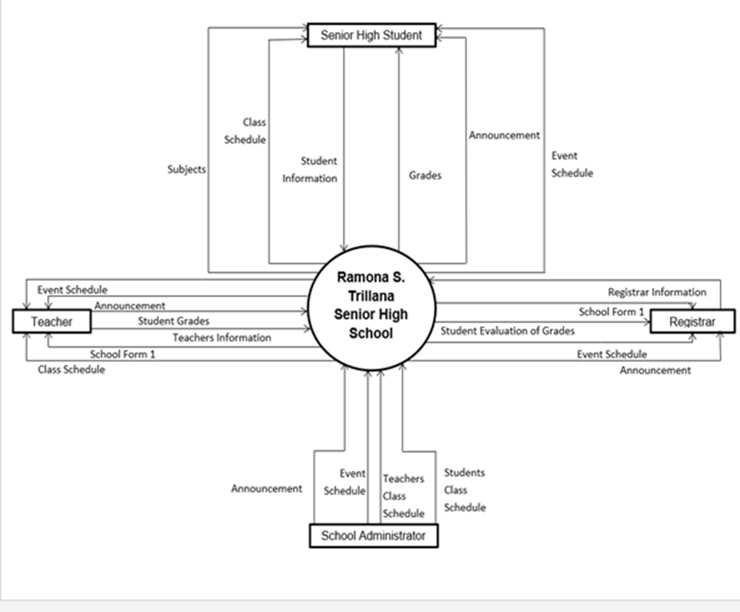**Figure 1. Context Data Flow of the Current System**

Figure 2 illustrates the hierarchical diagram of the current enrollment management system, grade management, and student record management. Enrollment management includes the students' inputted information, which will encode all the information to Excel to produce the school form 1. The grade management processes the grades that calculate all the scores of every requirement and makes the printed copy of the grades distributed to the parents. Also, sort the grades of every student to produce grades evaluation. The announcement management created by the school administrator will distribute it to the group chat of the teachers, and they will send it to the respective group chat of every section. In the event schedule, they will write the program for the whole month on a whiteboard or bulletin board, and they will erase it once the month ends and document the event again for the next month.  (See figure 2).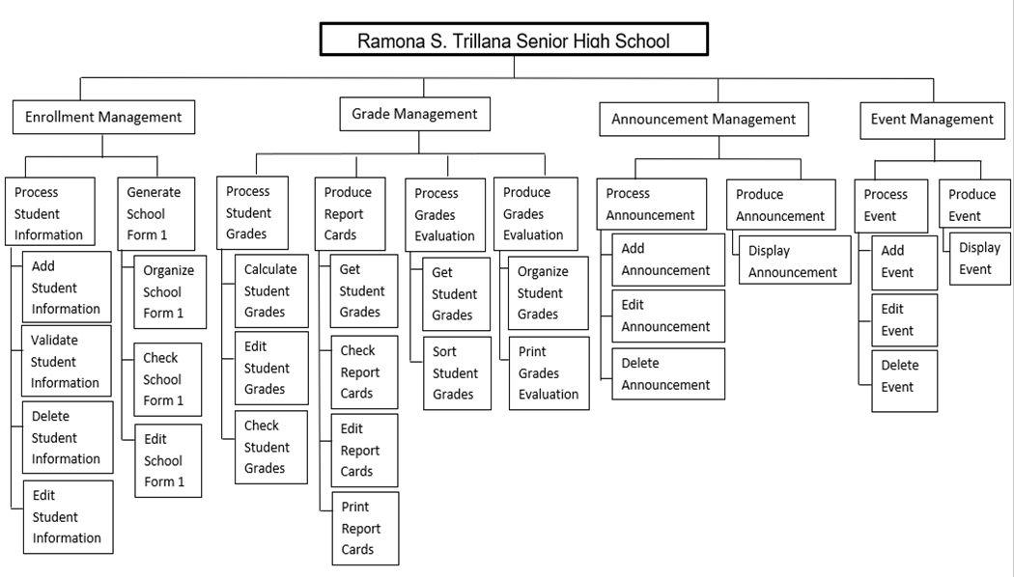

**Figure 2. Hierarchical Diagram of the Current System**

**Requirement Documentation**

Based on the context data flow and hierarchical diagram of the current system, the researcher listed all the Online School Portal System requirements in Ramona S. Trillana Senior High School. All the functional and non-functional requirements stated are approved by the client.

**Functional Requirements**

Functional Requirements are categorized into input, output, process, and stored data. The functions listed below are the functional requirements of the Online School Portal System of Ramona S. Trillana Senior High School.

**Input**

●      The system will collect the user’s information.

●      The system will capture students' grades.

●      The system will gather student and teacher’s class schedules.

●      The system will capture the subjects of the student.

●      The system will collect class sections and capacity.

●      The system will gather the announcements and event schedules.

**Output**

●      The system will send the verification through email.

●      The system will notify the user if the account is already verified.

●      The system will produce School Form 1.

●      The system will produce class sections.

●      The system will display the user’s information.

●      The system will distribute students' and teachers’ class schedules.

●      The system will display the subjects of the student.

●      The system will display the unofficial report of the grades of students.

●      The system will display the announcement and event schedule.

**Process**

●      The system will validate the user’s account.

●      The system will organize School Form 1.

●      The system will generate an export School Form 1 in excel format.

●      The system will generate an unofficial copy of grades.

●      The system will organize imported Student Grades in table format.

●      The system will organize class sections.

●      The system will update the users about the announcement and event schedule.

**Stored Data**

●      The system will store the user’s information.

●      The system will store the student grades.

●      The system will store School Form 1.

●      The system will save the announcement and event schedule posted.

**Non-functional Requirements**

Non-functional requirements are labeled based on the PIECES framework. The non-functional requirements of the Online School Portal System of Ramona S. Trillana Senior High School are stated below:

**Information**

●      All of the information of students must be collected and accurate.

●      The functions are not accessible for the account that is still not verified.

●      The report of grades is updated every quarter.

**Economy**

●      The system will reduce the cost of materials.

**Control**

●      The system prevents unauthorized users.

●      The system will secure that all of the information needed will be captured properly.

●      The system will secure the privacy of the users.

**Efficiency**

●      The teachers can distribute the grades of the students with a little amount of effort.

●      The system produces output easily and conveniently.

●      The system can produce class sections easily.

**Service**

●      The system would be learned in a short period of time.

●      The system will be used by the school administration, teachers and students.

**Design of Software, Systems, Product/ or Process**

The Level 0 diagram of the developed system is a high-level overview of the entire system or process that's being studied or described. In this diagram, the overall process of every feature of the online school portal system is illustrated.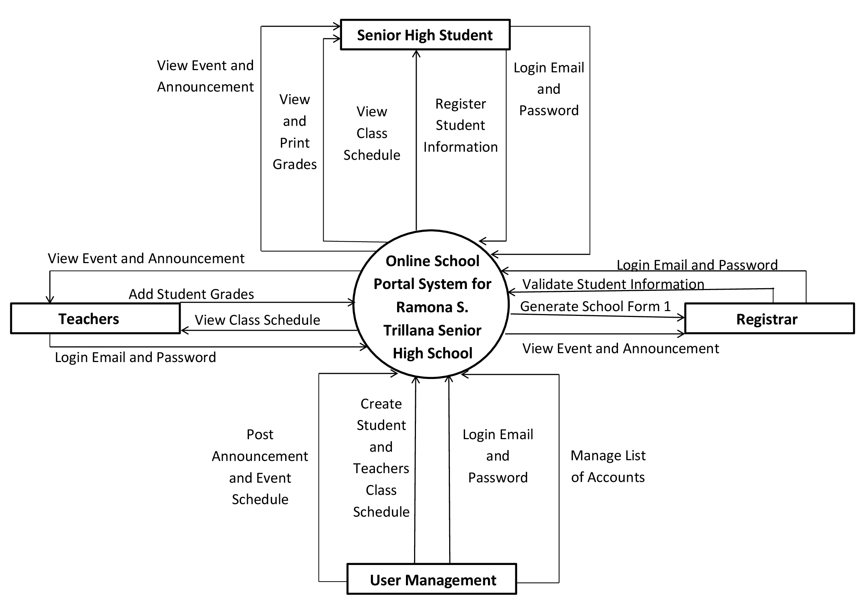

**Figure 3. Level 0 Diagram of the Developed System**

The context data flow diagram illustrates the event that will happen to the developed system. Teachers and registrar will input their information into the school portal. Senior high students will also input their information and pass the documents needed. Then, the School Form 1 will be displayed to the advisers, registrar, and user management’s account. Teachers have the authority to update the grades of the students in their accounts. User management is the one who can add, edit, delete announcements, event schedules, students, and teacher’s class schedules and will be distributed to the respective account.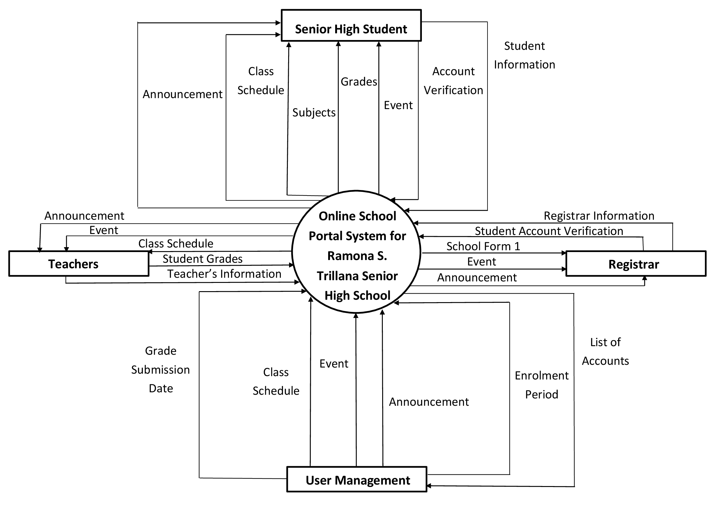

**Figure 4. Context Data Flow Diagram of the Developed System**

This hierarchical diagram shows the process of every function of the Online School Portal System of Ramona S. Trillana Senior High School. It includes Enrollment Management, Grade Management, Event Management, and Announcement Management. The Enrollment Management can add, validate, delete and edit student information that produces the School Form 1. In the Grade Management process, which the teachers can add, edit, and check. Then, it produces unofficial report cards that need to get, checked, edited, and can also print but it is an unofficial copy. In the Event and Announcement Management process, the school administration can add, edit and delete event schedules. Then it produces a schedule that will visible to students and faculty.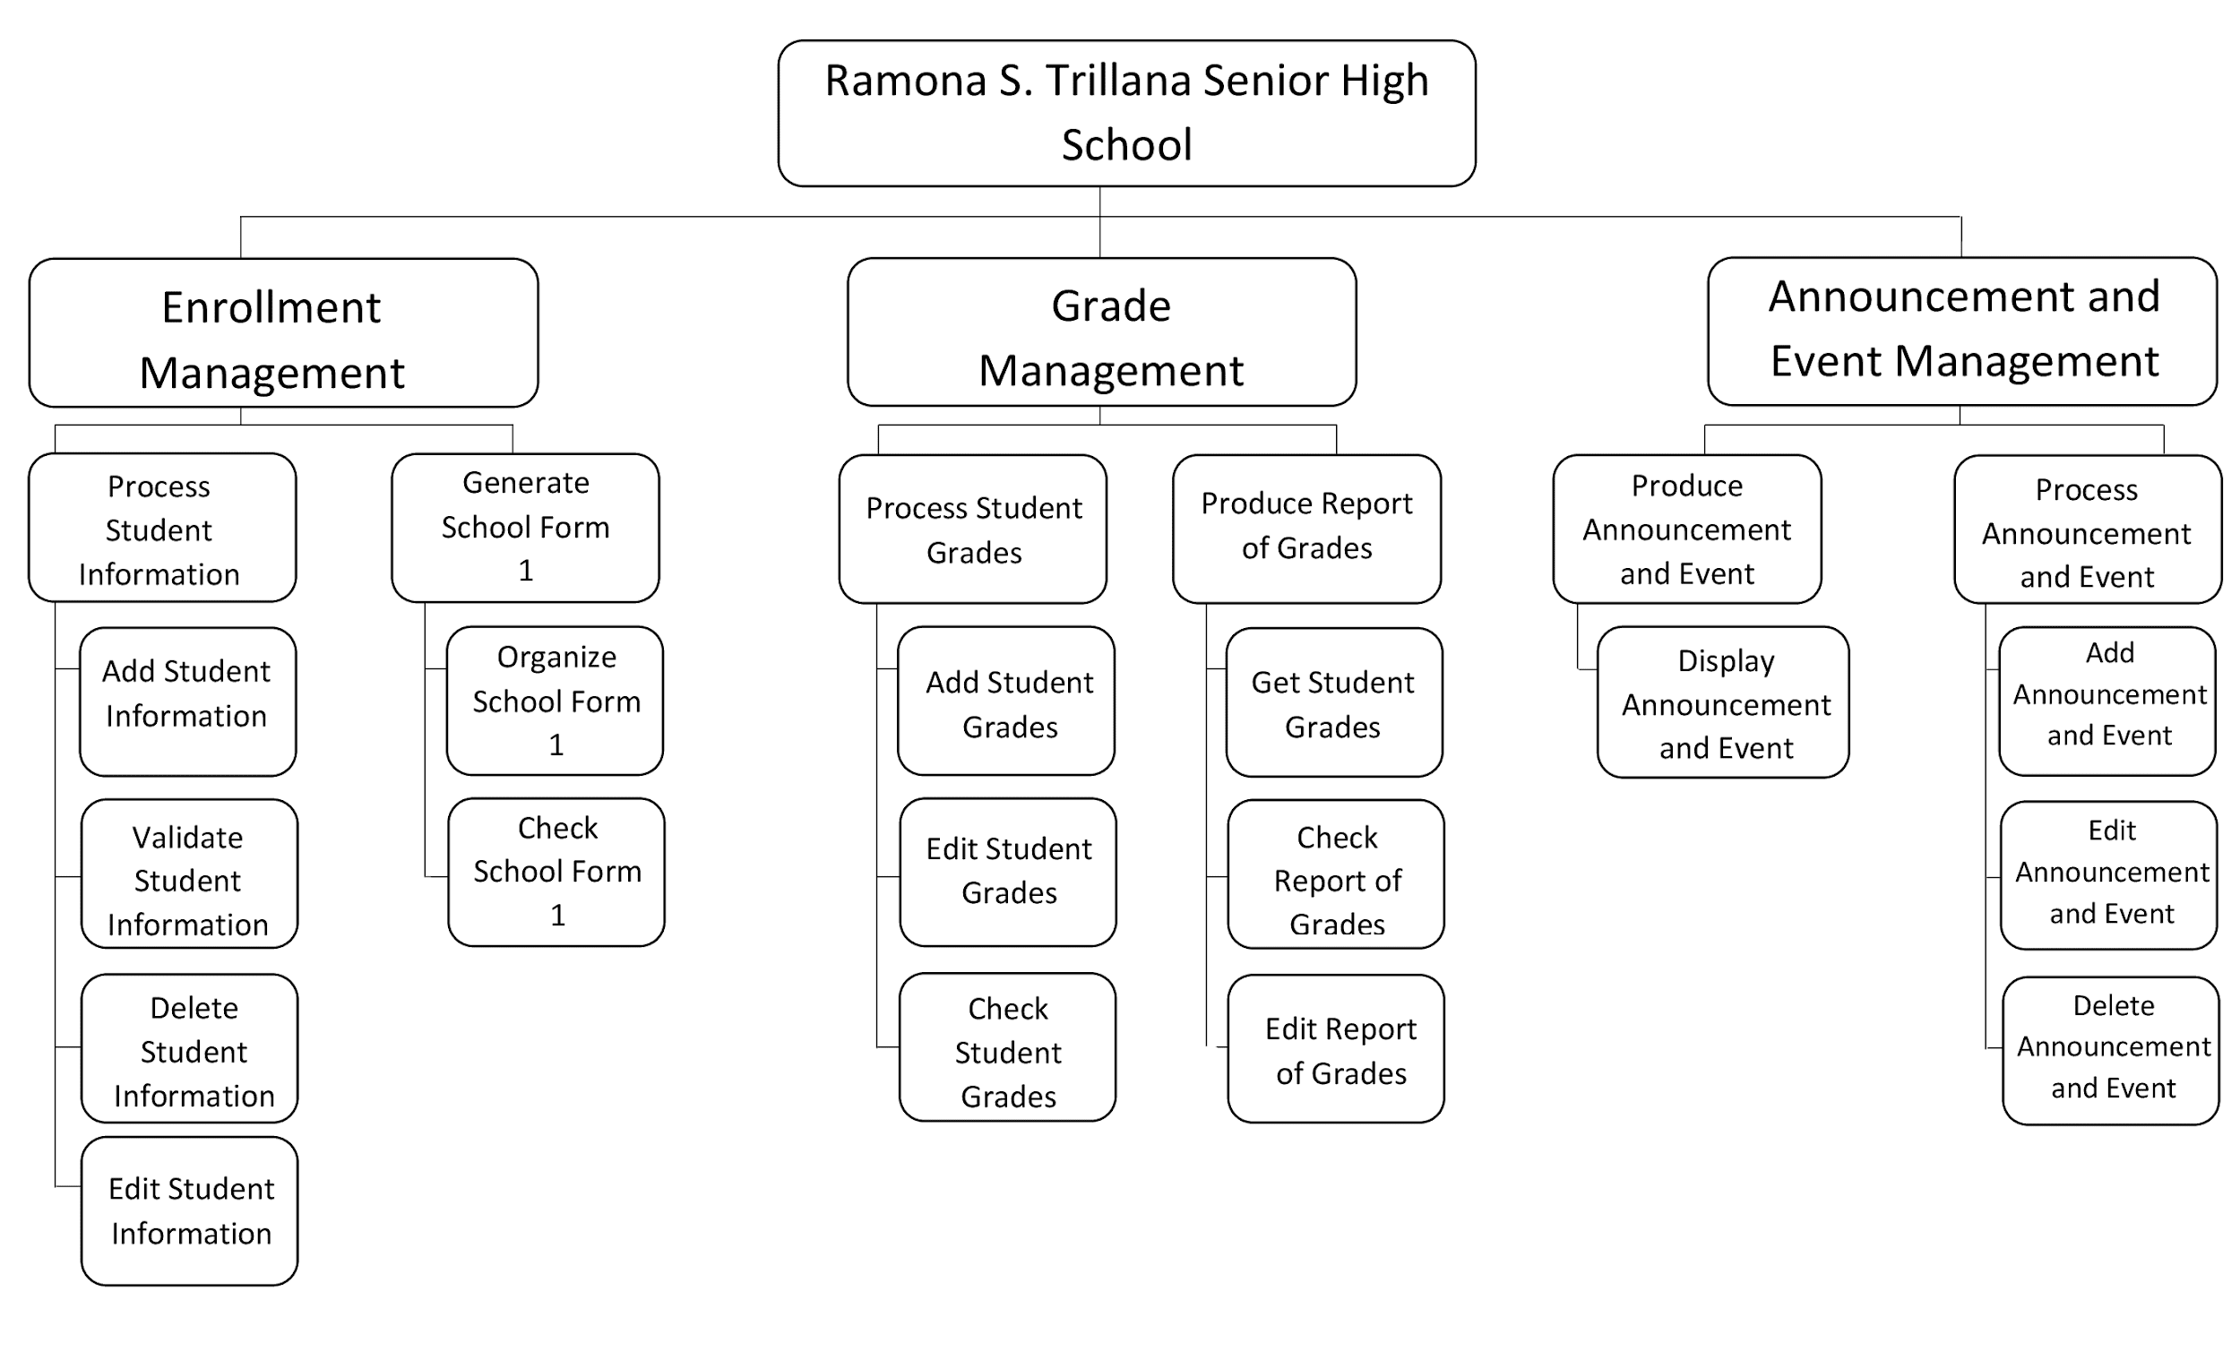

**Figure 5. Hierarchical of the Developed System**

Figure 6 shows the entity diagram of the developed system, Online School Portal System of Ramona S. Trillana Senior High School. The researchers used this diagram to determine the data needed in every entity and its relationship.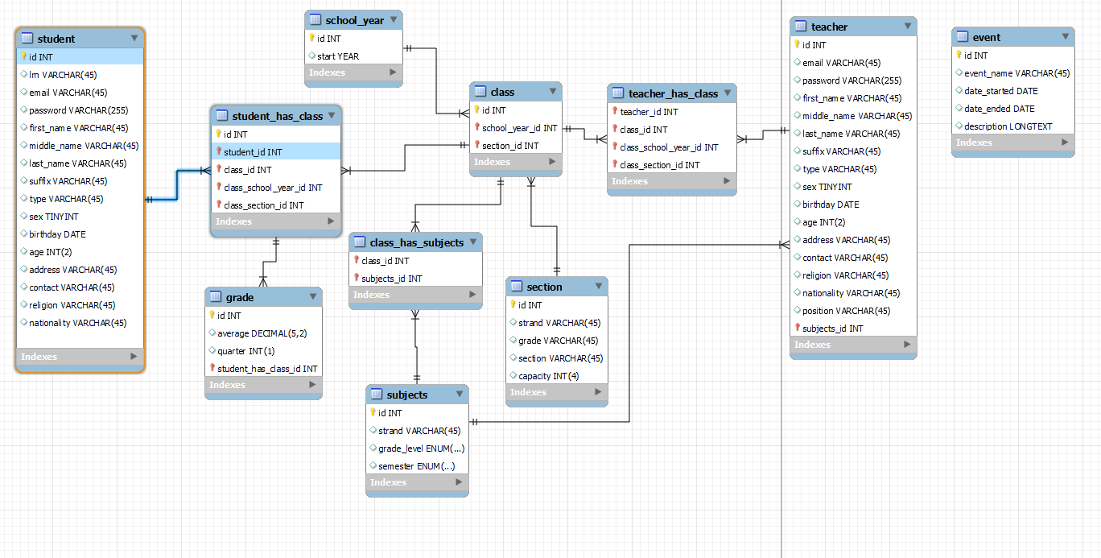

**Figure 6. Entity Relationship Diagram of the Developed System**

**Development and Testing**

The developed system is a web-based system. The developers used Hypertext markup language (HTML) to describe information structure on a webpage. Together with a Cascading style sheet (CSS) for describing the portal presentation, including layout, colors, and fonts. The developers used Hypertext Preprocessor (PHP) for the dynamic content that can interact with the databases and Javascript to manipulate dynamic content and handle every process for the system functionality. It is mainly used for validation and to execute complex actions. The developers used MySQL for database management and utilized Web hosting to create a website or web page on the Internet.

The researchers purchased A web host, also called a web hosting provider, a company that offers the technology and services required to view a website or webpage on the Internet. The developers used XAMPP, a popular cross-platform web server that allows programmers to write and test their code on a local webserver. They also used Apache HTTP server to connect a server to website users' browsers (Firefox, Google Chrome, Safari, and others) and deliver files back and forth between them in a client-server framework.

The Online School Portal System of Ramona S. Trillana Senior High School experienced further testing: compatibility testing, interface testing, user interface testing, performance testing, and acceptance testing. The developers tested the web application to other web browsers to ensure compatibility testing. Next is the interface testing; the developers tried to access all the menus, buttons, and options to make sure that it all is functional. The third testing is the user interface testing which the users are the ones who tested and checked the content if all functions are working. In performance testing, the developers tried to see if the main functions and the additional functions of the school portal follow the process indicated in the diagram shown in the Design of Software, Systems, Product/ or Process phase. Lastly is the acceptance testing, where the developers made a test plan for every function if it met the functional and non-functional requirements and if it is acceptable to use.

**Implementation Plan**

The Implementation Plan for the system describes how developers implemented the developed study and its complete procedures. It aims to implement the Online School Portal successfully and to meet all the requirements.

Developers presented the developed Online School Portal System to Ramona S. Trillana Senior High stakeholders and requested approval to implement the portal. The developers discussed everything about the school portal and how to use it. The developers also provided a user's manual for the stockholders to understand and be familiar with how the school portal works. The researchers demonstrated and gave instructions while the stockholders are using the system. And researchers conducted an assessment about the level of acceptability of the Online School Portal System using the Evaluation Criteria for Websites.

**Chapter 4**

**Results and Discussion**

This chapter presents the results of the study based on the general and specific objectives stated in Chapter 1. This section consists of discussion, analysis, interpretation, and implications of the summarized test results, as well as the limits and the significance level of the system’s capabilities.

The following are the specific objectives that the study aims to answer:

1. Integrate the following main functions:
   * 1. Information Management

i.    Create an Account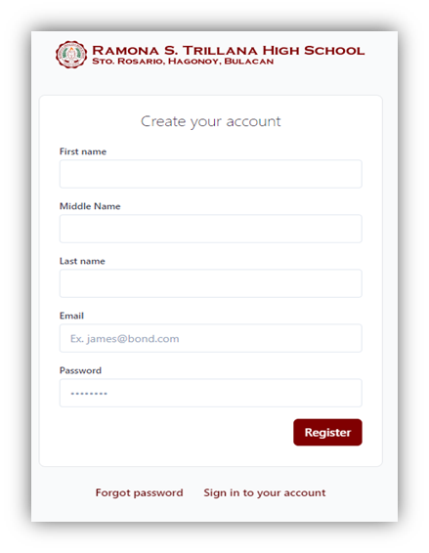

**Figure 7.**

In figure 7, students, teachers, and registrar can create an account in the School Portal by providing their First name, Middle name (if available), Last name, Email, and Password that is not less than 6 characters and it should contain a combination of numbers, uppercase, lowercase, and special characters.

 ii.        Edit Account Information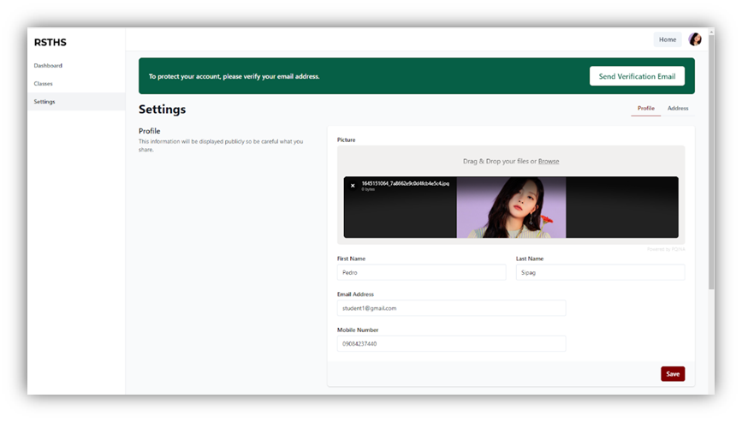

**Figure 8.**

As shown in Figure 8, users can edit their account information by going to the settings of their portal account. They can edit their personal information, address, profile picture, and also their email and password.

iii.        Verifying Email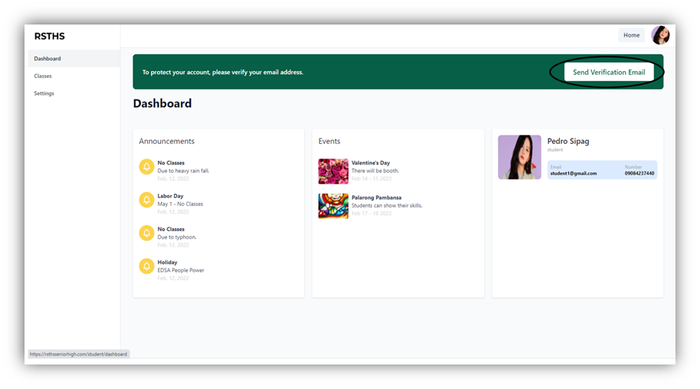

**Figure 9.**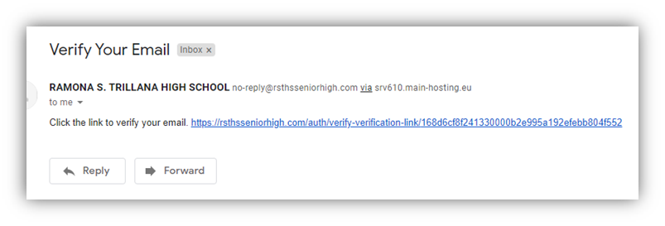

**Figure 10.**

Figure 9 and Figure 10 show that users can verify their email through the Send verification email button. After clicking the button, users will receive an email including the link to verify their email in the portal. Users should follow the link and it will redirect to their portal accounts. It also means that their email is already verified.

iv.        Delete Account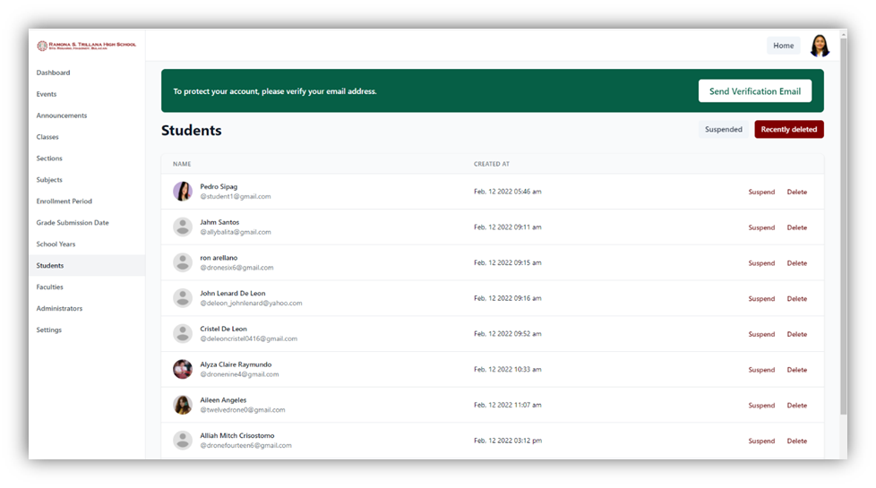

**Figure 11.**

In Figure 11, the School Administrator can see all the accounts of students and Faculties in the portal. In which, the administrator can suspend and delete an account. Suspended and Deleted accounts can no longer access the portal.

v.         Generate Students’ Information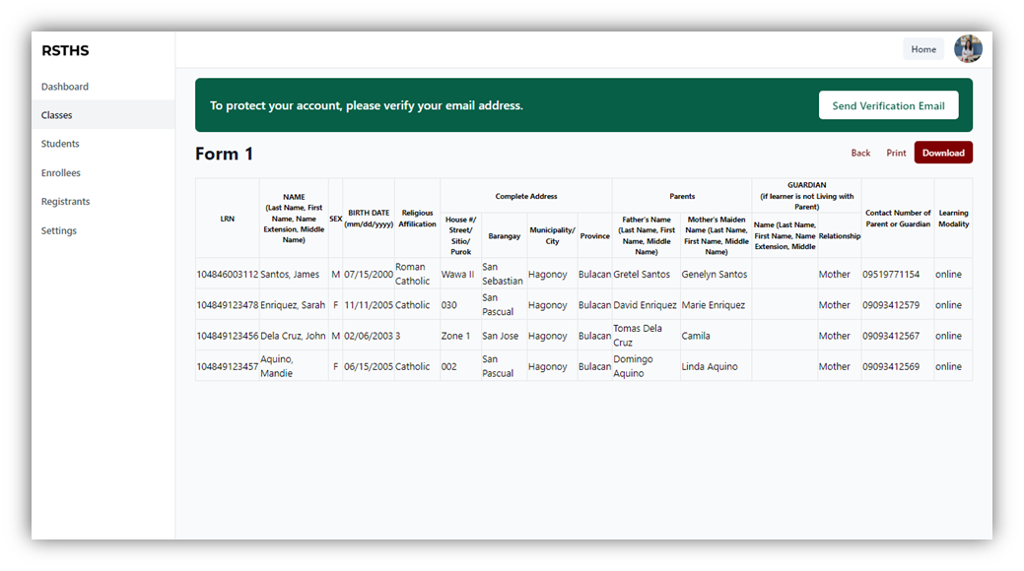

**Figure 12.**

Figure 12 displays the function of generating School Form 1. Wherein, School Form 1 consists of students’ information coming from the enrollment form answered by the students. The registrar can generate, download (in excel format), and print the School Form 1 using the portal.

b. Enrollment Management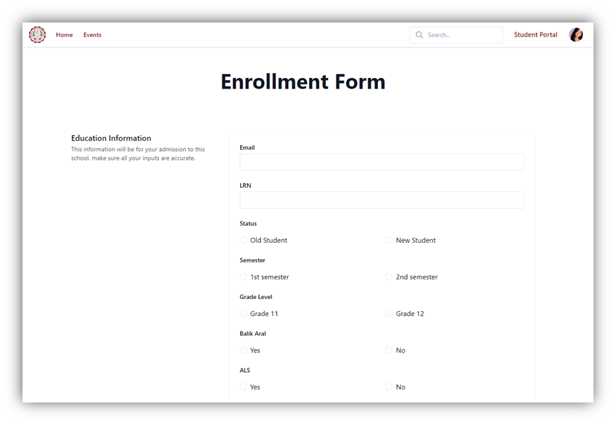

**Figure 13.**

Figure 13 shows the enrollment function in the school portal. Wherein, both incoming and old senior high students can register in the portal by clicking the enroll and register button. Students must fill out all the information needed in the enrollment form.

c. Grades Management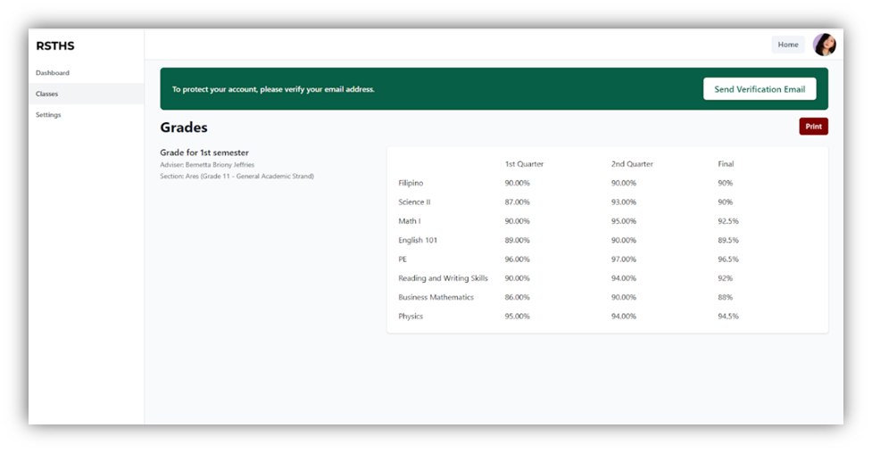

**Figure 14.**

As shown in Figure 14, students can view their reports of grades uploaded by their subject teachers. Including the subjects, grades in the 1st and 2nd quarters, and their final grades automatically computed by the portal. By clicking the Print button, students have an option to print their report of grades but it is only an unofficial copy.

d. Announcement Management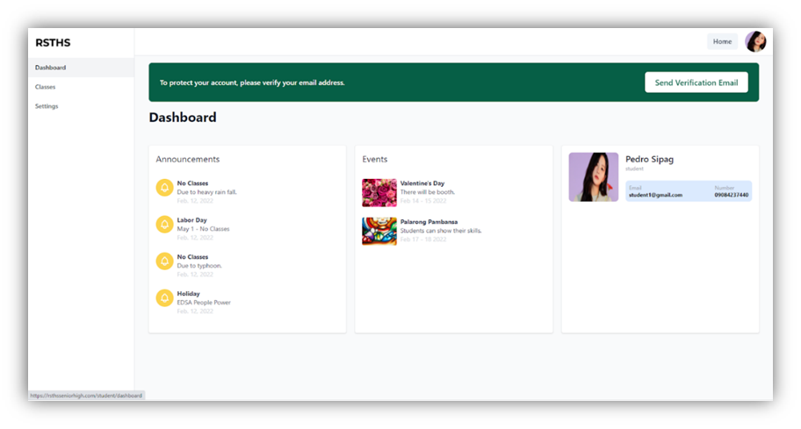

**Figure 15.**

Figure 15 displays the dashboard where the announcements in the portal will be posted. It includes the name of the announcement, the date, and also the description.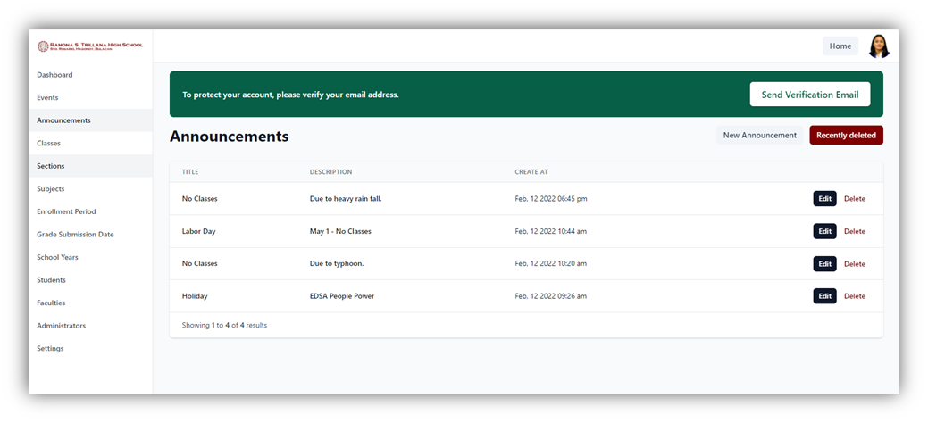

**Figure 16.**

Figure 16 shows the announcement function of user management. Wherein, the school administrator can add, edit, and delete announcements in the portal. Deleted announcements can be recovered or they can be permanently deleted.

e. Event Management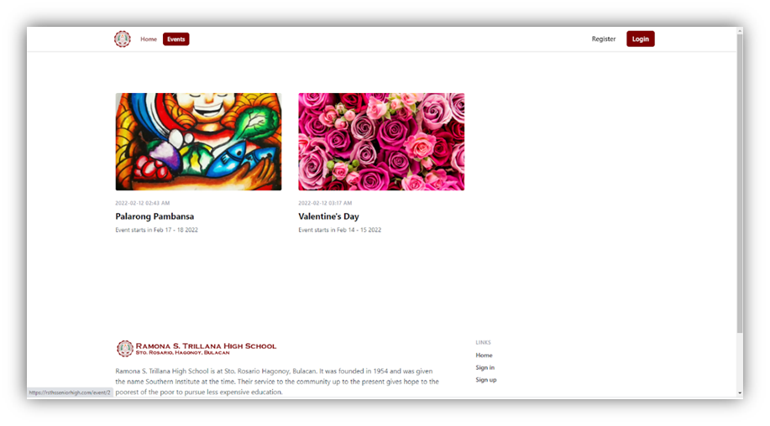

**Figure 17.**

As shown in Figure 17, the Event page displays all the current events in Ramona S. Trillana Senior High. It includes the name of the event, poster or image, date, and description.

**Figure 18.**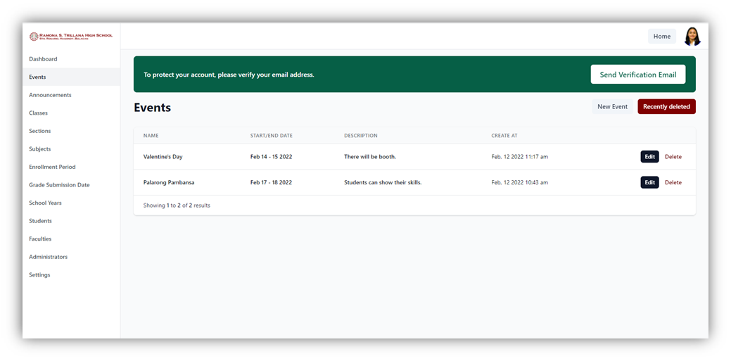

In Figure 18, the school administrator is the only one who can add, edit, and delete events. Deleted events can also be restored by the school administrator.

2.            To identify and utilize the following system requirements and the effective development of the system such as:

a. Functional Requirements

are a function or feature that must be included in the Online School Portal System of Ramona S. Trillana Senior High School. The researchers analyzed the functional requirements to be able to satisfy the needs of the school and be acceptable to all of the users of the system. The researchers organized the functional requirements by classifying each according to input, process, output, and stored data.

The developed Online School Portal System captures efficiently all the needed information of the users. It can accept incoming enrollees of the school within the given period of time by the school administrator. Using the developed system, teachers can send unofficial copies of students’ grades and the School Administrator can also post events and announcements of the school.

The Online School Portal System will automatically generate the School Form 1 based on the information inputted by the students in their enrollment form. The school administrator can set the class schedule of the students and teachers that will be posted in their accounts. All the information of the students is secured and stored in the portal system.

b. Non-Functional Requirements

Nonfunctional requirement is a requirement that specifies criteria that can be used to judge the operation of a system, rather than specific behaviors. The researchers analyzed the non-functional requirements to be able to identify the quality attributes such as performance, information, economics, control, efficiency, and service.

All of the students' information is accurate and properly captured by the system because of the input restrictions in the enrollment form. Unauthorized users cannot access the portal since they are not verified by the registrar. Users cannot view other users' information. It also means that their privacy is secured. Students’ grades are also updated every quarter. The school portal system will be used by the school administrator, teachers, and students. The beneficiaries can learn the system in a short period of time. It will reduce the time and cost of materials needed by the teachers and school administrators to do their tasks. The system can produce an output including the class sections easily and conveniently.

c. Software Development Tools

i. Visual Studio Code

Visual Studio Code is a simple yet capable source code editor for Windows, macOS, and Linux that works on the desktop. Debugging, syntax highlighting, intelligent code completion, snippets, code refactoring, and embedded Git are all features of Visual Studio Code. This source code editor has many advantages. The usability is very easy. The file is arranged hierarchically and includes standard software such as a toolbar, status bar, and sidebar. It also contains a floating Windows Explorer window with the directory structure of files that can be fixed in one location according to convenience. These files can be opened or renamed from this location, and changes will be applied to the storage automatically.

   ii.        XAMPP Server

XAMPP is a popular cross-platform web server that allows programmers to write and test their code on a local server. The Apache Friends developed it, and the audience can edit or modify the native source code. Before publishing a website or client to the main server, a local host or server can use XAMPP to test it on computers and laptops. With XAMPP, developers can work on projects on computers running any of the three common operating systems, and quickly move projects between them. XAMPP is also suitable for projects of a larger scale or with more complex requirements.

iii.        MySQL Server

MySQL is an open-source relational database management system (RDBMS) based on Structured Query Language that is supported by Oracle. MySQL is available on almost any platform, including Linux, UNIX, and Windows. MySQL was designed with the goal of quickly processing big databases. Despite the fact that MySQL is commonly installed on a single machine, it can transfer the database to several places because users can access it through various MySQL client interfaces. These interfaces communicate with the server using SQL commands and then show the results.

 iv.        Apache HTTP Server

The Apache HTTP Server is a free and open-source web server that uses the internet to deliver web content. It's known as Apache, and it soon became the most popular HTTP client on the internet after its release. Apache's capacity to manage enormous quantities of traffic with minimal configuration is one of its advantages. It scales well, and developers can customize Apache to do whatever they want because of its modular nature. Unwanted modules can also be removed by developers to make Apache more lightweight and efficient.

3.            Test and evaluate the system using the Evaluation Criteria for Websites.

|  |  |  |
| --- | --- | --- |
| **Respondents** | **Frequency** | **Percentage** |
| **IT Experts** | 5 | 11.11% |
| **Teachers** | 7 | 15.56% |
| **Students** | 33 | 73.33% |
| **Total** | 45 | 100% |

**Table 1**

Presents five IT experts, seven teachers, and thirty-three students are among the responders to the survey. The overall mean distribution in each of the criteria is discussed in the interpretation and presentation of tables. It also shows the interpretation of the mean distributions, which ranges from Poor, Fair, Good, Very Good, and Excellent as the highest interpretation.

         The researcher devised an evaluation instrument based on the Software Quality Model following a five-point Likert scale:

|  |  |
| --- | --- |
| **Rating** | **Description** |
| 5 | Excellent |
| 4 | Very Good |
| 3 | Good |
| 2 | Fair |
| 1 | Poor |

**Table 2. Five Point Likert Scale Type**

The ratings from the respondent are treated statistically using a Likert Scale and were recorded based on the weighted mean or average. Their response to the Software Quality Evaluation Criteria such as

Authority, Purpose, Coverage, Currency, Objectivity, Accuracy, Functionality, Training, and Documentation.

There are three commonly used measurements of the central location in descriptive statistics: The mean of which has its appropriate use in describing the sample or population being studied; If three measurements are used to describe the sample or population being investigated, the weight mean is used because it is more trustworthy in computing data and is regarded to be the most stable measure of central location connected with interval and/or ratio data if the distribution is normal.

The descriptive rating for the weight score is 5 = "Excellent," 4 = "Very Good," 3 = "Good," 2 = "Fair," and 1 = "Poor." The mean formula will be used to compute the respondents' ratings of various categories.

Formula:

Where:

         M - mean

         N - Total number of respondents

         r - Number of respondents

|  |  |  |
| --- | --- | --- |
| **INDICATORS** |  | **Responses** |
| **A.**  **Authority. This element reveals that the person, institution or agency responsible for a site has the qualifications and knowledge to do so.** | **Mean** | **Description** |
| 1.       Authorship: Is it clear who developed the site? | 4.51 | Excellent |
| 2.       Is contact information clearly provided: e-mail address, snail mail address, phone number, and fax number? | 4.51 | Excellent |
| 3.       Credentials:  Did the author state qualifications, credentials, or personal background that gives them authority to present information? | 4.56 | Excellent |
| 4.       Is the site supported by an organization or a commercial body? | 4.47 | Very Good |
| **General Weighted Mean** | 4.51 | Excellent |
| **B.**  **Purpose. The purpose of the information presented in the site should be clear. Some sites are meant to inform, persuade, state an opinion, entertain, or parody something or someone.** | **Mean** | **Description** |
| 1.       Does the content support the purpose of the site? | 4.53 | Excellent |
| 2.       Is the information geared to a specific audience (students, scholars, general readers)? | 4.53 | Excellent |
| 3.       Is the site organized and focused? | 4.56 | Excellent |
| 4.       Are the outside links appropriate for the site? | 4.42 | Very Good |
| 5.       Does the site evaluate the links? | 4.48 | Very Good |
| 6.     [Check the domain of the site](http://libraries.dal.ca/using_the_library/tutorials/evaluating_web_resources/types_of_urls.html). The URL may indicate its purpose. | 4.40 | Very Good |
| **General Weighted Mean** | 4.49 | Very Good |
| **C.**  **Coverage. It is difficult to assess the extent of coverage since depth in a site, through the use of links, can be infinite. One author may claim comprehensive coverage of a topic while another may cover just one aspect of a topic.** | **Mean** | **Description** |
| 1.       Are the topics explored in depth? | 4.49 | Very Good |
| 2.       Compare the value of the site’s information compared to other similar sites. | 4.47 | Very Good |
| 3.       Do the links go to outside sites rather than their own? | 4.27 | Very Good |
| 4.       Does the site provide information with no relevant outside links? | 4.38 | Very Good |
| 5.       Are the links (if any) evaluated and do they complement the documents' theme? | 4.40 | Very Good |
| 6.       Is it all images or a balance of text and images? | 4.49 | Very Good |
| 7.       Is the information presented cited correctly? | 4.49 | Very Good |
| 8.       If a page requires special software to view the information, how much are you missing if you don't have the software? | 4.40 | Very Good |
| 9.       Is it free or is there a fee to obtain the information? | 4.49 | Very Good |
| 10.   Is there an option for text only, frames, or a suggested browser for better viewing? | 4.44 | Very Good |
| **General Weighted Mean** | 4.43 | Very Good |
| **D.**  **Currency. This refers to 1) how current the information presented is, and 2) how often the site is updated or maintained. It is important to know when a site was created when it was last updated, and if all of the links are current** | **Mean** | **Description** |
| 1.       Links are up-to-date | 4.58 | Excellent |
| 2.       The links provided should be reliable. Dead links or references to sites that have moved are not useful. | 4.53 | Excellent |
| 3.       Information provided so trend related that its usefulness is limited to a certain time period? | 4.49 | Very Good |
| 4.       Has the site been under construction for some time? | 4.40 | Very Good |
| **General Weighted Mean** | 4.5 | Excellent |
| **E.**               **Objectivity. The objectivity of the site should be clear. Beware of sites that contain bias or do not admit its bias freely. Objective sites present information with a minimum of bias.** | **Mean** | **Description** |
| 1.       Is the information presented with a particular bias? | 4.29 | Very Good |
| 2.       Does the information try to sway the audience? | 4.38 | Very Good |
| 3.       Does site advertising conflict with the content? | 4.20 | Very Good |
| 4.       Is the site trying to explain, inform, persuade, or sell something? | 4.36 | Very Good |
| **General Weighted Mean** | 4.31 | Very Good |
| **F.**   **Accuracy. There are few standards to verify the accuracy of the information on the web. It is the responsibility of the reader to assess the information presented.** | **Mean** | **Description** |
| 5.       Reliability: Is the author affiliated with a known, respectable institution? | 4.42 | Very Good |
| 6.       References: do statistics and other factual information receive proper references as to their origin? | 4.47 | Very Good |
| 7.       Does the reading you have already done on the subject make the information seem accurate? | 4.49 | Very Good |
| 8.       Is the information comparable to other sites on the same topic? | 4.38 | Very Good |
| 9.       Does the text follow basic rules of grammar, spelling, and composition? | 4.47 | Very Good |
| 10.   Is a bibliography or reference list included? | 4.33 | Very Good |
| **General Weighted Mean** | 4.43 | Very Good |
| **G.**  **Functionality** | **Mean** | **Description** |
| 1.       Accessibility. Is there breadth of browser compatibility? A minimum & maximum monitor resolution? Is there is an appeal to a universal audience - multilingual translations, cultural sensitivity, disability access & services? | 4.56 | Excellent |
| 2.       Speed & Bandwidth Sensitivity. Consider overall page sizes & complexity, average download times, download order & image redraws; wait to first reaction/interaction times. | 4.42 | Very Good |
| 3.       HTML Quality. Clean HTML with no faulty code, workability of active x, rollovers, applets, etc., page titles, descriptions, keywords & tags, Java & JavaScript dependency, image dependency. | 4.53 | Excellent |
| 4.       Navigation & Links. Navigation functionality & clarity, link integrity, quality & depth of links provided. | 4.49 | Very Good |
| 5.       Legality.  Original artwork, music, intellectual property, etc., international copyright laws are correctly observed, quotations, images & intellectual property from 3rd parties are appropriately cited, legal site content & legal site activities. | 4.56 | Excellent |
| 6.       Compliance. Adherence to standards. | 4.62 | Excellent |
| 7.       Security. Provision for security requirements. | 4.64 | Excellent |
| **General Weighted Mean** | 4.55 | Excellent |
| **H.**      **Training and Documentation** | **Mean** | **Description** |
| 1.       Availability of guides and printed documentation (technical or user’s manual). | 4.60 | Excellent |
| 2.       Provision for training/tutorials or real interactive learning. | 4.58 | Excellent |
| 3.       Provision for help component. The text should be clear and use language correctly, with appropriate headings and subheadings. Unfamiliar terms should be defined and explained. An organization should be logical. All information should be readily accessible for reference. | 4.60 | Excellent |
| **General Weighted Mean** | 4.59 | Excellent |
| **Overall Weighted Mean** | 4.48 | Very Good |

In terms of Authority, the respondents marked as “Excellent” with a general weighted mean of (4.51) which indicates that the system has authorship and credentials. The Purpose indicator classifies as “Very Good” with the mean value of (4.49) which means that all the information presented in the portal is all clear. On the indicator Coverage, the respondents were graded as “Very Good” with a general weighted mean of (4.43) which shows that the system has comprehensive coverage. In terms of Currency that measures the reliability and usefulness of the system, it is marked as “Excellent” with a mean value of (4.50). The Objectivity indicator has a (4.31) mean value and is graded as “Very Good” which indicates that the objective of the developed system is clear and no bias. The indicator of Accuracy classifies as “Very Good” with a mean value of (4.43) which indicates that all the information in the portal is accurate and has references, correct grammar, spelling, and composition. Regarding the Functionality indicator, the weighted mean is (4.55) with the description of “Excellent” which means the functions of the system are compatible, working properly, and following the security requirements. In terms of Training and Documentation defined as the availability of guides, user’s manual, and training provided by the developers, the respondents graded as “Excellent” with a mean value of (4.59). As a whole, the developed system received a mean value of (4.48) which means that the Online School Portal System for Ramona S. Trillana Senior High is “Very Good” in terms of overall performance.

**Chapter 5**

**Summary and Recommendations**

This chapter contains a summary of the study as well as recommendations based on the findings. It provides explanations and justifications of how the objectives of the study are met. It also includes a discussion of system enhancements that could be implemented.

**Summary**

The study examines the development of the Online School Portal System for students, teachers, and school administration at Ramona S. Trillana Senior High School. In this project, the explanation and reasons for the study objectives are discussed.

The study's primary concern is to make the processes at Ramona S. Trillana Senior High School more convenient and resource-efficient. It includes enrollment management, grade management, student information management, event and announcement management.

The developed system aims to provide a gateway for students to access their grades, enroll, and stay up-to-date on school events and announcements. It will also help the teachers and the school administration manage tasks effectively and efficiently. To achieve the project objectives, the researchers gathered information about the current condition of the school and the faculties involved in managing its school operations. Using the school portal, it is much easier and faster to collect and store the records of the students in the database. The Senior high school students, faculties, and the school administration are all beneficiaries of the school portal.

The main features of the Online School Portal System for Ramona S. Trillana Senior High School are the following: The school portal system has an enrollment function for incoming and old senior high school students. The registrar can manage students’ information and generate the School Form 1. Teachers can submit the students' grades through the portal and the students will receive them. The developed system also provides a download and print function for both unofficial copies of School Form 1 and the Report of Grades. The system allows the school registrar to verify the enrollment form and the accounts of the students. The school portal authorizes the school administration to manage all the accounts, sections, and subjects. Students can only enroll within the enrollment period set in the portal. On the other hand, teachers cannot submit the grades of the students if they are not within the grade submission period. The system has user-level access for teachers and students viewing and updating personal and account information. The developed Online School Portal System is intended to help students, teachers, and the school administration improve and reduce the amount of human effort and resources consumed by the school processes.

**Recommendations**

         Based on the conclusions, the researchers come up with the following recommendations:

1. The Online School Portal System for Ramona S. Trillana Senior High School may notify the users about the announcement and events through Push notifications.
2. The Online School Portal System for Ramona S. Trillana Senior High School may reduce the workload of teachers by having an upload function for the grades of students in an excel format.
3. The Online School Portal System for Ramona S. Trillana Senior High School may produce more output such as Grade Evaluation for every quarter of the school year.
4. The Online School Portal System for Ramona S. Trillana Senior High School may include as users the junior high school and external campuses students and teachers of the mentioned school.

**USER’S MANUAL FOR STUDENTS**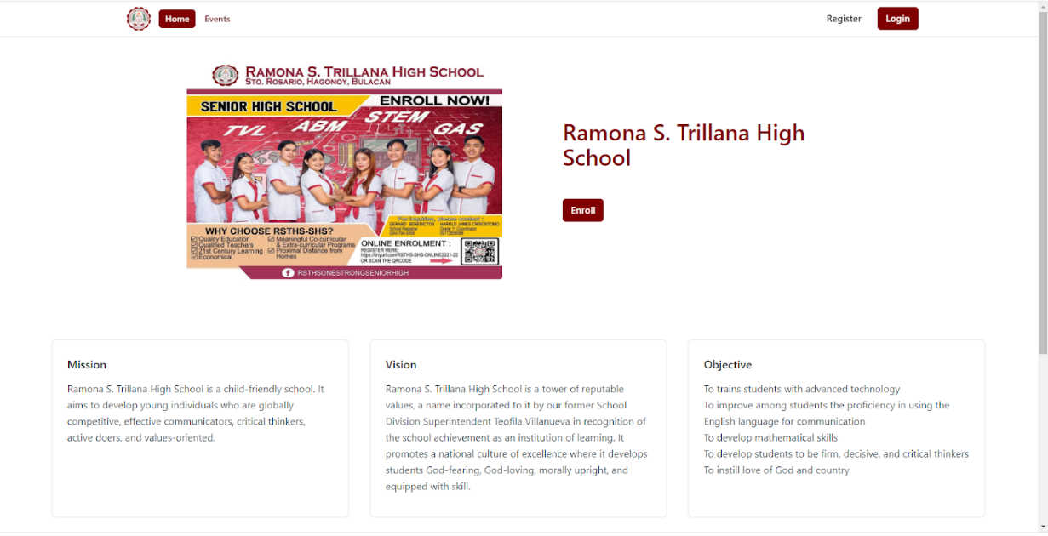

The main page of the portal consists of some information about the school including the Mission, Vision, and Objectives of Ramona S. Trillana High School. There are also Register, Login, and Enroll button.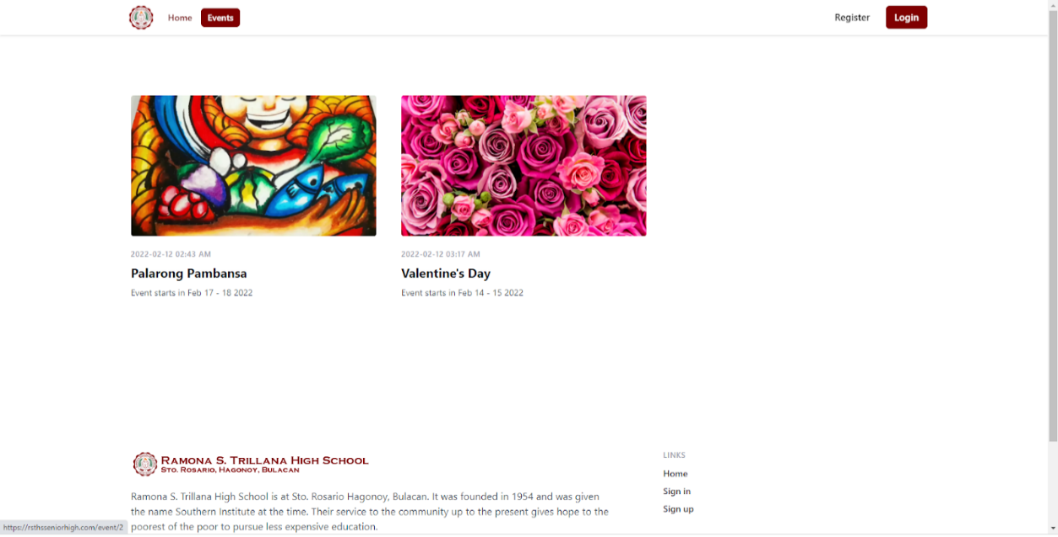

In the Events, the users can view all the information and schedules about the incoming events of Ramona S. Trillana Senior High.

The incoming SHS student who wants to enroll in Ramona S. Trillana Senior High must register in the portal by clicking the register button after or before submitting the required documents in the school.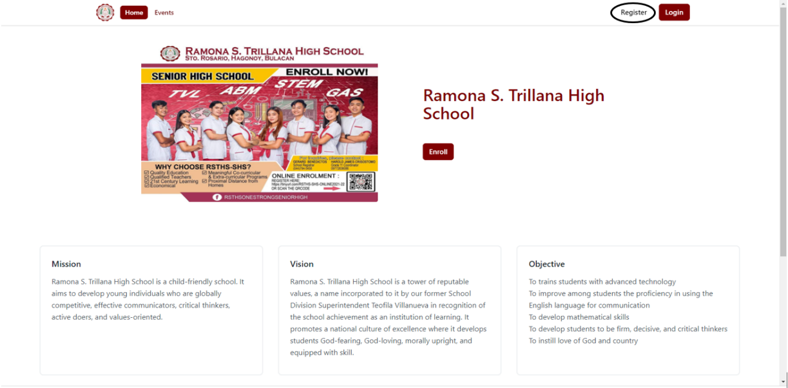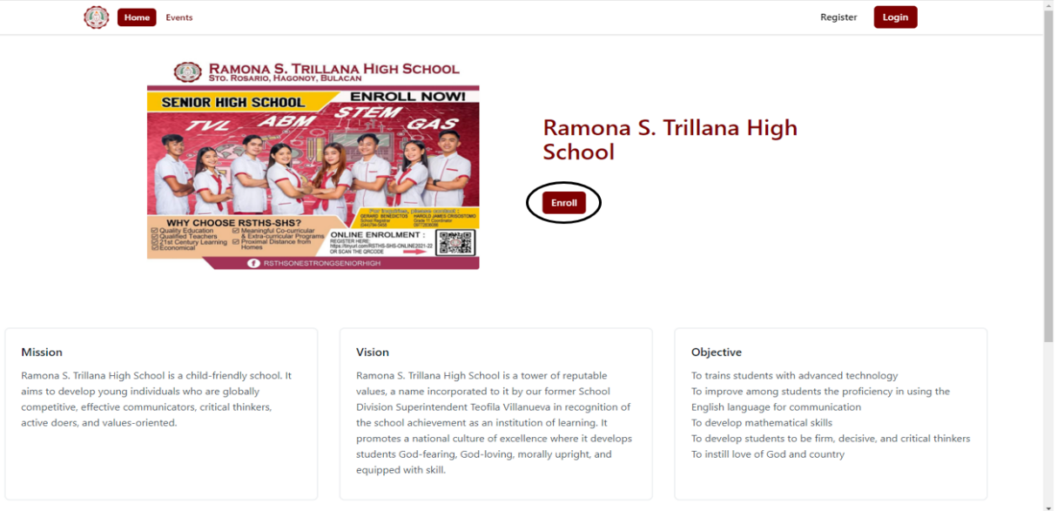

On the other hand, the currently enrolled SHS student who already have an account in the portal and wants to enroll for Grade 12, must click the enroll button in the main page.

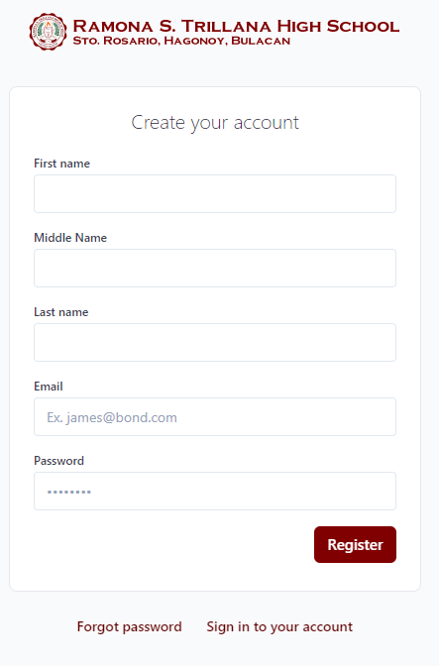

After clicking the register button, users must create an account by inputting First name, Middle name (if available), Last Name, Email, and Password that is not less than 6 characters and it should contain a combination of numbers, uppercase, lowercase and special characters. Then click Register and it will now display the enrollment form.

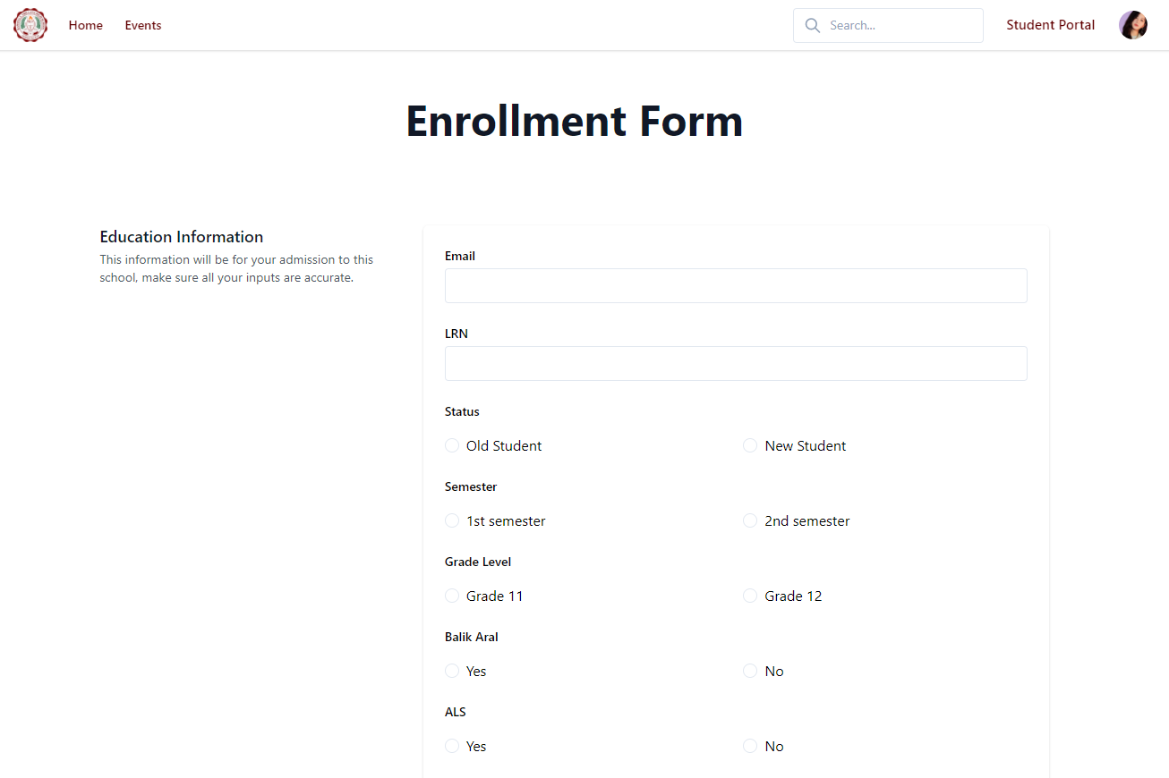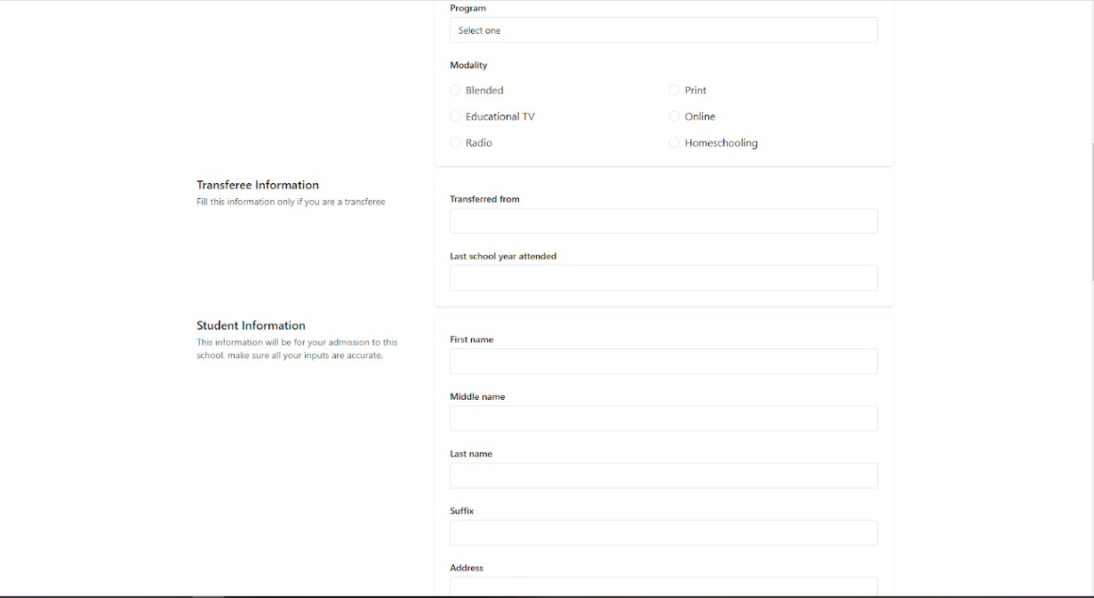

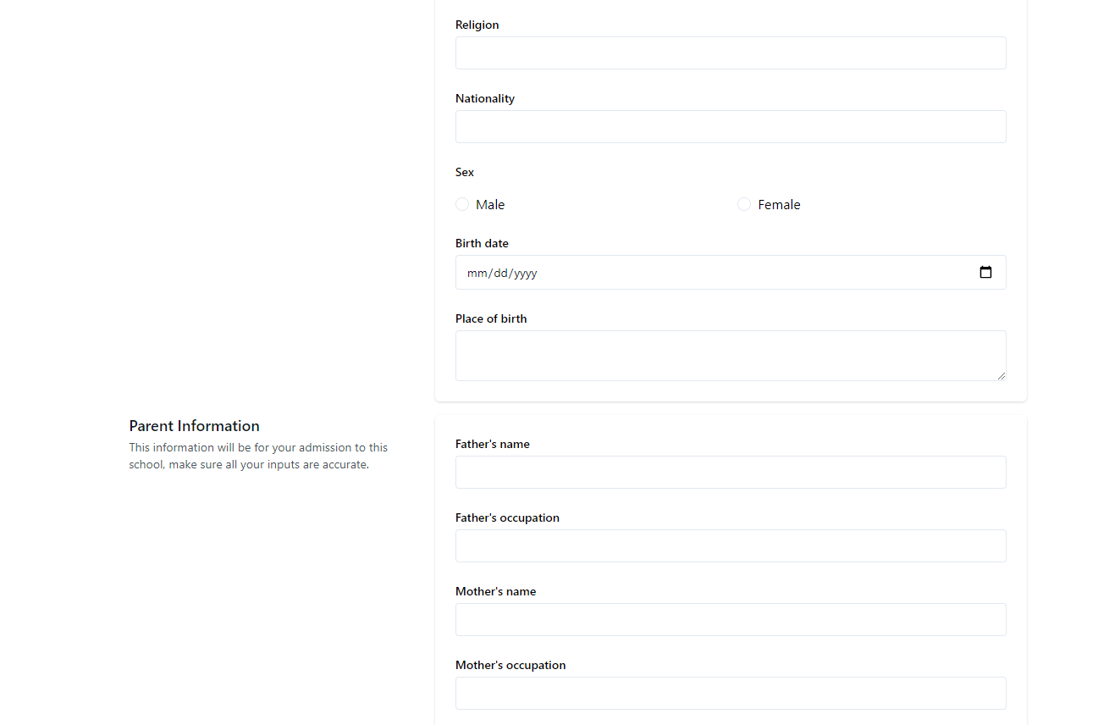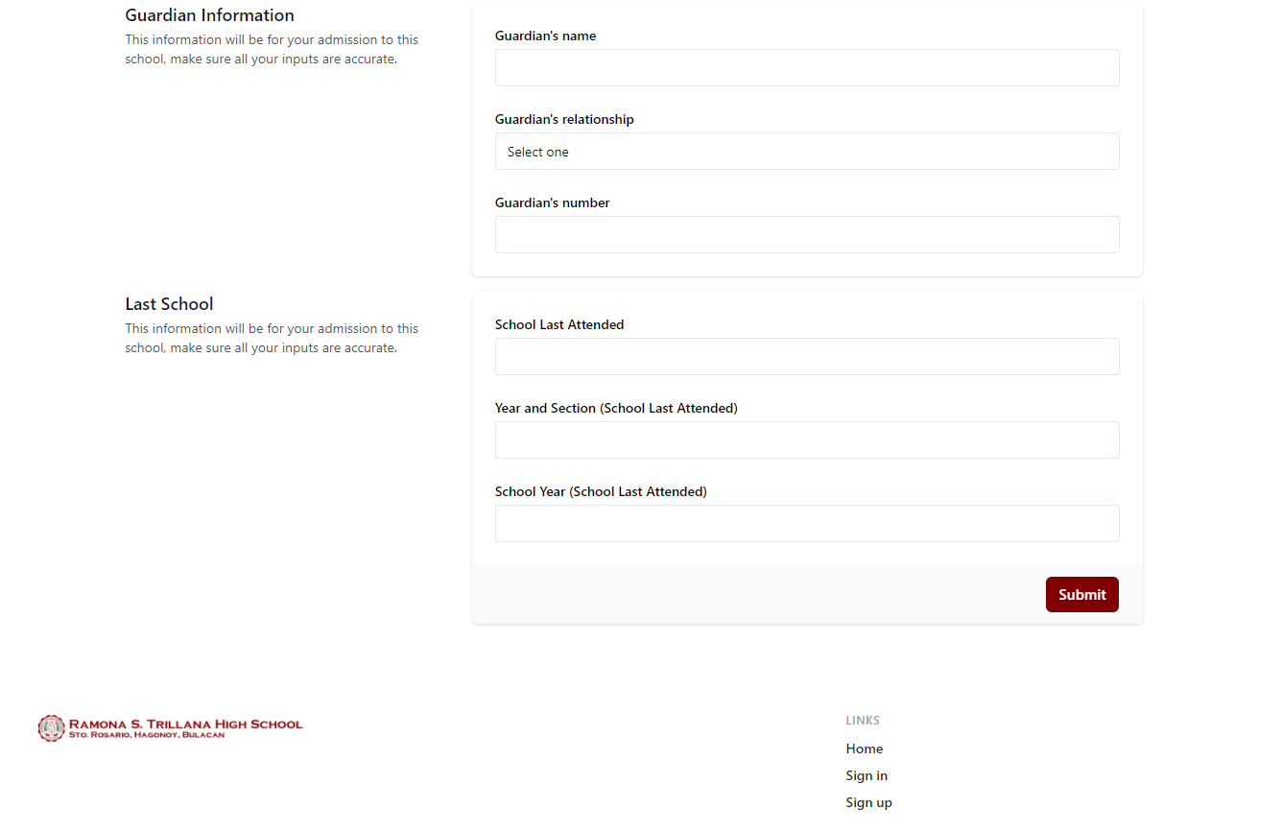

The users must input all the information needed in the Enrollment Form including email that should be the same with the email that the users used in creating an account, LRN which is fixed into 12-digit numbers, personal information, parents’ information, guardian information, also the last school attended information. Then click submit.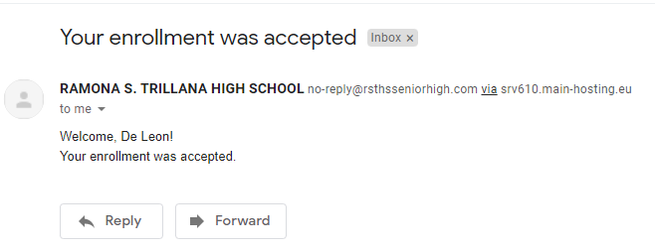

The enrollment form will be submitted to the registrar. After the registrar check and review all the information of the students, their account will be now verified and the portal will send an email to them saying that their enrollment form is already accepted.

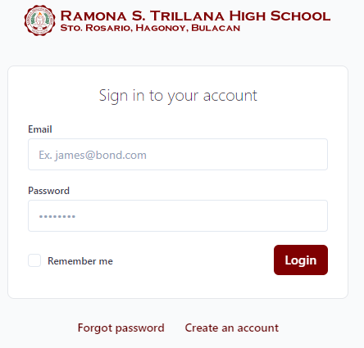

The users can now login using their account by inputting their email and password. And if they forgot their password, they have an option to recover it by clicking the forgot password option.

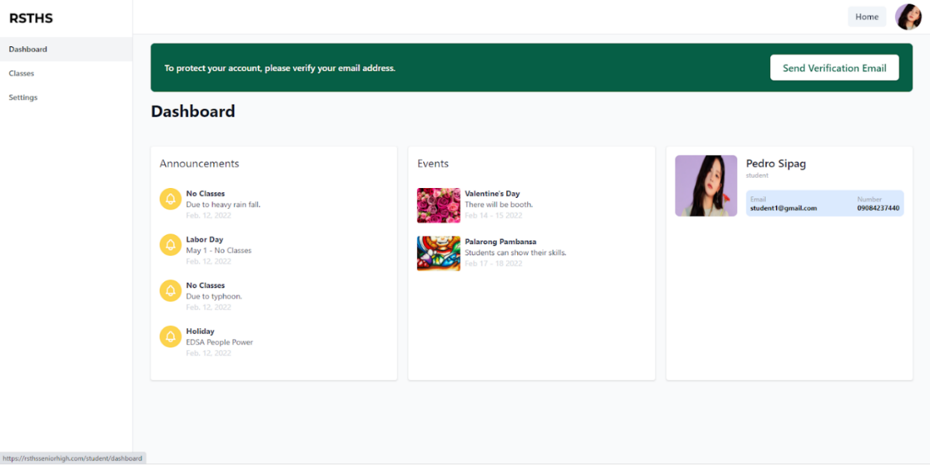

After logging in, the users can now access the portal. It will show the dashboard that will display the different announcement and events posted by the school. Also, the basic information about the student.

There will be also a send verification email button in the student’s account. Users should click the button to verify their email.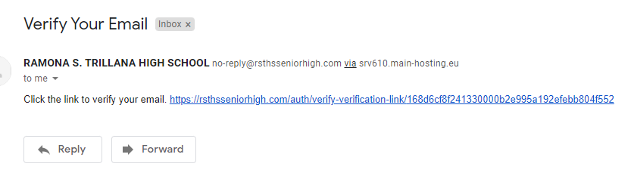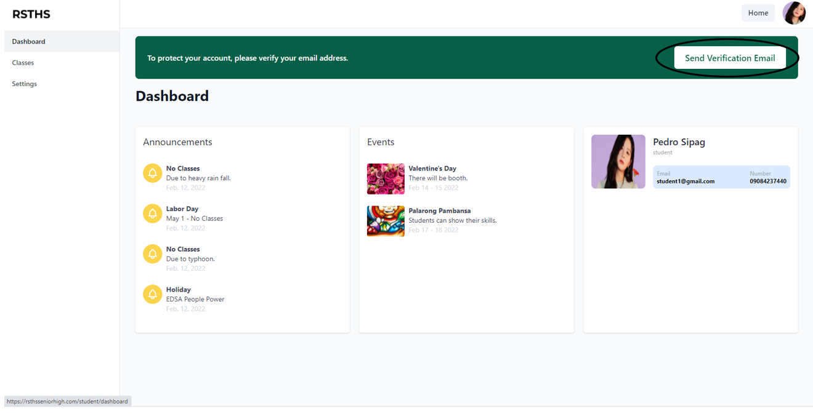

After clicking the button, there will be an email including the link to verify the email of the user. Students should follow the link and it will redirect to their portal accounts. It also means that their email is already verified.

By selecting Classes menu, it will display the section, strand, and the adviser of the student. There are also buttons for viewing the student’s schedule and grades.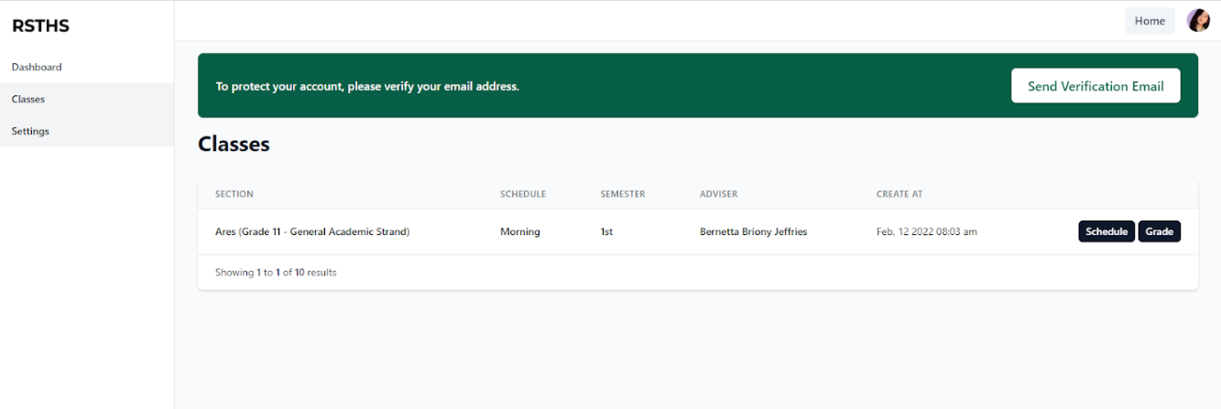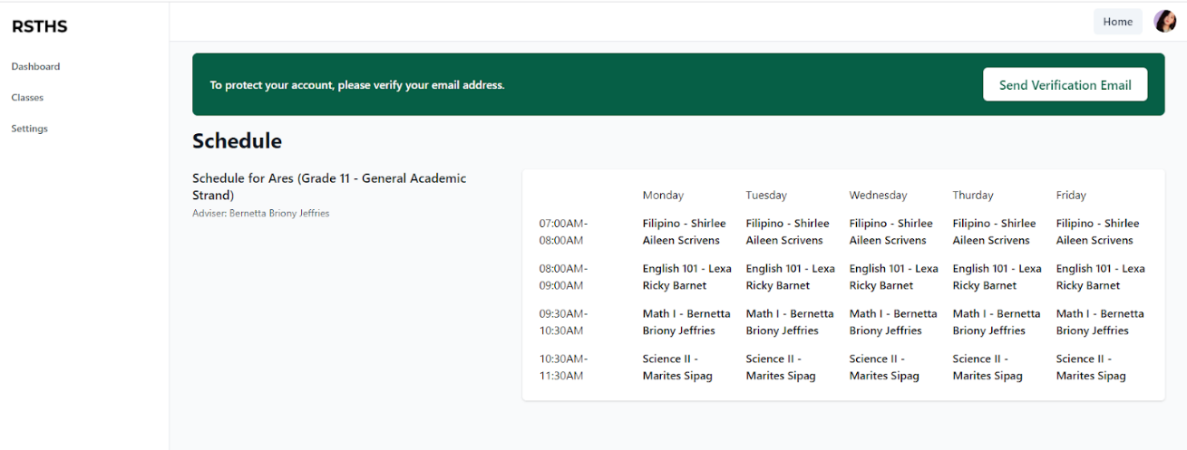

By pressing the schedule button, it will display the complete class schedule of the student. Including the time, subjects, and subject teacher’s name.

In the Grade button, it will display the report of grades of the student per semester. Including the subjects, grades in 1st and 2nd quarter, and their final grades automatically computed by the portal.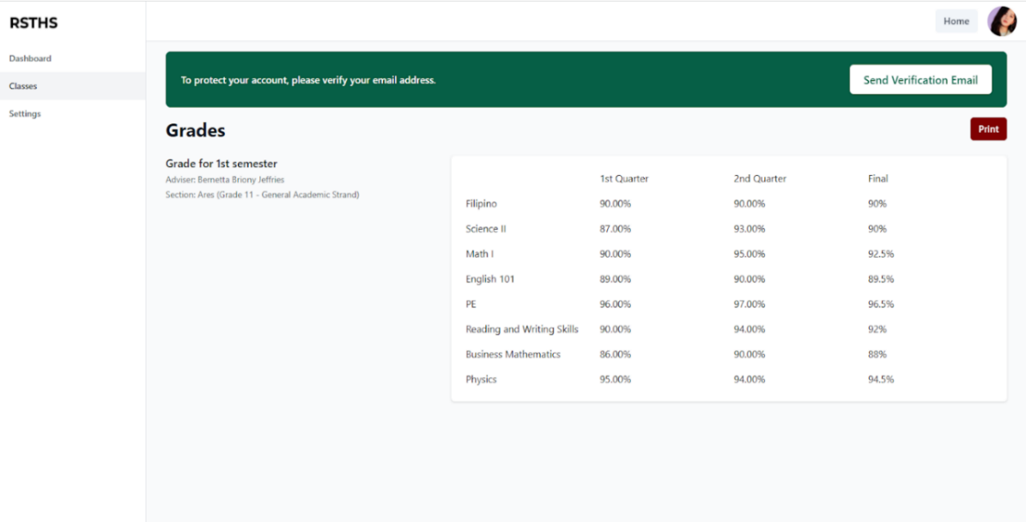

By clicking the Print button, Students have an option to print their report of grades but it is only an unofficial copy.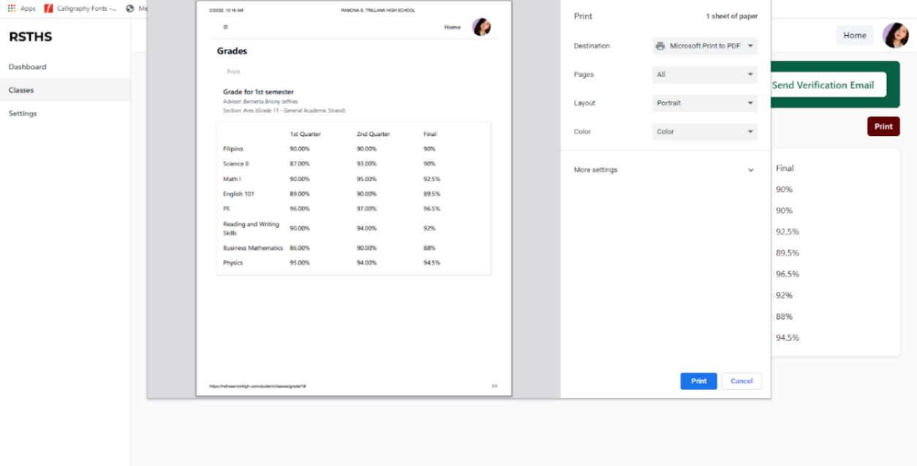

In Settings, users can edit their personal information. They can also set their profile picture by uploading an image.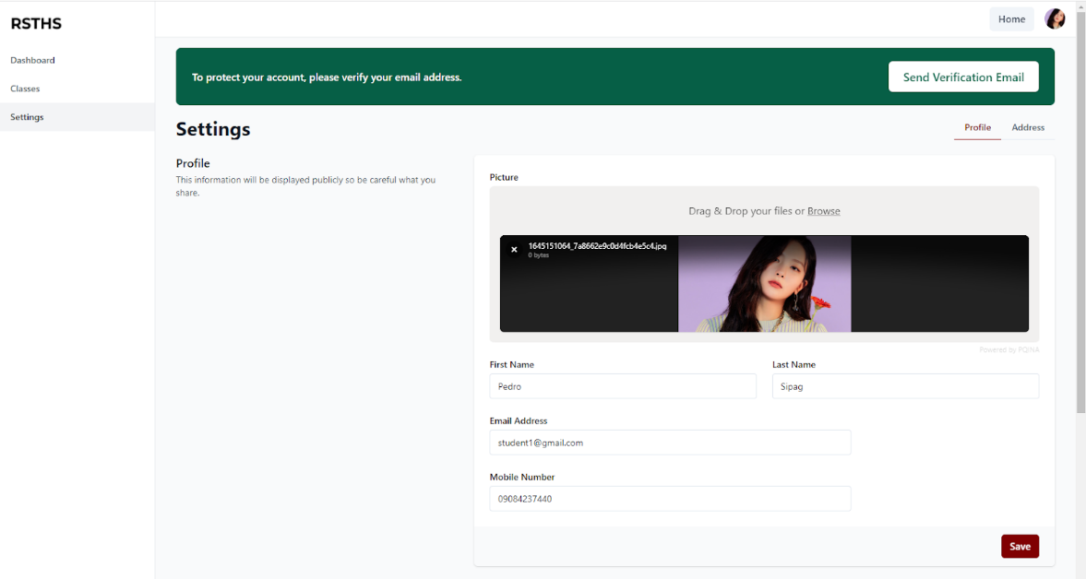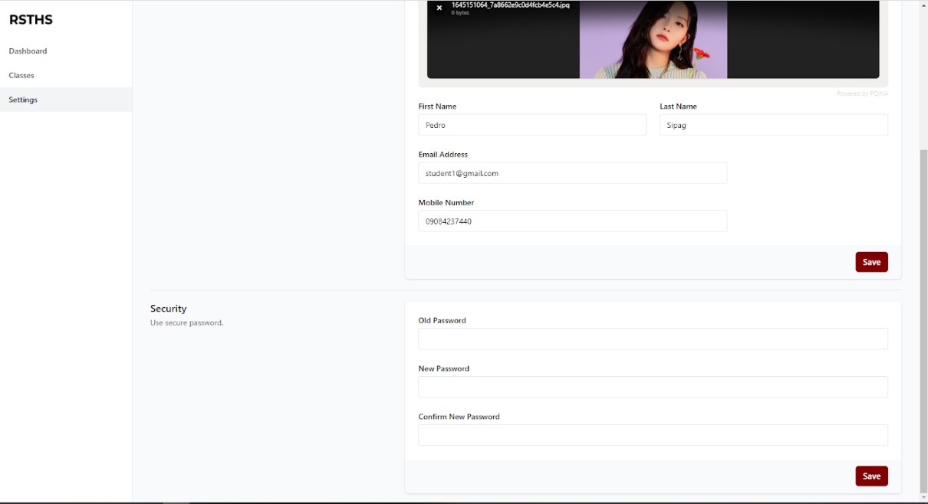

The users can also change their password in the portal by inputting their old password, their new password, and confirm new password. Then click save.

**USER’S MANUAL FOR TEACHERS**

The main page of the portal consists of some information about the school including the Mission, Vision, and Objectives of Ramona S. Trillana High School. There are also Register, Login, and Enroll button.

In the Events, the users can view all the information and schedules about the incoming events of Ramona S. Trillana Senior High.

For Teachers who are still not registered in the portal, they must create an account by clicking the register button.

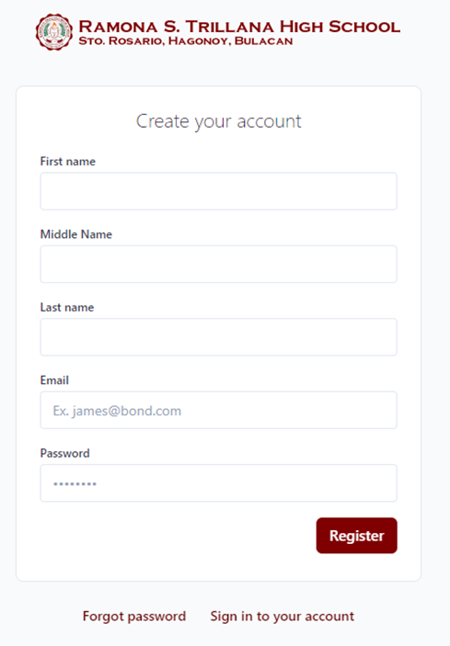

After clicking the register button, users must create an account by inputting First name, Middle name (if available), Last Name, Email, and Password that is not less than 6 characters and should contain a combination of numbers, uppercase, lowercase and special characters. Then click Register.

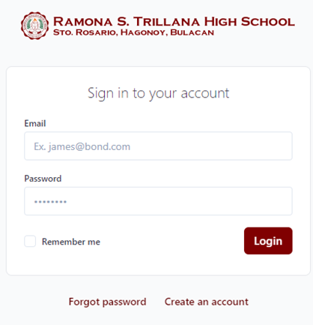

After creating an account, Teachers can now login using their email and password. And if they forgot their password, they have an option to recover it by clicking the forgot password option.

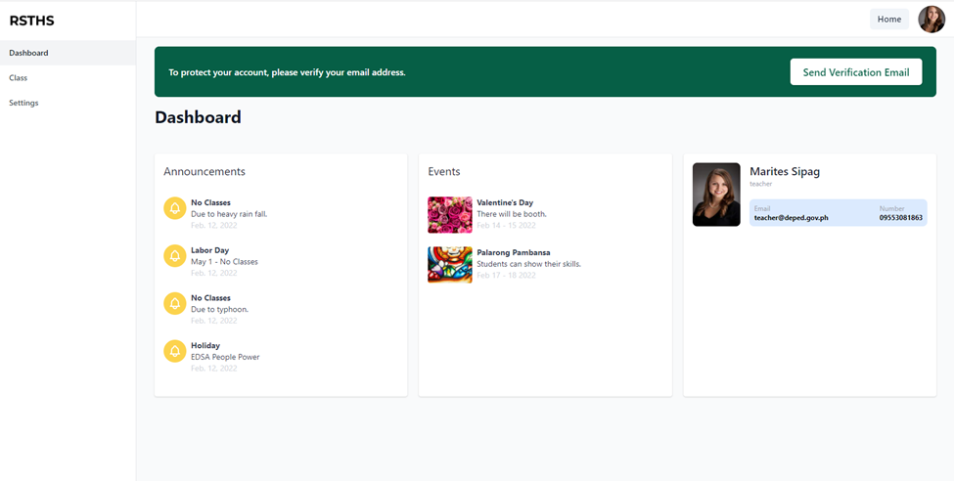

After logging in, the users can now access the portal. It will show the dashboard that will display the different announcement and events posted by the school and the basic information about the teacher. There is also a send verification email button in the top of the page wherein users will receive an email including a link that will verify their email.

In the Class menu, teachers can view all the class sections that they handled including their subject and their adviser. 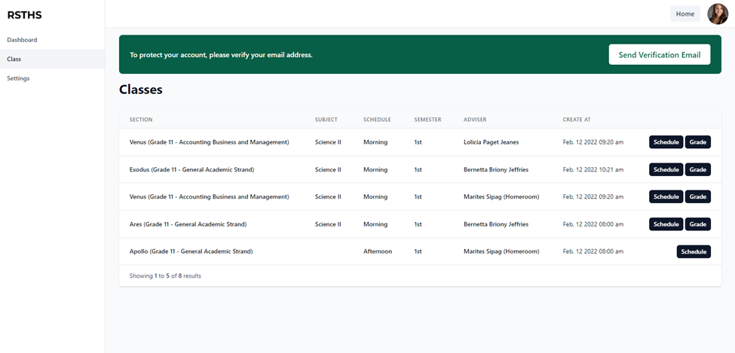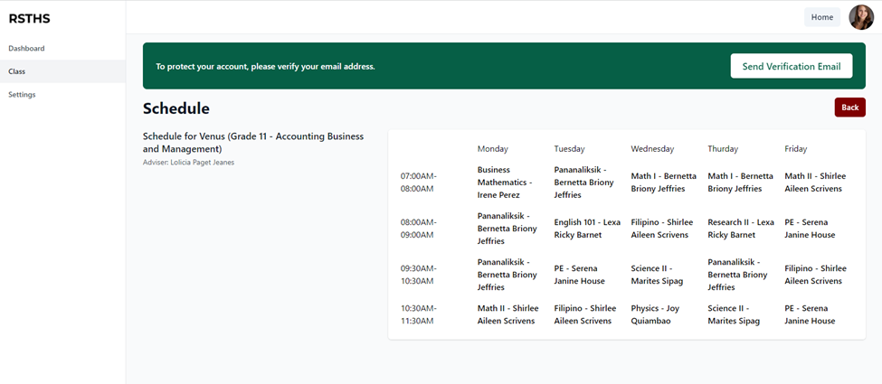

Teachers can also see their schedule in different section by clicking the schedule button.

In the grade button, teachers must input the grade of their student together with their final average automatically computed by the portal. Then click save.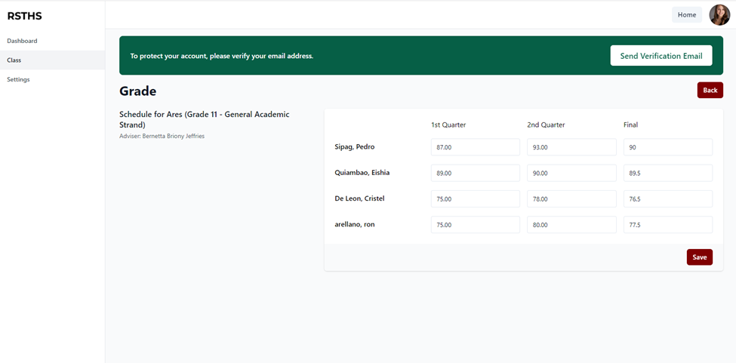

Note: Teachers can only submit the grades of their students in the time of distribution given by the school administration.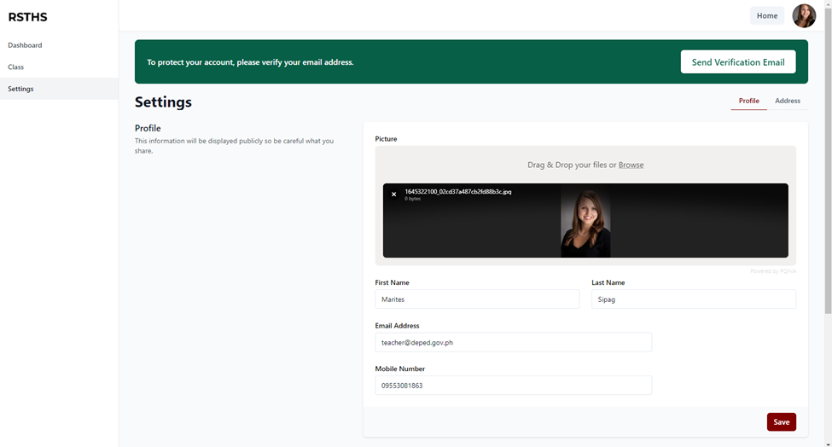

In Settings, users can edit their personal information. They can also set their profile picture by uploading an image.

The users can also change their password in the portal by inputting their old password, their new password, and confirm new password. Then click save.

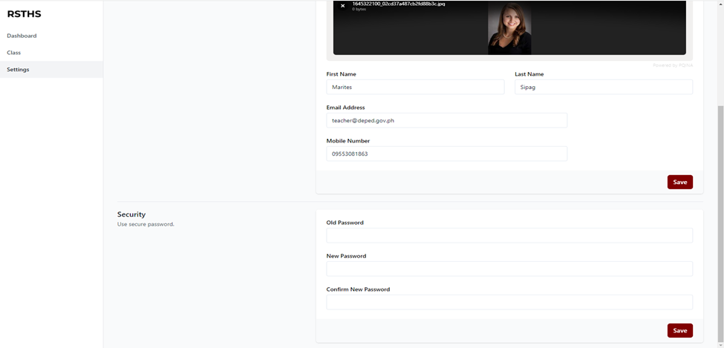

**USER’S MANUAL FOR REGISTRAR**

The main page of the portal consists of some information about the school including the Mission, Vision, and Objectives of Ramona S. Trillana High School. There are also Register, Login, and Enroll button.

In the Events, the users can view all the information and schedules about the incoming events of Ramona S. Trillana Senior High.

For Registrars who are still not registered in the portal, they must create an account by clicking the register button.



After clicking the register button, users must create an account by inputting First name, Middle name (if available), Last Name, Email, and Password that is not less than 6 characters and should contain a combination of numbers, uppercase, lowercase and special characters. Then click Register. The user management will now verify the account.



After creating and verifying the account, Registrars can now login using their email and password. And if they forgot their password, they have an option to recover it by clicking the forgot password option.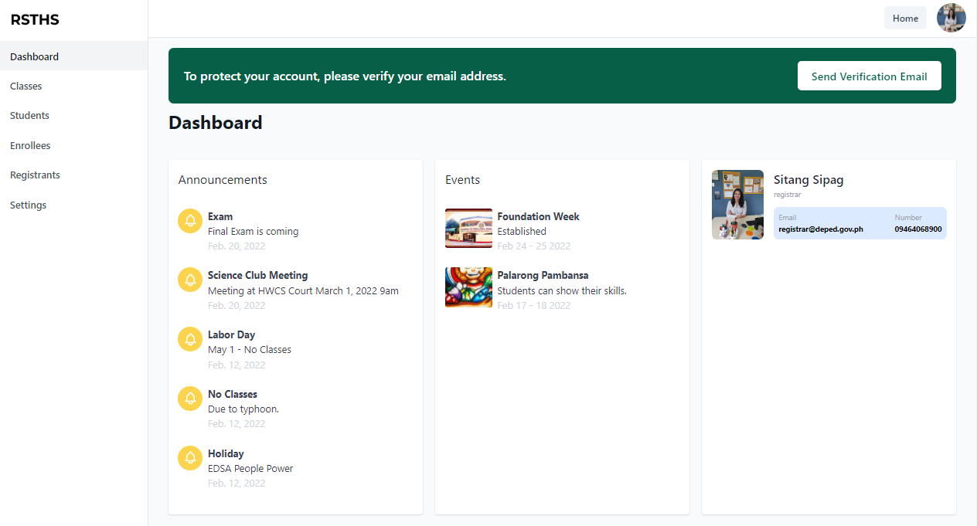

After logging in, the users can now access the portal. It will show the dashboard that will display the different announcement and events posted by the school and the basic information about the registrar. There is also a send verification email button in the top of the page wherein users will receive an email including a link that will verify their email.

In Classes menu, registrars can view all the class sections including the semester and the adviser.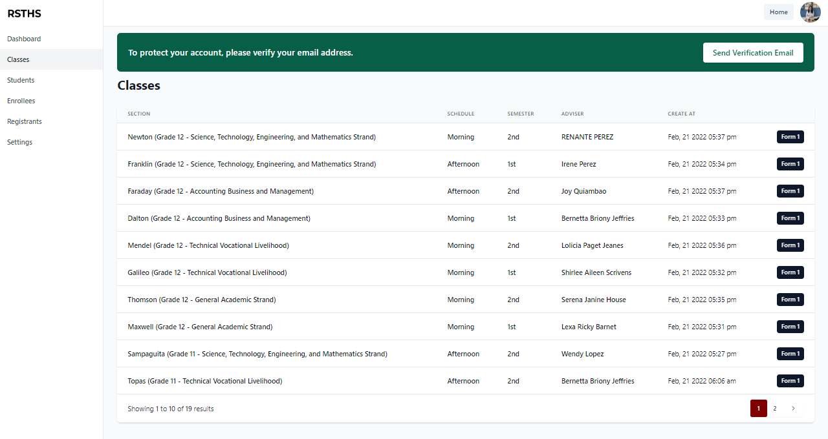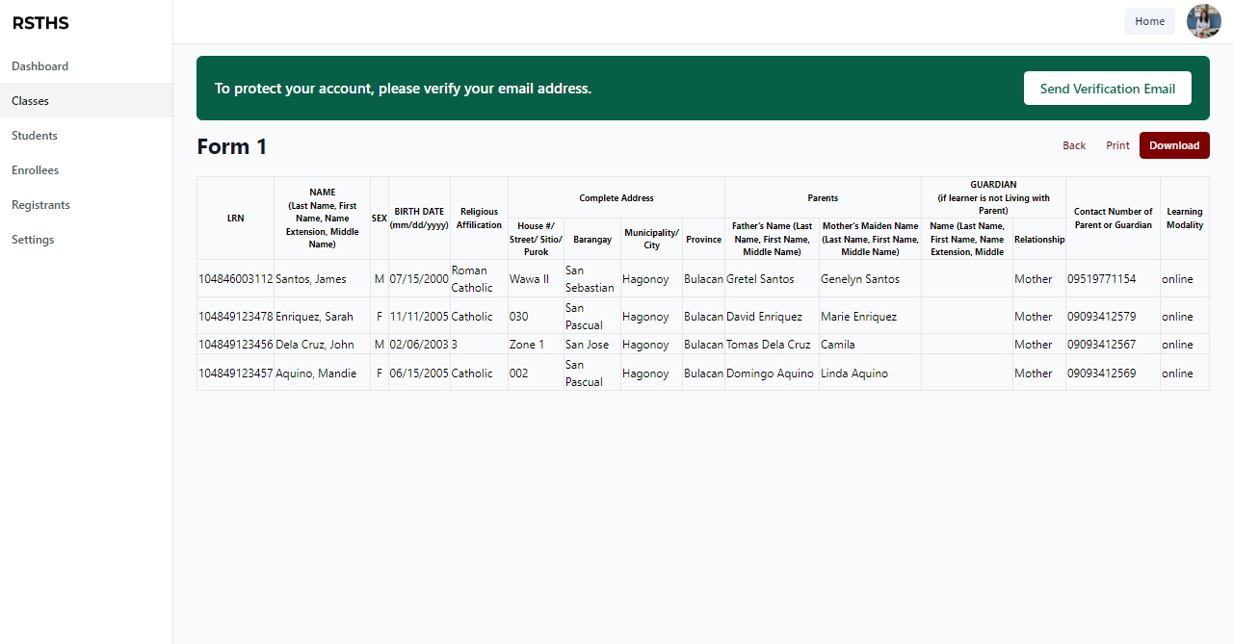

By clicking the Form 1 button, it will display the School Form 1 of the class section. School Form 1 consists of student information coming from registration form. Registrar have an option to print and download the School Form 1 in an excel format.

Registrars can view the list of students currently registered in the portal. In which, the registrar can also suspend and delete a student account. Suspended and deleted accounts can no longer access the portal.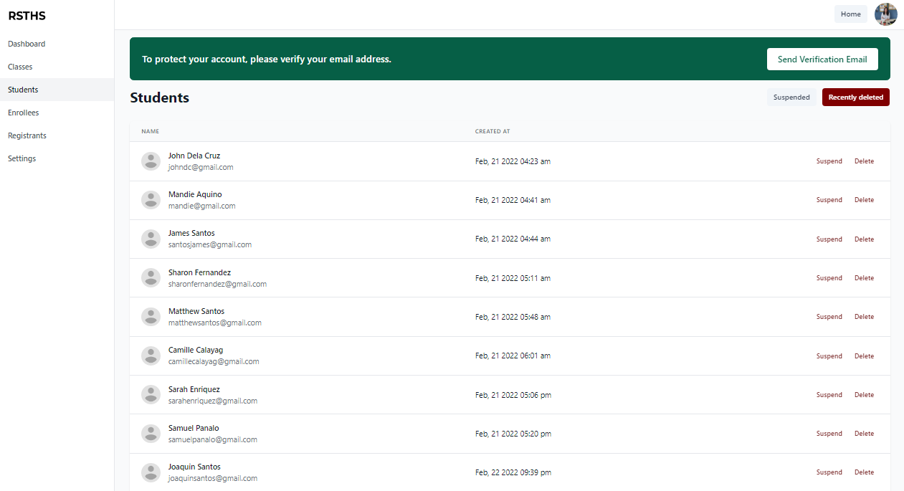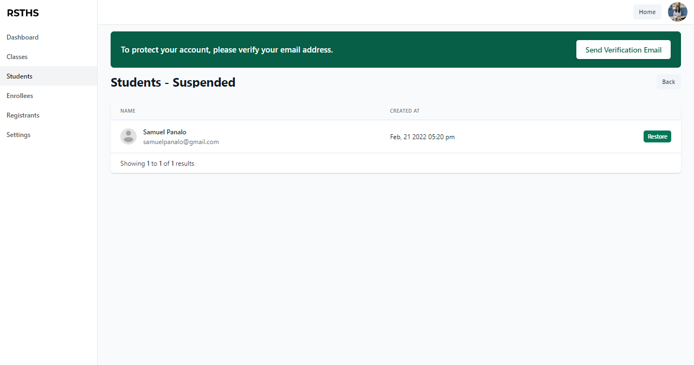

By clicking the Suspended button, registrar can see all the suspended accounts that can be restored.

Enrollees’ menu displays the list of verified student accounts that doesn’t have a class yet. Registrar is the only one who can assign a class section in every student in the portal. 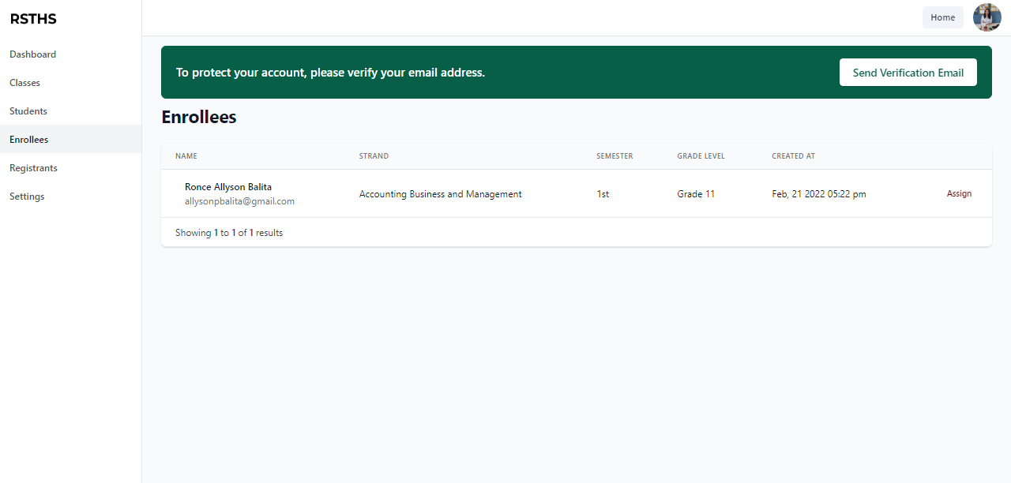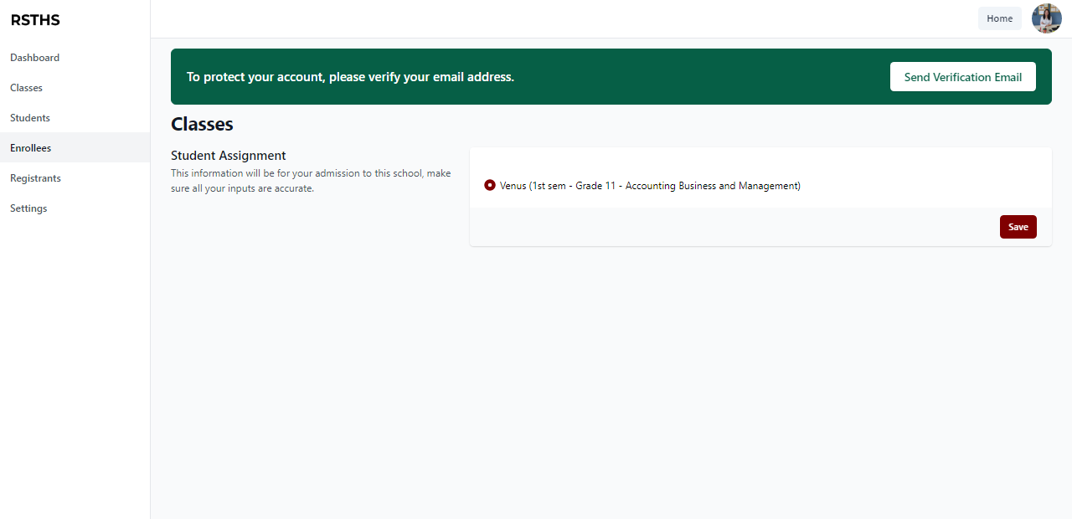

By clicking the Assign button, the portal will display the list of sections available based on the strand and grade level given by the student in the registration form. The registrar will just select a section then click Save.

In Registrants, the registrar can view all the students trying to enroll and register in the school portal. 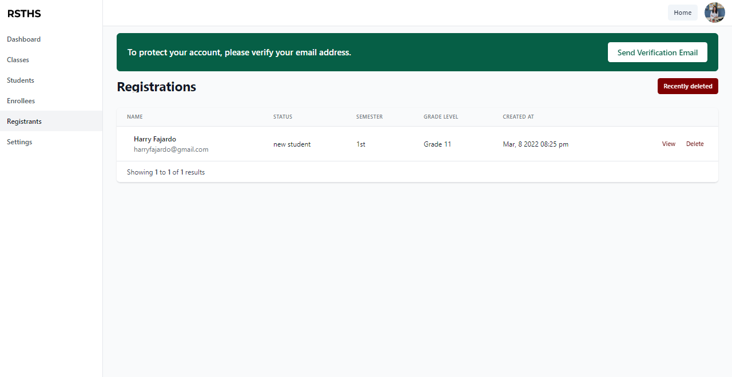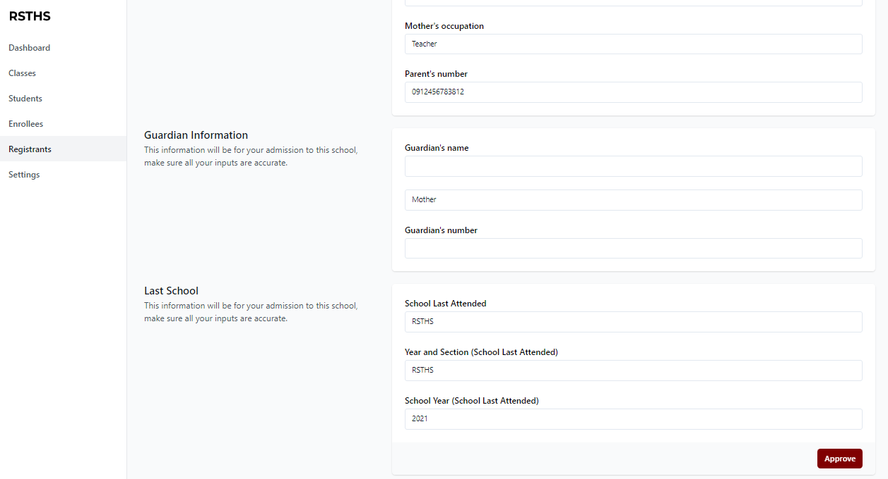

Clicking View Button will display the Registration Form answered by the student. The registrar can validate and check all the information based on their requirements. Then click Approve.

Registrar can also delete unverified accounts. Deleted accounts will transfer into the recently deleted accounts wherein the registrar has an option to restore or permanently delete it.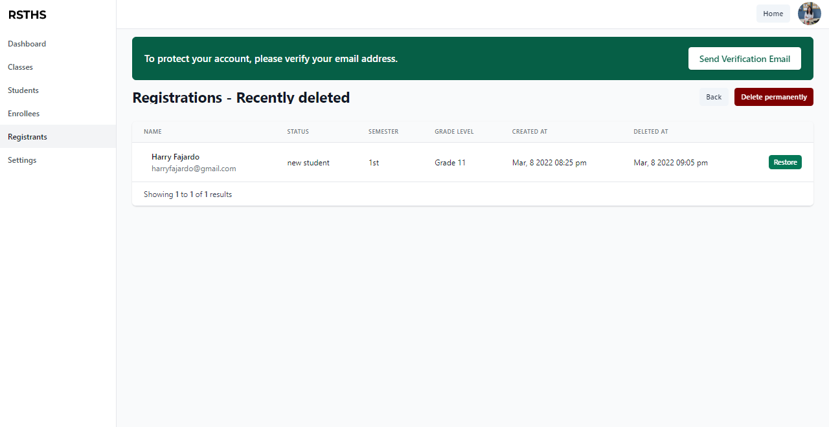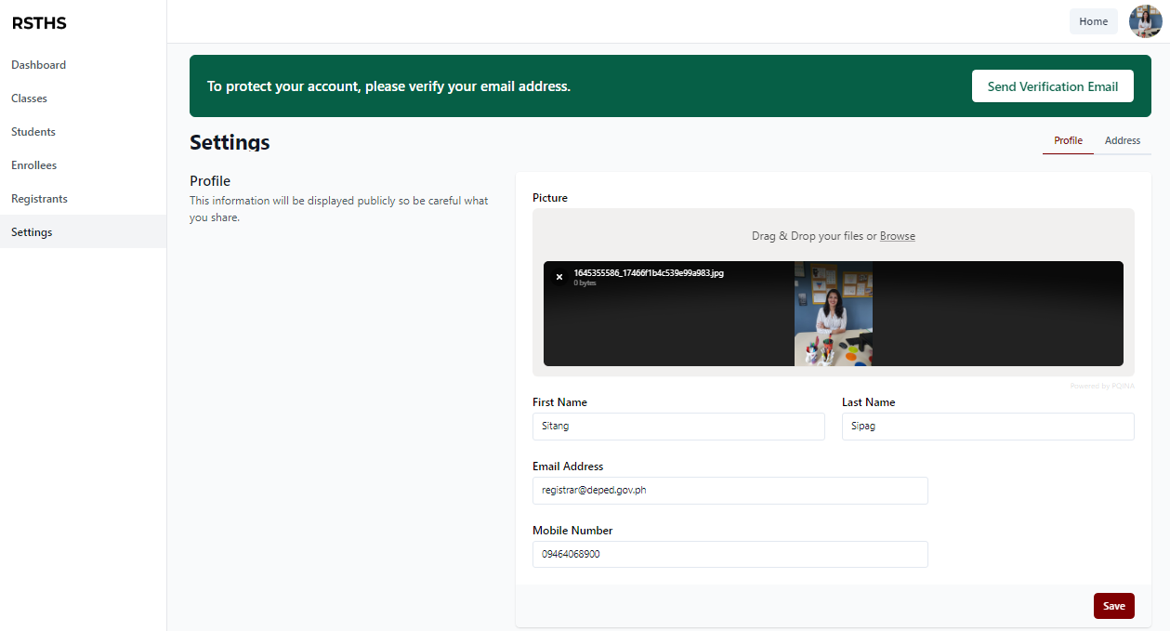

In Settings, Registrar can edit personal information and can also set profile picture by uploading an image.

The School Administrator can also change password in the portal by inputting old password, new password, and confirm new password. Then click Save.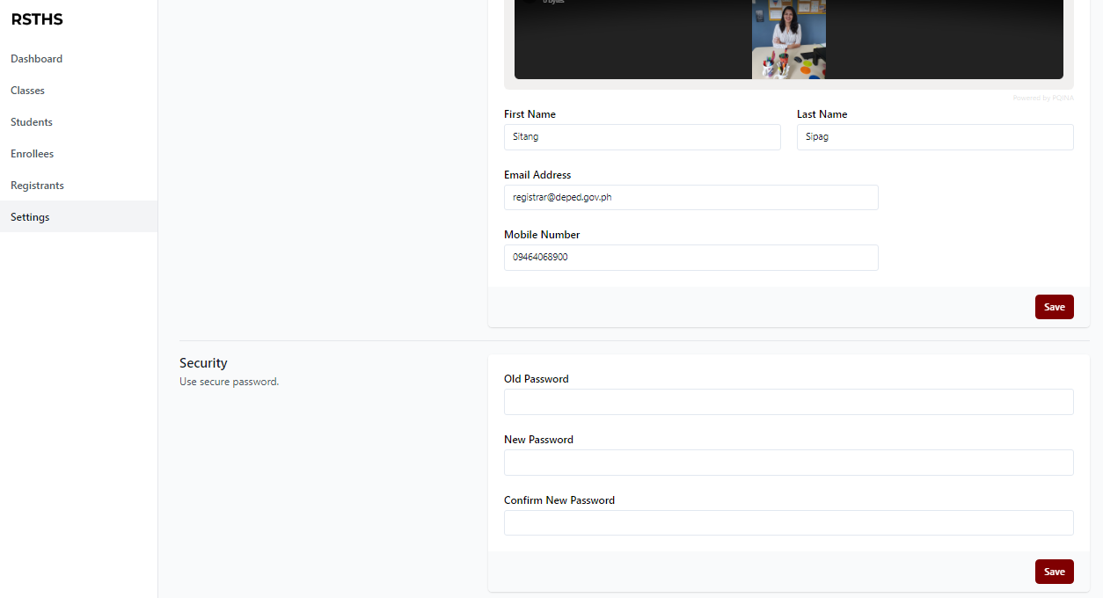

**USER’S MANUAL FOR SCHOOL ADMINISTRATION**

The main page of the portal consists of some information about the school including the Mission, Vision, and Objectives of Ramona S. Trillana High School. There are also Register, Login, and Enroll button.

In the Events, the users can view all the information and schedules about the incoming events of Ramona S. Trillana Senior High.

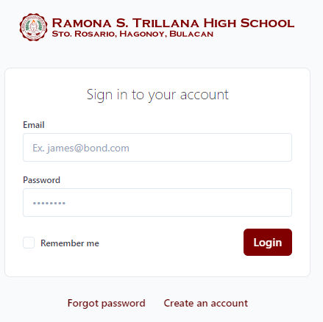

The School Administrator can login using the email and password provided by developers.

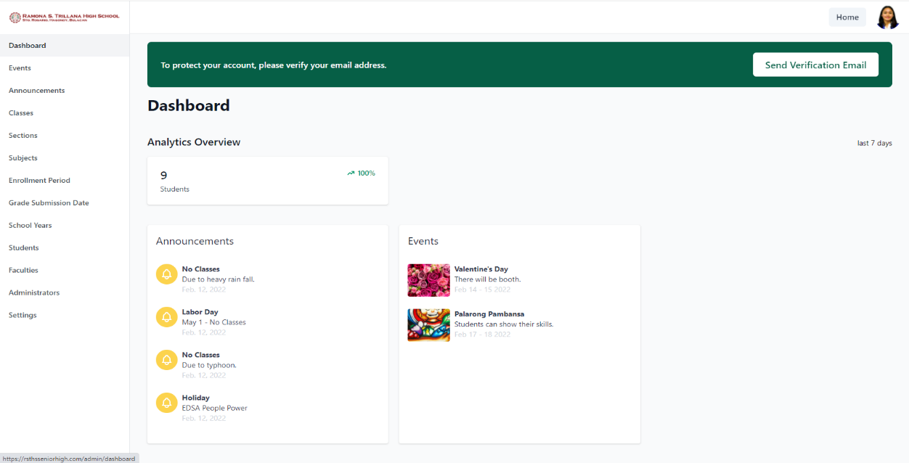

After logging in, the School Administrator can now access the portal. In the Dashboard, it will show the analytics overview about the number of students in the portal. It will also display the different announcement and events of school.

In Events menu, the School Administrator can see all the events posted in the portal including the date and description.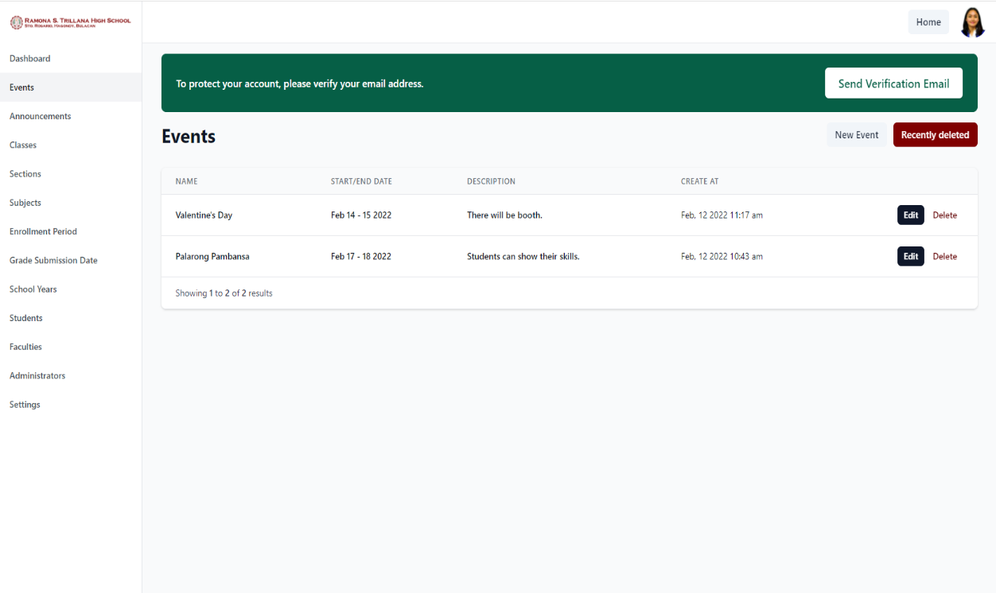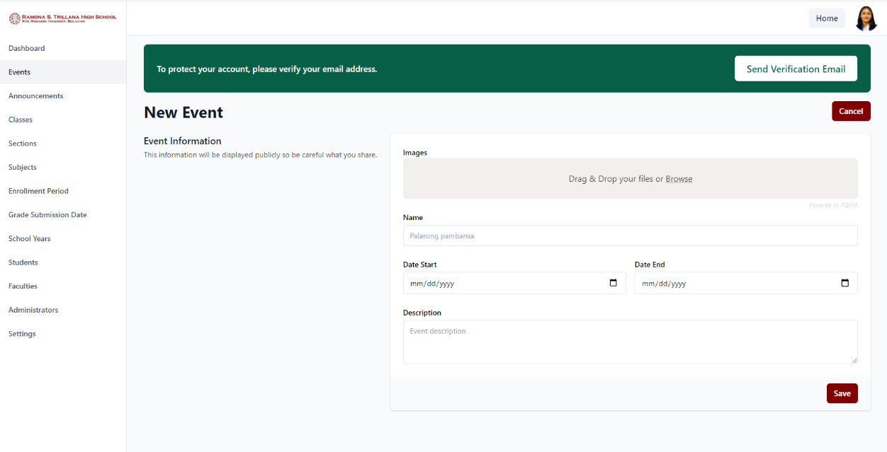

The School Administrator can add an event by clicking the new event button. It will ask for the name of the event, image or poster, start and end date, also the description. Then click Save. It will now be posted in the main page of the portal.

The School Administrator can delete an event. Using the delete button, it will go to recently deleted events and the School Administrator can permanently delete it or restore it.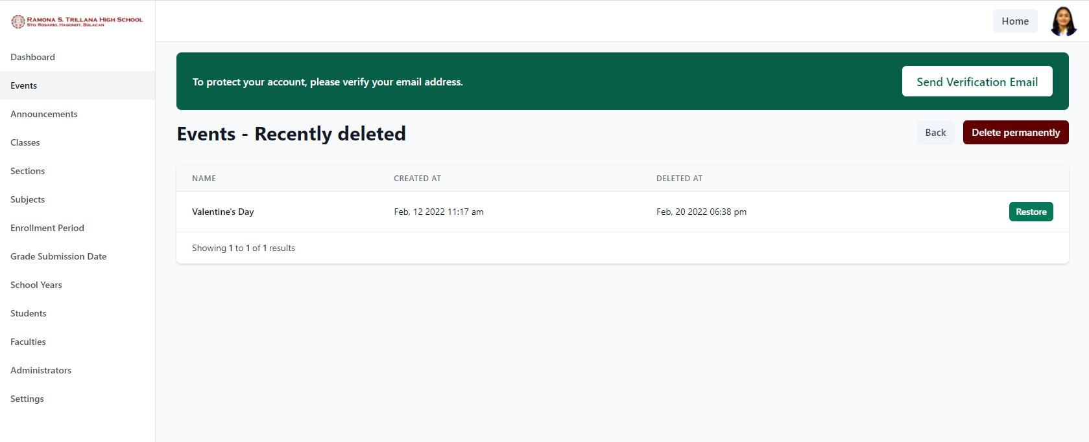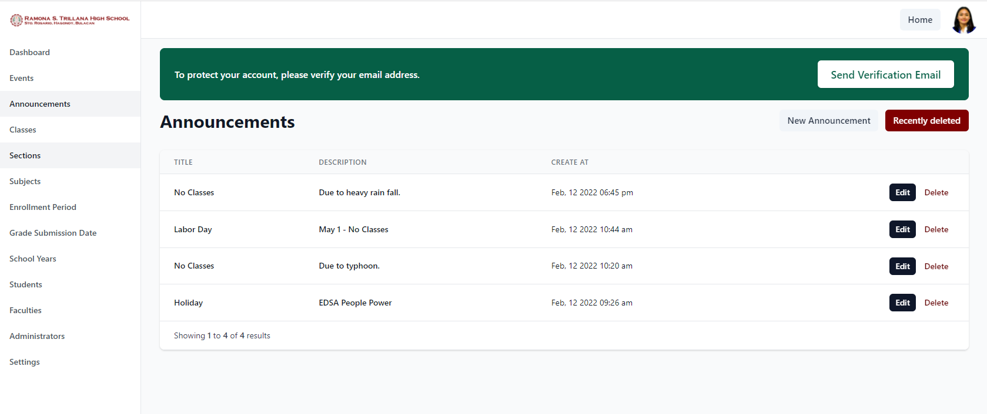

The School Administrator is the only one who can post an announcement. Using the announcement menu, the School Administrator can view, edit, and delete all the announcements.

In adding new announcement, just click on new announcement button and it will ask for the name of the announcement also the description. Then click post. The announcement will now be posted in the account of all the users.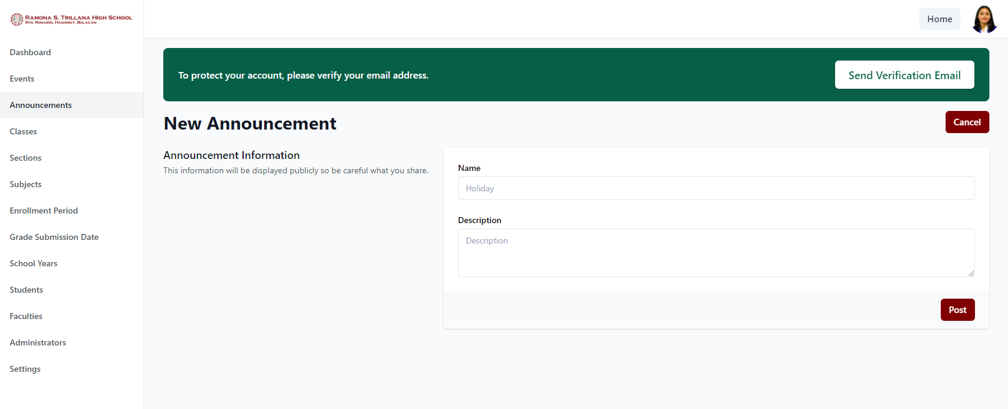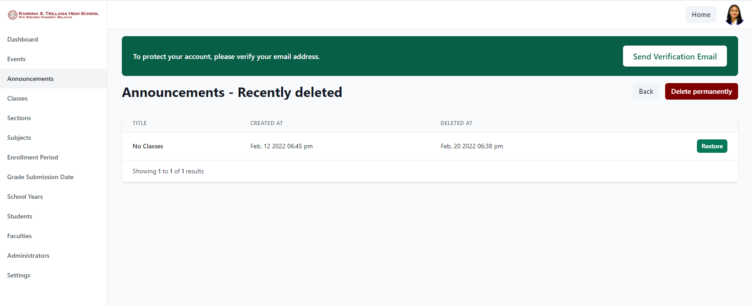

The deleted announcement will go in the Recently deleted announcements wherein the School Administrator can also restore and delete it permanently.

In Classes menu, the School Administrator can see all the class sections in Ramona S. Trillana Senior High. This is the menu where the administrator can add and edit the schedule of every section including their adviser by just adding a new class.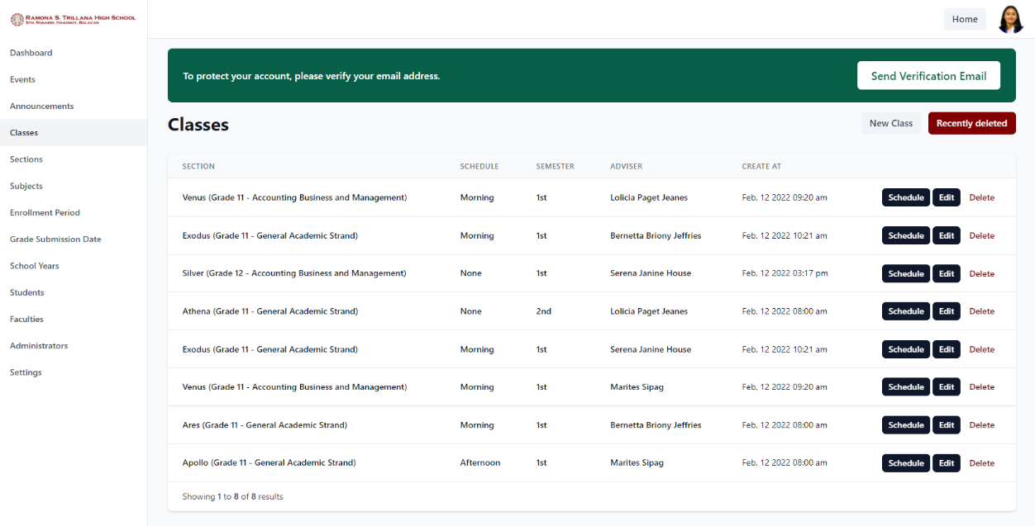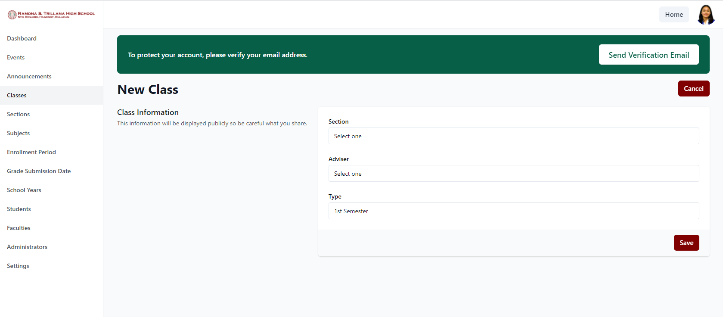

Adding New Class means that the School Administrator will assign a teacher to be an adviser. The administrator must select a section, teacher that will going to be an adviser, and the type of class (1st Semester or 2nd Semester). Then click Save.

The School Administrator can also edit a class. Then click update.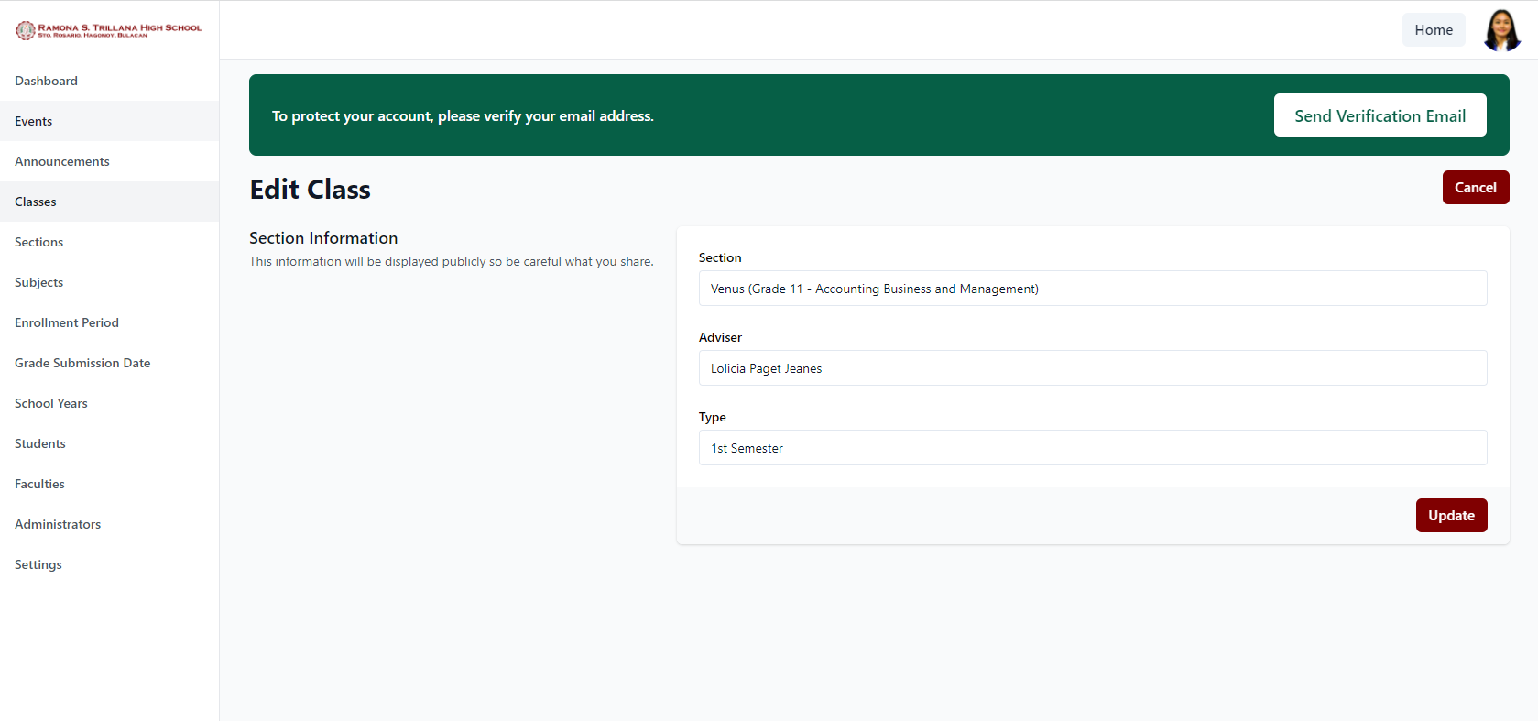

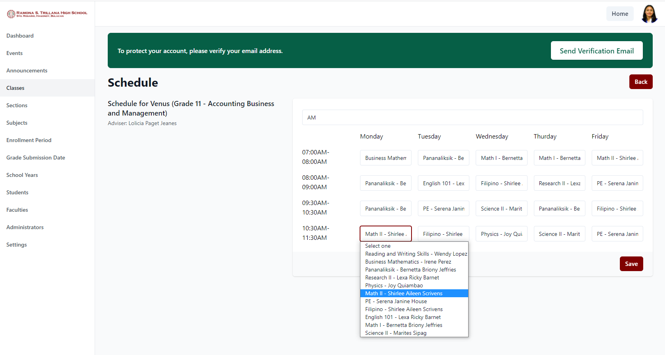

By clicking the Schedule button, the School Administrator can set the schedule of each sections including the teacher’s name and the time of class. Then just click save. It will be posted in teacher and student accounts.

The School Administrator can also delete a class and it will go into the trash. Wherein the administrator can restore it.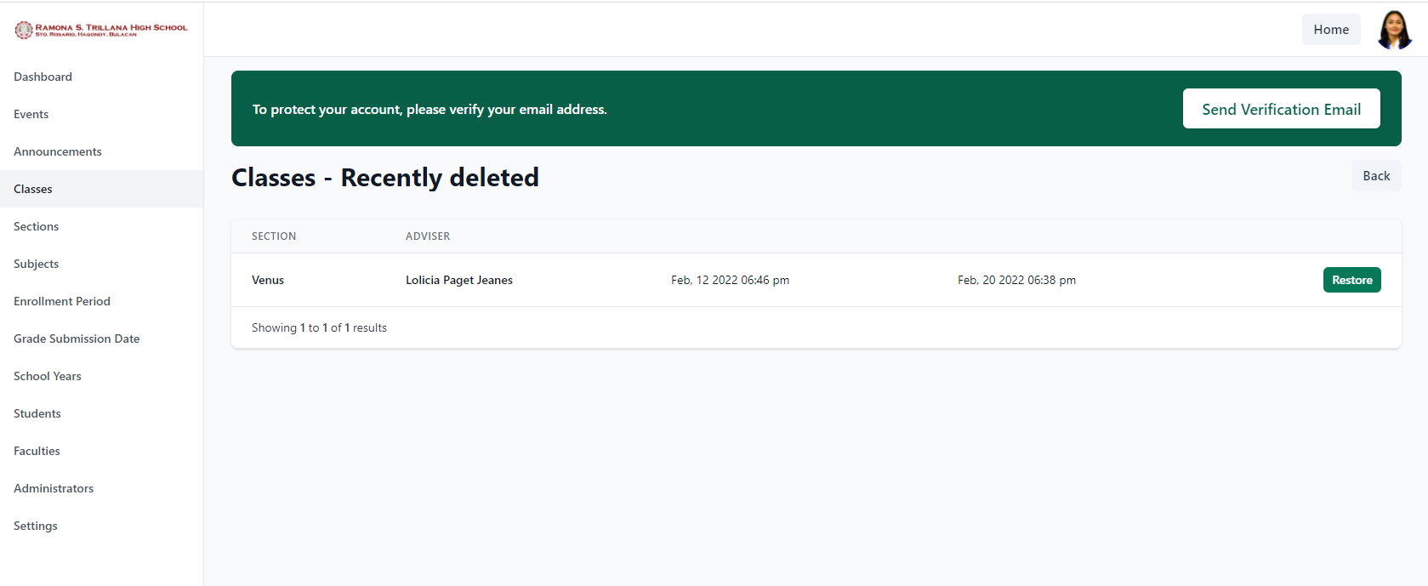

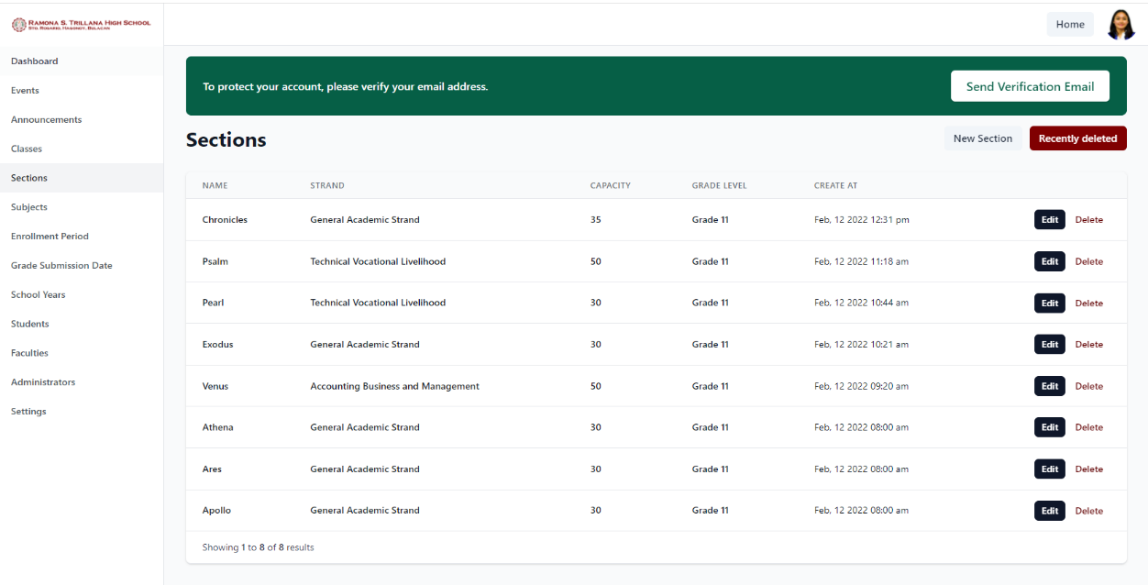

The Section menu display all the class sections including their strand, grade level, and its capacity. The School Administrator is the one who can add, edit, and delete a section.

To add a section, the School Administrator must click new section button and input all the information needed including the section’s name, capacity, grade level, and the strand. Then click Save.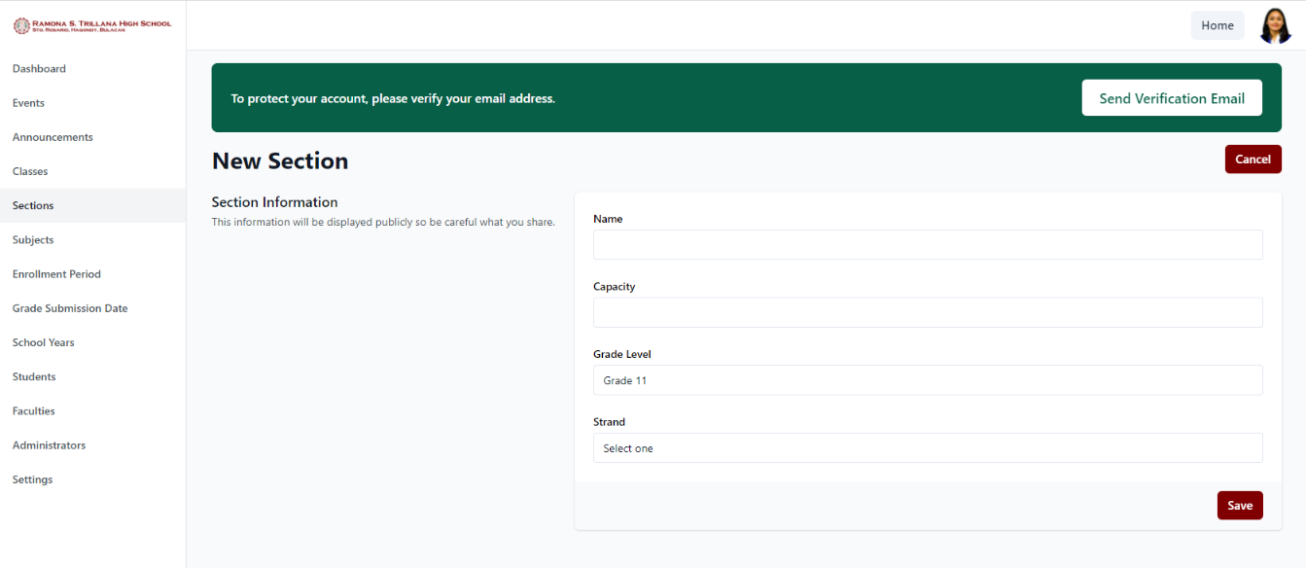

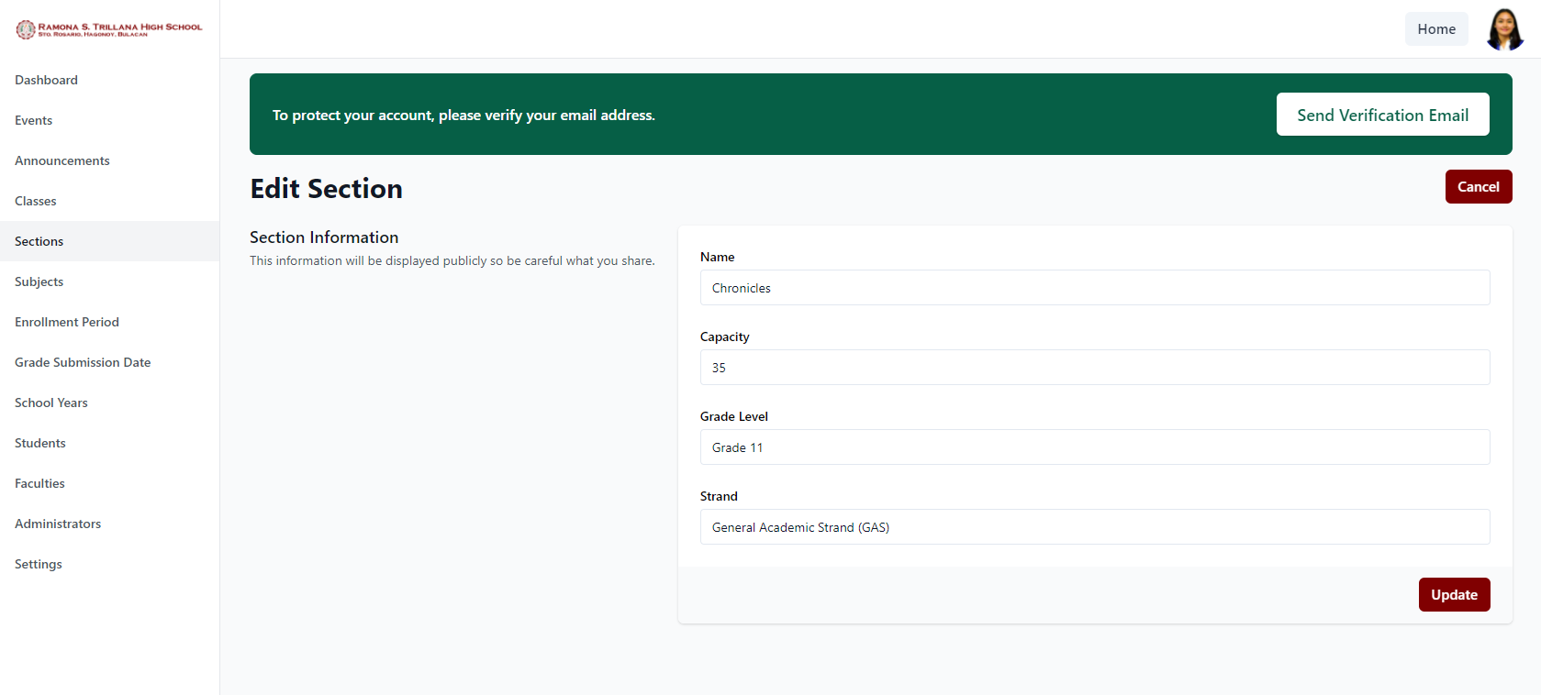

To edit a section, just click the edit button and it will display the current information about the section and the School Administrator can edit or change it. Then click update.

The School Administrator can delete a section and it will go into the trash. Wherein, it can also be restored.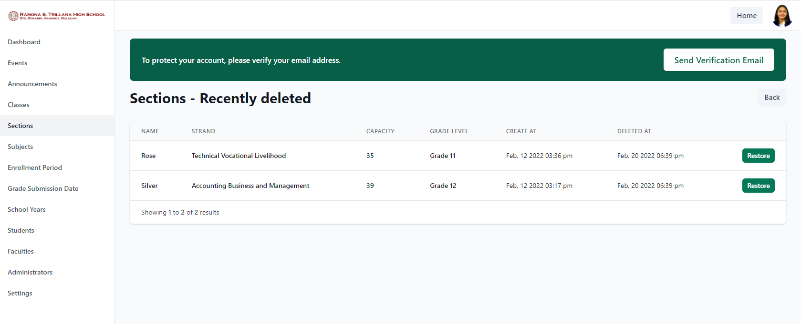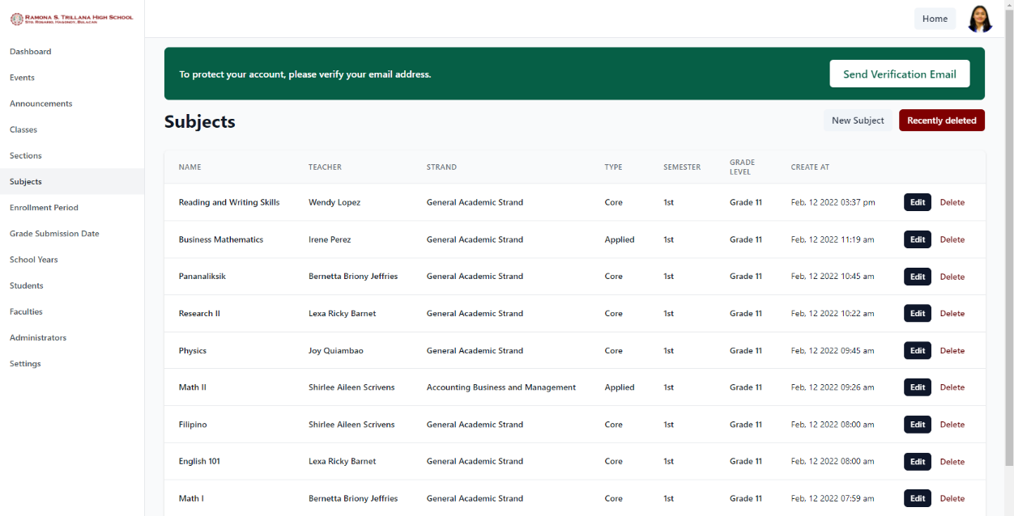

Subject menu displays all the subjects in every strand including the name of the teacher who handled that subject, the type of subject (Core, Applied, or Specialized Subject) and also the grade level where the subject is offered.

To add a subject, just click New Subject and it will ask for the subject name, the teacher, the type of subject, the grade level and the strand where the subject will be offered. Then click Create. The School Administrator can also edit a subject by clicking the edit button.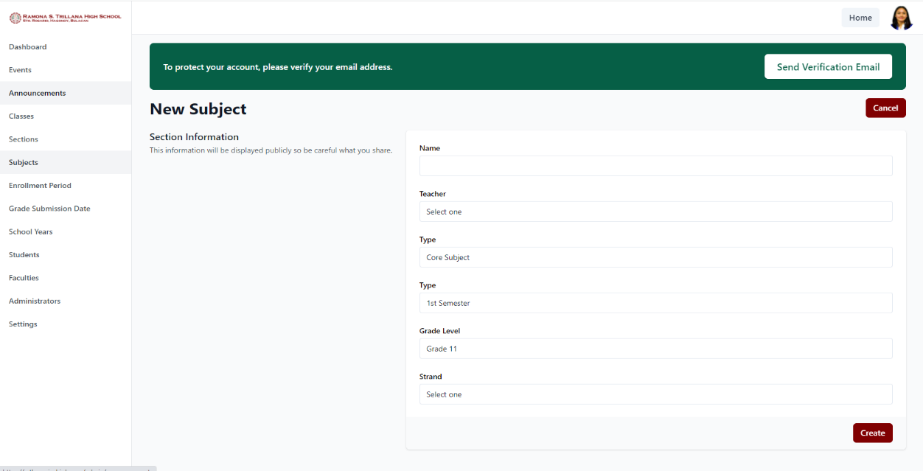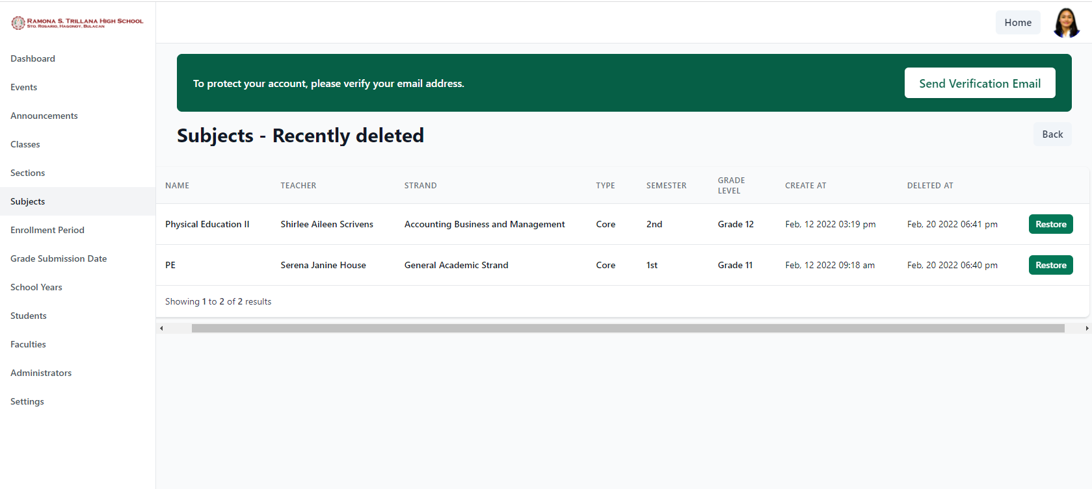

Deleted subjects will also go into the recently deleted subjects wherein the School Administrator can also restore it.

In the next menu, School Administrator can set the enrollment period in the portal. The students can only enroll within the start and end date of enrollment given by the School Administrator. 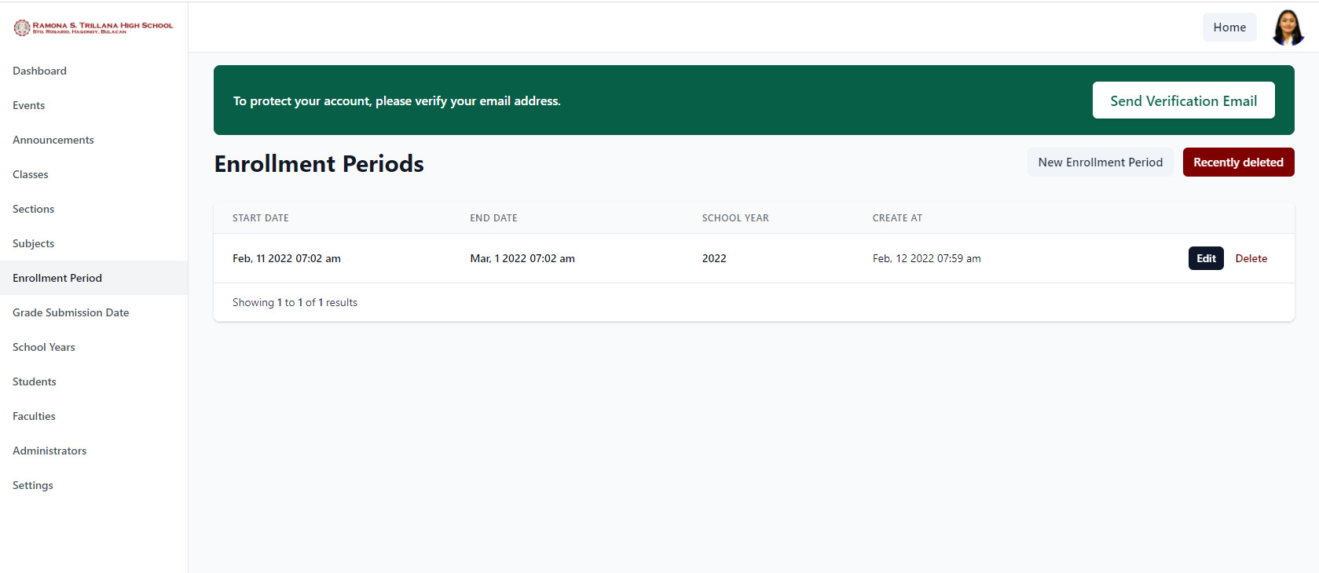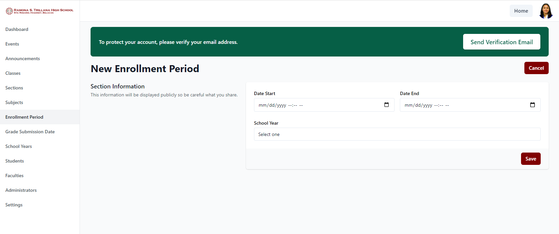

Adding new enrollment period includes selecting when the date of enrollment will start and end also the school year.

The School Administrator can also edit the enrollment period by clicking the edit button and selecting new date of enrollment. Then click update.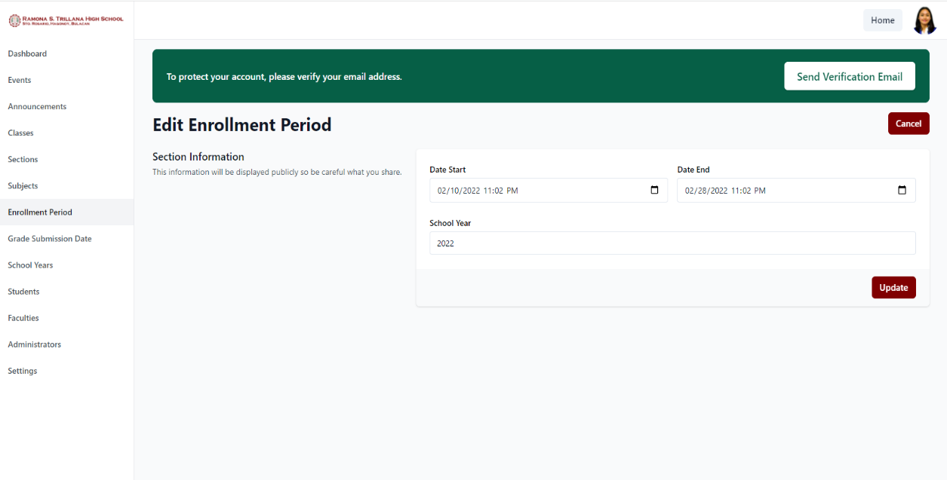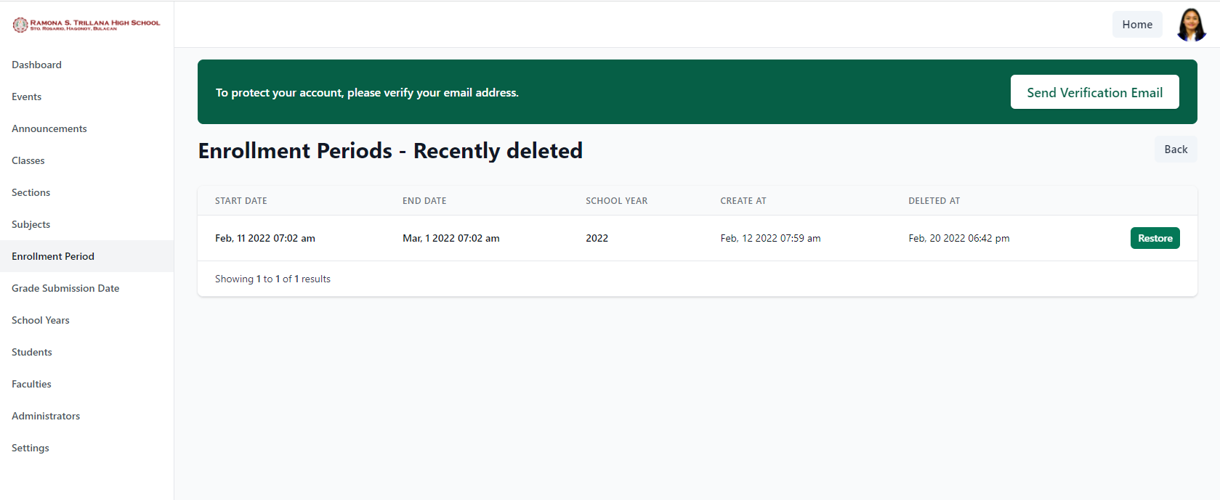

School Administrator can also delete an enrollment period and it will go into the trash. Wherein, it can also be restored.

Aside from setting the enrollment period, the school administrator can also set the date of grade submission. Wherein the teachers can only submit the grades of their students within the given period.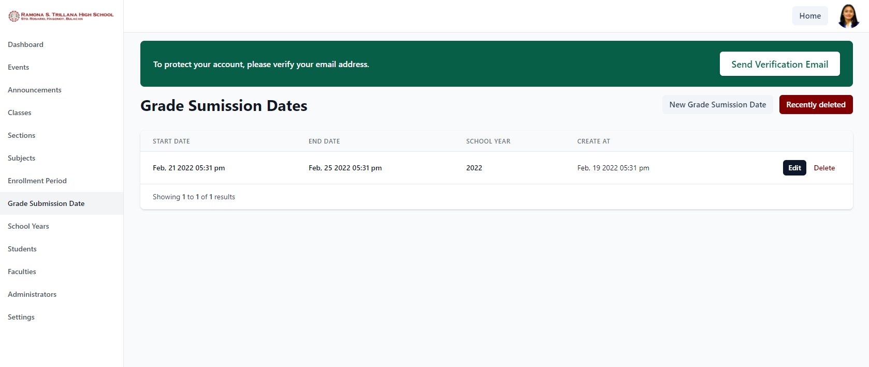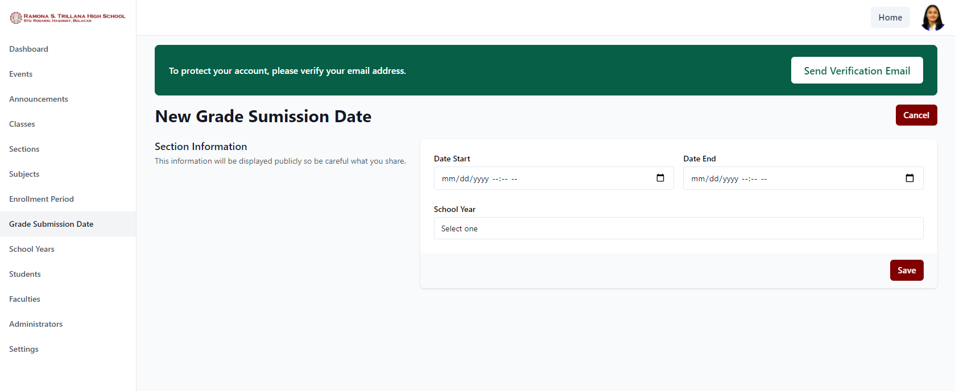

Adding new grade submission period requires start and end date also the school year. Then click save.

The Grade Submission Date can also be deleted and it will go into the trash and the School Administrator can restore it.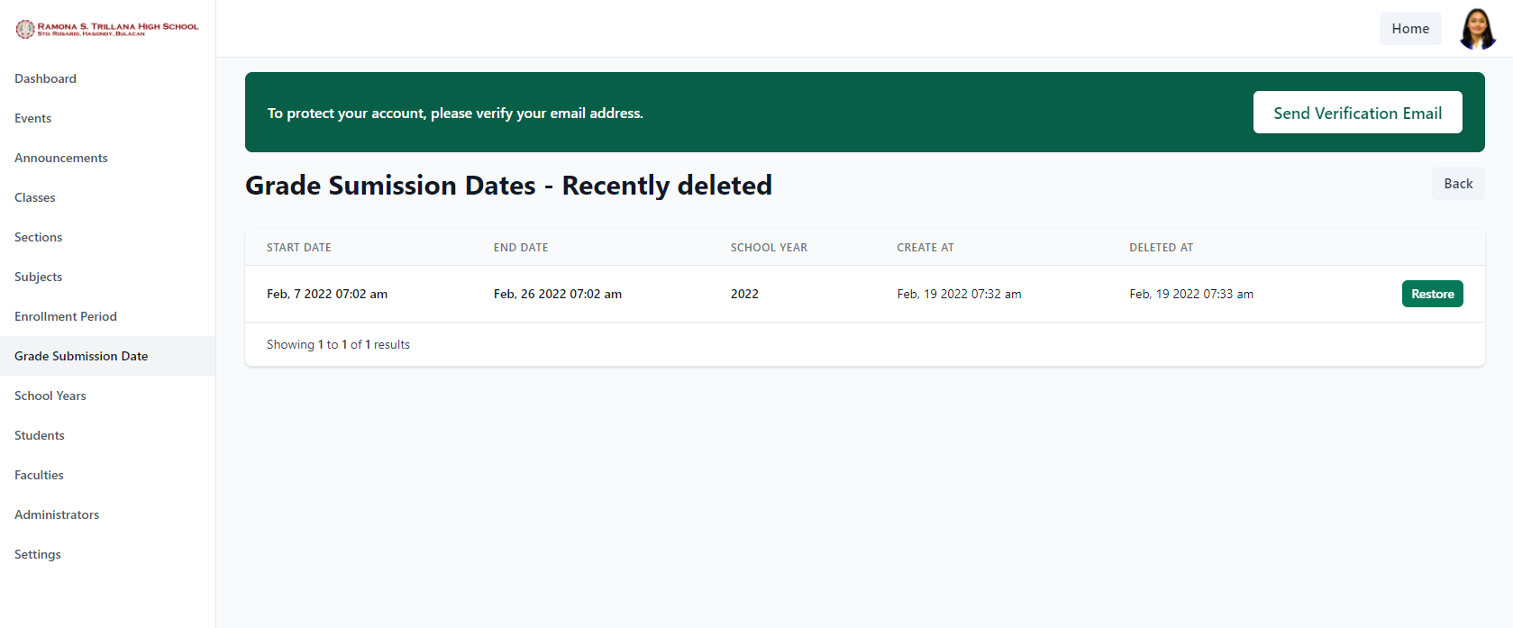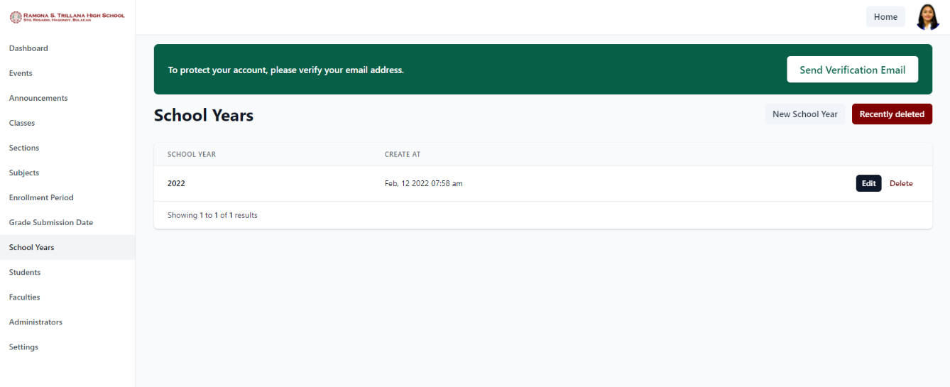

The School Administrator will be the one who will add, edit, and delete the school year in the portal.

In the Students menu, the School Administrator can see all the account of students in the portal. In which, the administrator can suspend and delete a student account. Suspended accounts can no longer access the portal.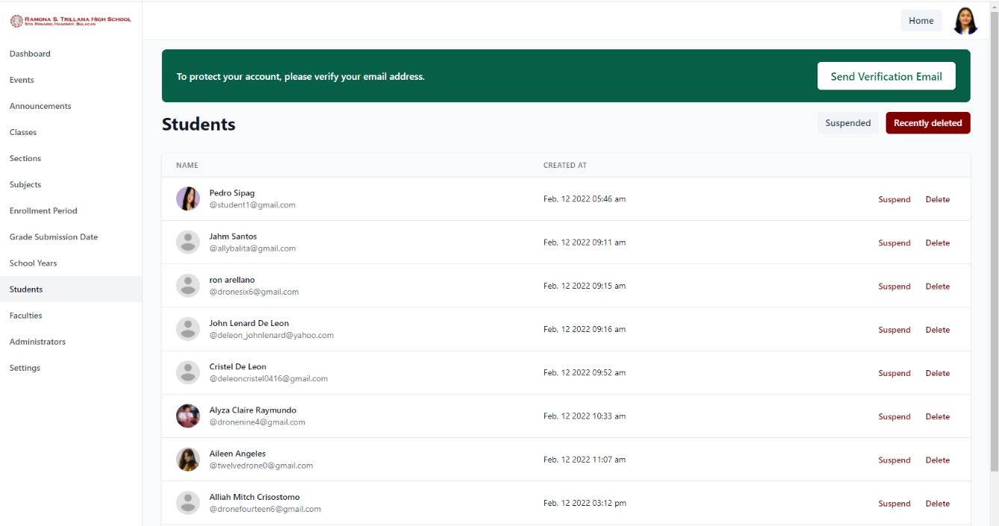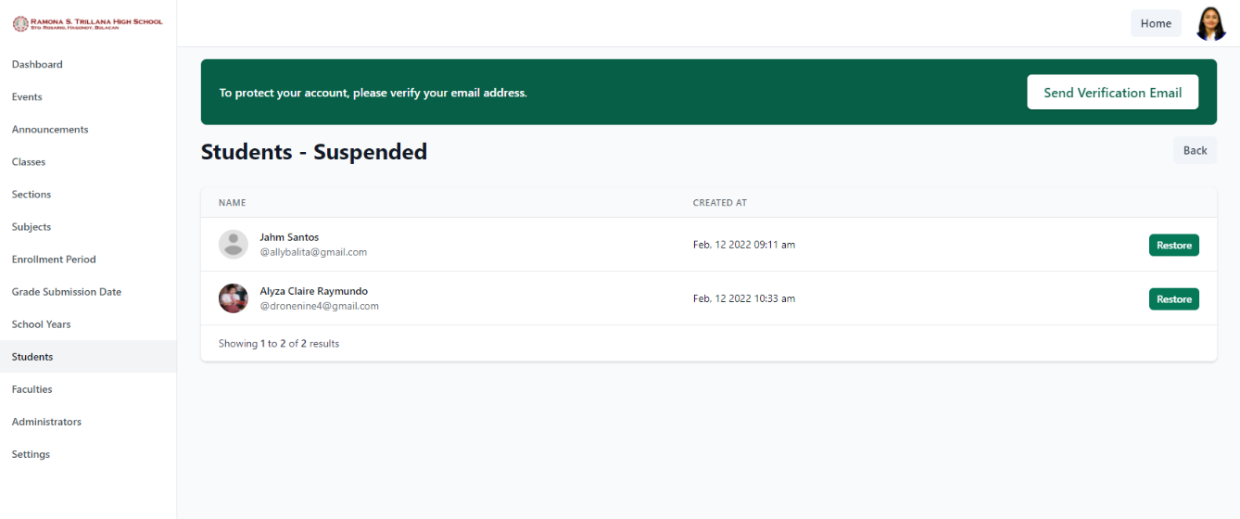

By clicking the Suspended button, it will display all the accounts suspended by the administrator and it can be restored.

In Faculties, it will display all teacher accounts. The School Administrator can assign a teacher to be a registrar. Also, administrator can suspend and delete a teacher’s account. 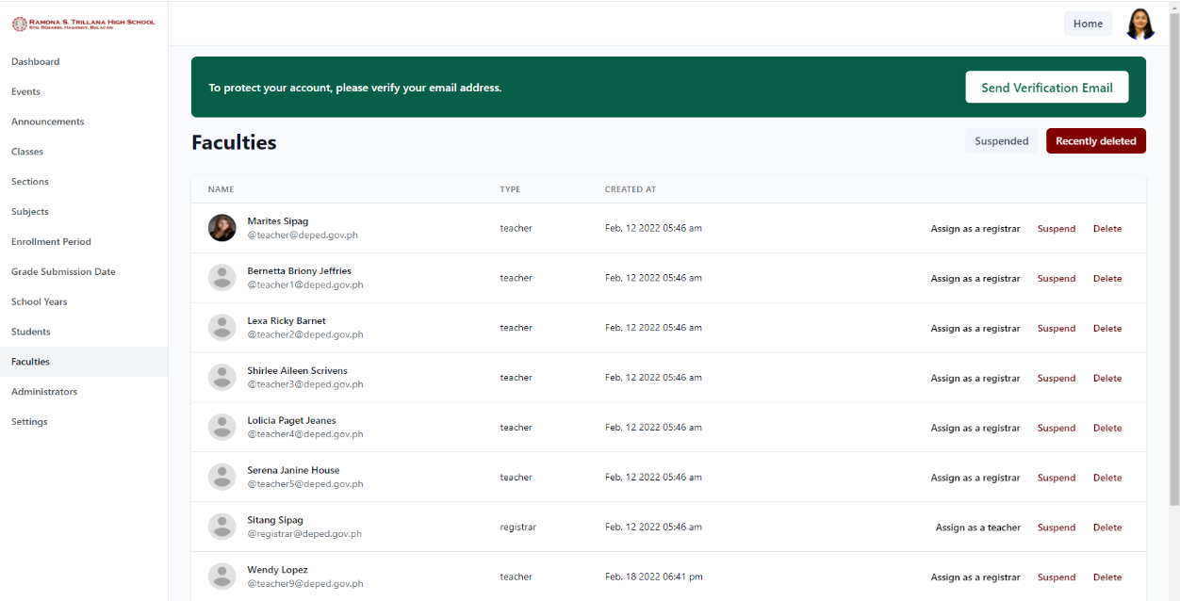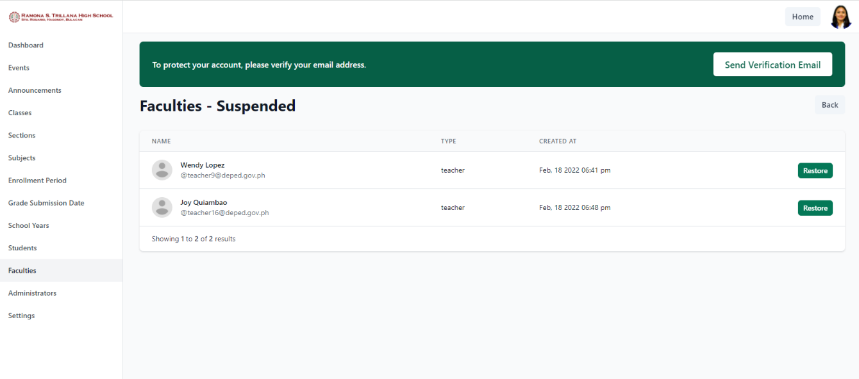

By clicking Suspended button, it will show the list of suspended teacher accounts. School Administrator can also restore it.

In the Administrators menu, it will display the account and the information about the School Administrator in the portal.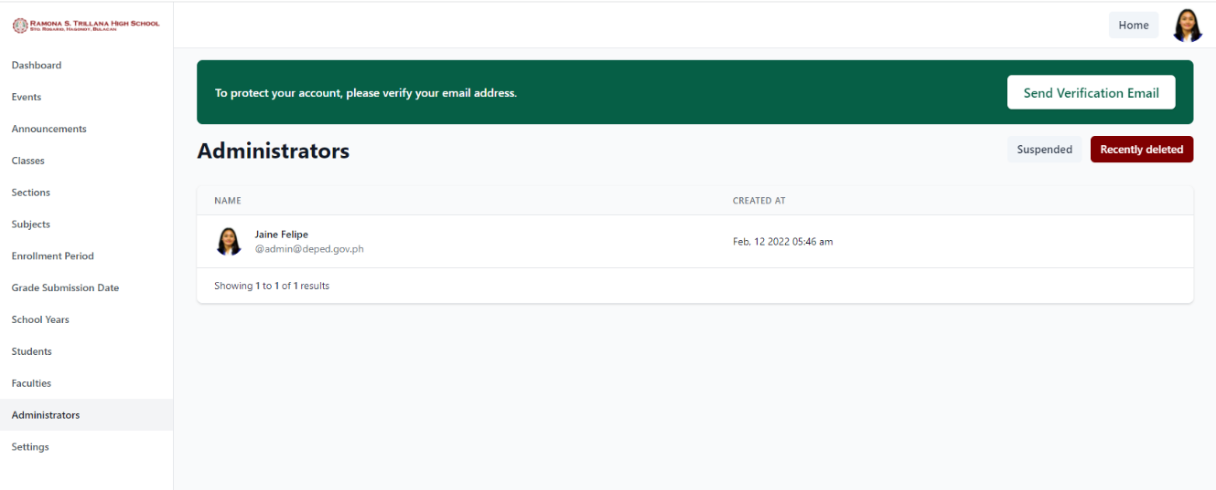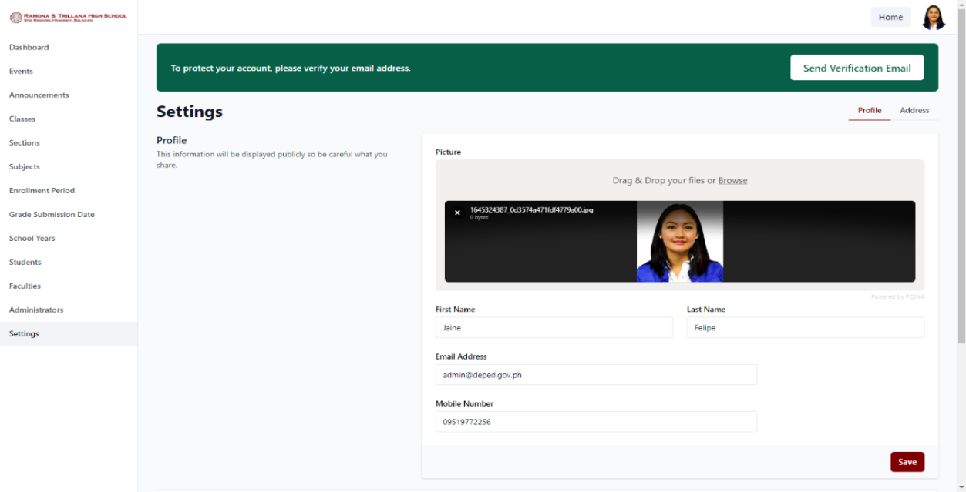

In Settings, Administrator can edit personal information and can also set profile picture by uploading an image.

The School Administrator can also change password in the portal by inputting old password, new password, and confirm new password. Then click save.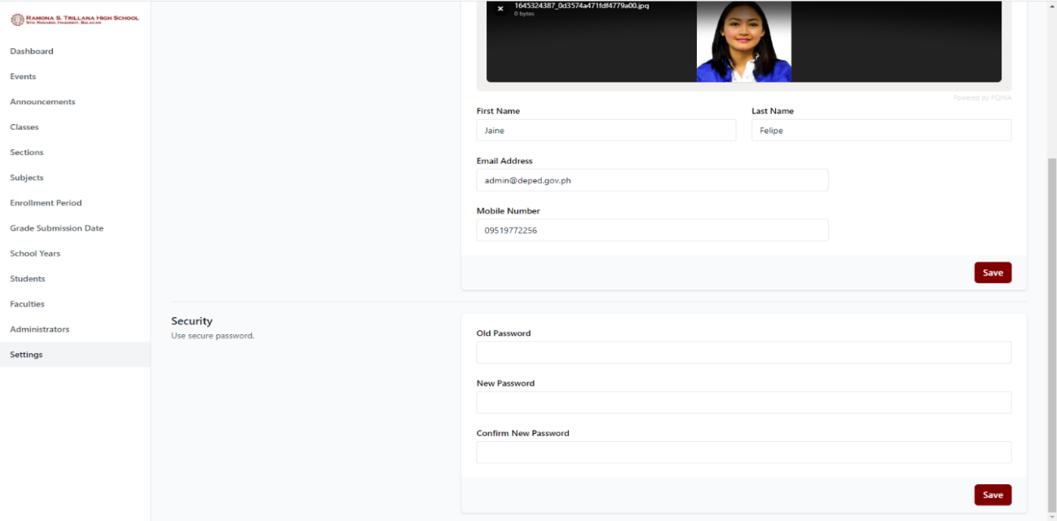

**References**

[1] Reddy, K. V. L., & Gupta, B. N. S. (2019, February). A Novel Approach on Online College Portal. Retrieved from https://svkpandksrajucollege.edu.in/wp-content/uploads/2021/03/2018-19-BNSG-6.-PAPER.pdf

[2] Thulasi NP, K. (2016). Online Student Portal - A Learning Portal for Every Student. Retrieved from https://www.ijedr.org/papers/IJEDR1603051.pdf

[3] Raut, M. R., Lokhande, T. P., Godbole, K. D., More, S. J., Hatmode, S. S., & Tibude, N. D. (2019). PCE Staff/Student Portal. Retrieved from http://www.ijcstjournal.org/volume-7/issue-1/IJCST-V7I1P4.pdf

[4] Saghapour, M. (2017, July 31). An empirical investigation of campus portal usage. Retrieved July 1, 2021, from https://link.springer.com/article/10.1007/s10639-017-9635-9?error=cookies_not_supported&code=41911b4c-19cc-4817-a5b1-bed9ffc17006

[5] capstoneguide. (2020, August 5). School Management System Capstone Project Document. Retrieved July 1, 2021, from https://capstoneguide.com/school-management-system-capstone-project-document/

[6] Villaverde II, M. (2019). Online Grading System. Retrieved from https://www.studocu.com/ph/document/isabela-state-university/bachelor-of-science-in-civil-engineering/other/online-grading-system-chapter-3-4-and-5-pdf-documentation/5528338/view

[7] Jasim, Y. A. (2021, March 3). ON ANNOUNCEMENT FOR UNIVERSITY WHITEBOARD USING MOBILE APPLICATION | Jasim | CSRID (Computer Science Research and Its Development Journal). Retrieved July 1, 2021, from<http://csrid.potensi-utama.ac.id/index.php/CSRID/article/view/384>

[9] Orlando, J., PhD. (2017, March 17). What Research Tells Us About Online Discussion. Retrieved July 1, 2021, from<https://www.facultyfocus.com/articles/online-education/online-student-engagement/research-tells-us-online-discussion/>

[10] Onyema, E. M., Deborah, E. C., Alsayed, A. O., Naveed, Q. N., & Sanober, S. (2019, November). Online Discussion Forum as a Tool for Interactive Learning and Communication. Retrieved from<https://www.researchgate.net/profile/Alhuseen-Alsayed/publication/337654925_Online_Discussion_Forum_as_a_Tool_for_Interactive_Learning_and_Communication/links/5de2e74d92851c836457d477/Online-Discussion-Forum-as-a-Tool-for-Interactive-Learning-and-Communication.pdf>

[11] Elhay, A. A. (2018, August 2). Teachers’ perceptions of out-of-class communication, teacher-student relationship, and classroom environment. Retrieved July 1, 2021, from<https://link.springer.com/article/10.1007/s10639-018-9782-7?error=cookies_not_supported&code=58c5fc21-dfa7-4d36-a0f0-19e06bba4510>

[12] Overview. (n.d.). Retrieved July 1, 2021, from<https://docs.oracle.com/javaee/1.4/tutorial/doc/JMS2.html>

[13] Beal, V. (2021, May 28). Student Portal. Retrieved July 1, 2021, from<https://www.webopedia.com/definitions/student-portal/>

[14] @stevenaustin. (2019, February 9). Importance of having student portal. Retrieved July 1, 2021, from<https://teletype.in/@stevenaustin/SyjCcb2NN>

[15] K, K. (2021, May 4). How to Register a Brand-New Domain Name – A Simple Easy-To-Follow ‘How to’ Guide. Retrieved July 1, 2021, from<https://winningwp.com/how-to-register-a-domain-name/>

[16] Journal, I. (2017, January). Online College Portal. Retrieved July 1, 2021, from<https://www.academia.edu/33600850/Online_College_Portal>

[17] Elcom Technology. (2021, April 5). How to Design the Perfect School Portal. Retrieved July 1, 2021, from<https://www.elcom.com.au/resources/blog/school-portal-design>

[18] Kumar, S. (2019, July). A REVIEW ON CLIENT-SERVER BASED APPLICATIONS AND RESEARCH OPPORTUNITY. Retrieved July 2021, from<https://www.researchgate.net/publication/335015436_A_REVIEW_ON_CLIENT-SERVER_BASED_APPLICATIONS_AND_RESEARCH_OPPORTUNITY>

[19] Gadong, E. S. A., & Chavez, M. R. LEARNERS’ REACTIONS TOWARDS AN ONLINE DISCUSSION FORUM IN A WEB-BASED LEARNING MANAGEMENT SYSTEM.<https://www.researchgate.net/profile/Early-Sol-Gadong/publication/322364169_LEARNERS'_REACTIONS_TOWARDS_AN_ONLINE_DISCUSSION_FORUM_IN_A_WEB-BASED_LEARNING_MANAGEMENT_SYSTEM/links/5a5607aeaca272bb6962dd00/LEARNERS-REACTIONS-TOWARDS-AN-ONLINE-DISCUSSION-FORUM-IN-A-WEB-BASED-LEARNING-MANAGEMENT-SYSTEM.pdf>

[20] Tico, D. (2016). WEB PORTAL SYSTEM WITH SMS NOTIFICATION. Retrieved June 29, 2021, from<https://www.academia.edu/27255320/WEB_PORTAL_SYSTEM_WITH_SMS_NOTIFICATION>

[21] TUP Manila. (n.d.). Retrieved from<http://www.tup.edu.ph/>

[22] Home - Student Portal. (n.d.). Retrieved July 1, 2021, from<https://our.upou.edu.ph/student>

[23] Miranda, M. G. P., Antuerpia, J. F., Barroso, E. P., Alcera, J. A., & Agustin, L. F. (2019, April). ENROLLMENT SYSTEM WITH DESCRIPTIVE ANALYTICS. Retrieved from<https://www.researchgate.net/profile/Louie-Agustin/publication/337707597_ENROLLMENT_SYSTEM_WITH_DESCRIPTIVE_ANALYTICS/links/5de65523a6fdcc283701352f/ENROLLMENT-SYSTEM-WITH-DESCRIPTIVE-ANALYTICS.pdf>

[24] Maggay, J. G. (2017, February). STUDENT INFORMATION AND ACCOUNTING SYSTEM OF CAGAYAN STATE UNIVERSITY – LASAM CAMPUS, PHILIPPINES. Retrieved from<https://www.researchgate.net/publication/327097792_STUDENT_INFORMATION_AND_ACCOUNTING_SYSTEM_OF_CAGAYAN_STATE_UNIVERSITY_-_LASAM_CAMPUS_PHILIPPINES>

[25] Perez, M. R. L., Lagman, A., & Adao, R. T. (2017, December). Event Management Solution Using Web Application Platform. Retrieved from<https://www.researchgate.net/publication/323822519_Event_Management_Solution_Using_Web_Application_Platform>

[26] Gadong, E. S. A., & Chavez, M. R. (2016, October). LEARNERS’ REACTIONS TOWARDS AN ONLINE DISCUSSION FORUM IN A WEB-BASED LEARNING MANAGEMENT SYSTEM. Retrieved from [https://www.researchgate.net/publication/322364169_LEARNERS’_REACTIONS_TOWARDS_AN_ONLINE_DISCUSSION_FORUM_IN_A_WEB-BASED_LEARNING_MANAGEMENT_SYSTEM](https://www.researchgate.net/publication/322364169_LEARNERS'_REACTIONS_TOWARDS_AN_ONLINE_DISCUSSION_FORUM_IN_A_WEB-BASED_LEARNING_MANAGEMENT_SYSTEM)

[27] Diamante, M. A. P., & Barrios, R. M. (2018, October). Relationship of Instant Messaging to the Face-to-Face Communication and Social Relationship of College Students. In *Abstract Proceedings International Scholars Conference* (Vol. 6, No. 1, pp. 241-241).<https://jurnal.unai.edu/index.php/isc/article/download/1163/693>

[28] Daugdaug, G. T., Enriquez, J. M. C., Grumo, K. D., Sabordo, D. Z., & Estorgio, R. P. (2018). CAMPUSCONNECT: A WEB AND ANDROID CAMPUS PORTAL.  *1st Semester of 2018*, 1<https://lm.uc.edu.ph/wp-content/uploads/2019/08/CCS-Journal-Vol-1-No-1.pdf#page=5>

[29] Almerino, P. M. (2020, October 19). Evaluating the Academic Performance of K-12 Students in the Philippines: A Standardized Evaluation Approach. Retrieved June 30, 2021, from<https://www.hindawi.com/journals/edri/2020/8877712/>

[30] Navarro, E. C., & Salas, R. F. (2020, April). TUP Manila. Retrieved from<https://www.researchgate.net/publication/341091039_Design_And_Development_of_NEUST_-San_Isidro_Campus_Website_Highlighting_Research_And_Extension_Services_And_Per_Area_Department>

[31] Jennilyn C. Mina, Marvin DG. Garcia, Ellen Jane G. Reyes (2020). Industry Partners’ feedback on the OJT performance of Bachelor of Science in Information Technology (BSIT) Students. International Journal of Advanced Engineering, Management and Science (ISSN: 2454-1311),6(4), 177-182.

[33] Daugdaug, G. T., Enriquez, J. M. C., Grumo, K. D., Sabordo, D. Z., & Estorgio, R. P. (2018). CAMPUSCONNECT: A WEB AND ANDROID CAMPUS PORTAL. *1 st Semester of 2018*, 1. [htt//lm.uc.edu.ph/wp-content/uploads/2019/08/CCS-Journal-Vol-1-No-1.pdf#page=5](https://lm.uc.edu.ph/wp-content/uploads/2019/08/CCS-Journal-Vol-1-No-1.pdf#page=5)

[34] Luz, J. M. (2020, November 19). [ANALYSIS] Too many children not enrolled this school year is a major concern. Retrieved June 30, 2021, from https://www.rappler.com/voices/ispeak/analysis-too-many-children-not-enrolled-this-school-year-major-concern

[35] Visual studio code. (2022, February 22). Wikimedia Foundation. Retrieved from <https://en.wikipedia.org/wiki/Visual_Studio_Code>

[36] Pedamkar, P. (2021, October 7). What is Visual Studio Code? Retrieved February 18, 2022, from https://www.educba.com/what-is-visual-studio-code/

[37] Xampp tutorial - javatpoint. www.javatpoint.com. (n.d.). Retrieved February 18, 2022, from https://www.javatpoint.com/xampp

[38] Moore, L. (2018, July, 31). What is mysql? Retrieved from <https://searchoracle.techtarget.com/definition/MySQL#:~:text=MySQL%20is%20an%20Oracle%2Dbacked,including%20Linux%2C%20UNIX%20and%20Windows.&text=MySQL%20is%20an%20important%20component,source%20enterprise%20stack%20called%20LAMP>.

[39] Hernandez, J. (2019, May 8). What is Apache? in-depth overview of Apache Web Server Retrieved from <https://www.sumologic.com/blog/apache-web-server-introduction/#:~:text=Apache%20HTTP%20Server%20is%20a,HTTP%20client%20on%20the%20web>